**IGLUNA 2021**

A test bed to demonstrate space technologies in extreme environment

**Student Documentation (SD)**



|  |  |
| --- | --- |
| **Team Name:** | LIGHT2 |
| **Revision:** | 05 |
| **Date of Issue:** | 31/07/2021 |
| **Document Name** | IGL_P08_LIGHT2_SD_05.pdf |

**Change history**

|  |  |  |  |
| --- | --- | --- | --- |
| Revision. | Date | Chapter | Modifications / Remarks |
| 01 | 09/11/2020 | 1-7 | Initial Submission |
| 02 | 10/2/2021 | 1-7 | Changes may be found in Section 3.1 |
| 03 | 27/05/2021 | 2, 3, 4, 7 | Changes may be found in Section 3.2 |
| 04 | 09/07/2021 | 1, 2, 3, 6 | Changes may be found in Section 3.3 |
| 05 | 31/07/2021 | 1.10, 7.1 | Added VFC results and lessons learned |

**Table of Content**

1 CORE DOCUMENTATION 7

1.1 Abstract 7

1.2 Graphical Abstract (Project Concept) 8

1.3 Mission or Project Statement 8

1.4 Need Statement 8

1.5 Project Relevance 8

1.6 Stakeholder Identification 10

1.7 Project Goals and Objectives 12

1.8 Project Top-Level Requirements 15

1.9 Risk Analysis 16

1.10 IGLUNA Field Campaign Results 19

1.11 Business Model 20

1.11.1 Executive Summary 23

1.11.2 Canvas Model 24

2 DETAILED PROJECT DESCRIPTION 26

2.1 Complete Project Requirements 26

2.1.1 Functional Requirements 26

2.1.2 Performance Requirements 27

2.1.3 Interface Requirements 28

2.1.4 Safety Requirements 29

2.1.5 Constraint requirements 30

2.2 Trade - Offs 31

● WavesharePOE HAT 32

● DSLRKIT 32

● PoE HAT 32

2.3 Project Management 33

2.3.1 Work Packages Overview 33

2.3.2 Project Plan 34

2.3.3 Collaboration Tools 34

2.4 Resources 35

2.4.1 Manpower 37

2.4.2 Budget 38

2.5 Project Set-Up 40

2.6 Concept of Operations 45

2.6.1 Guest Safety 49

2.6.2 Operations and Test procedures 49

2.7 Project Interfaces 50

2.7.1 Mechanical Interfaces 50

2.7.2 Power and Data Interfaces 50

2.8 Project Overview Summary 51

*2.8.1* List of Components *Table 2.8.1-1* 51

2.8.2 Project Overview Summary 61

2.9 Project Design 61

2.9.1 Mechanical Design 61

2.9.2 Mass Budget 62

2.9.3 Electronics Design 63

2.9.4 Power Budget 68

2.9.5 Heat release 69

2.9.6 Software Design 70

2.9.6.1 AR Helmet (HLS) 70

2.9.6.2 Server (Control Room Laptop) 77

2.9.6.3 Raspberry Pi 83

2.10 Data Management 84

2.10.1 Data Management Concept 84

2.10.2 Data Budget 85

2.11 Project Verification and Test Planning 86

2.11.1 Verification Matrix of the Requirements 86

2.11.2 Test Plans 89

2.11.3 Test Results 91

2.12 Project Equipment Needed 92

2.13 Outreach 92

2.14 Further Business Model Strategies 94

2.14.1 SWOT Analysis 94

2.14.2 Sponsoring and strategic partnership 94

2.14.3 Academic Support 95

2.14.4 Industrial Support 95

3 SD REVISIONS 97

3.1 Preliminary Design Review [PDR] 97

3.2 Critical Design Review [CDR] 98

3.3 Readiness Review [RR] 99

4 ABOUT THE TEAM 101

4.1.1 Point of Contact 101

4.1.2 Team Structure Overview 101

4.1.3 Team Members 102

5 LIST OF ABBREVIATIONS 107

6 REFERENCES 109

7 ANNEXES 110

7.1 Lessons Learned 110

7.1.1 Internal Lessons Learned 110

7.1.2 Lessons Learned with the Space Innovation 110

7.1.3 Lessons Learned with other Project Teams 111

7.1.4 Lessons Learned with sponsors 111

7.1.5 Lessons learnt during the Field Campaign 111

7.2 General Output and Feedback 111

7.3 Project Management 112

7.3.1 Work Packages Breakdown 112

7.3.2 Project Plan 112

7.3.3 SWOT Analysis 117

7.4 Detailed Project Description 119

7.4.1 List of Components 119

7.4.2 Biometrics 123

7.4.3 WebRTC 125

7.4.4 Electrical Design Concepts and Trade-Off Analysis 127

7.4.5 Software Design Concepts and Trade-Off Analysis 129

7.4.6 Test Plans 131

# CORE DOCUMENTATION

## Abstract

In the near future, the vision and the need of establishing an active human presence on the moon seems all the more urgent but more importantly all the more feasible after certain technological advancements are made. To begin with, the completion of space related tasks is a cognitively demanding and highly complex process that requires a high level of training. Furthermore, the orientation and localization of an astronaut in real or analogue missions requires constant communication with the base station’s operators. It is, therefore, necessary to overcome these limitations in order to reduce human error and increase the situational awareness of the astronaut.

In view of the vital role that new technologies will play in space development, LIGHT2 (Lunar navIGation HelmeT) aims at designing, implementing and testing an AR-based mission assistance system for use in future planetary mission analogues or even real missions. The system will consist of a mixed reality headset (Microsoft HoloLens), on which the information vital to the mission will be projected, accompanied by a weather station with appropriate sensors and a camera - which will serve as an environment sensing device, and a base station serving as operational support.

Biometric data characterizing the astronaut’s medical status, data concerning the environmental conditions as well as a map of the area will be available. Moreover, an interactable graphical interface will provide the astronaut with the necessary functions to complete his missions. Lastly, a networking system will relay the data from the weather box to the helmet.

For the IGLUNA 2021 Virtual Field Campaign, a lunar-like environment will be set up on an abandoned mining area, where an analogue EVA moonwalk will be recorded, showcasing the AR system’s full capabilities. During the duration of the shooting, a lunar weather station will be placed nearby, which will be collecting temperature, radiation, and humidity measurements, as well as visual feed, and sending them through the control room to the Hololens in real-time.

In the long-term, LIGHT’s system, by properly adjusting its features, incorporating networking capabilities with other devices (IoT, Robots, specialized equipment) and implementing AI guidance, could provide a more general and structured approach to team coordination and problem solving in the Industry or the Medical field.

## Graphical Abstract (Project Concept)

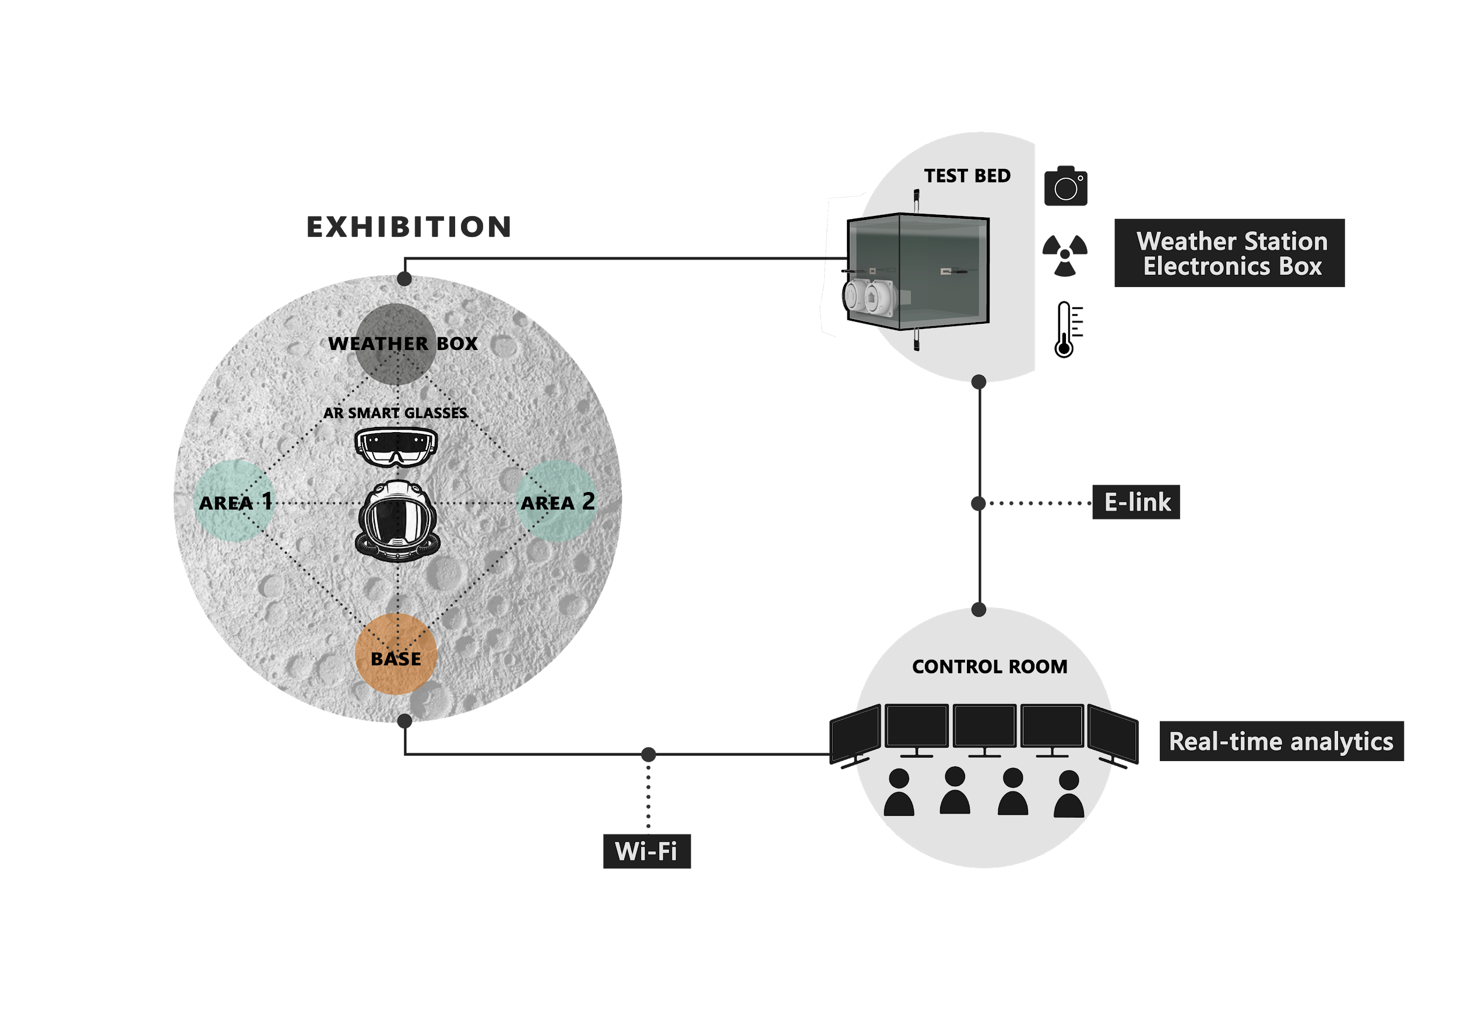

## Mission or Project Statement

LIGHT2 will be a general tool for astronauts’ navigation and assistance on both real and analogue lunar exploration missions based on Augmented Reality technology.

## Need Statement

Taking into consideration the complexity of a lunar mission, the cognitive load necessary for the orientation or localization of the astronaut and the successful completion of diverse mission objectives such as the repair of machinery and retrieval of items adds to the already heavy training regimes of astronauts. Consequently, the available time for free exploration and scientific field work in real missions is heavily reduced. Space agencies ought to streamline the process, should they eventually establish a sustainable infrastructure and economy on the Moon and beyond.

## Project Relevance

LIGHT2 is addressed primarily to space agencies and space-related companies for analogue or real space missions. The ability of AR technologies to visually represent information and provide interactability with said information could drastically simplify the training process of astronauts for space-related activities. Coupled with external communication, the software could aid even non-specialized personnel in completing complex tasks (equipment repair/maintenance, navigation in unknown/hostile environments, etc), paving the way for the commercialization of space. Moreover, both “structuring” the astronaut’s experience through an easy-to-use interface and increasing their autonomy could aid in several scientific activities on the surface of the moon, thus positively impacting future space research and operations.

These same principles of simplification of complex processes, remote coordination/aid, and increase of autonomy, apply to diverse tasks in the Industry, Construction work, Healthcare, Experimental Science and could very well establish the use of AR systems such as LIGHT2 in the workflow of scientists, engineers, and technicians on Earth.

Finally, the integration of AR technologies and networks of sensors is an exciting research area and business avenue, especially in the upcoming era of “smart” Homes and Cities. Thus, a system which demonstrates the ability to remotely communicate and control devices through AR interfaces would generate great academic and business interest.

## Stakeholder Identification

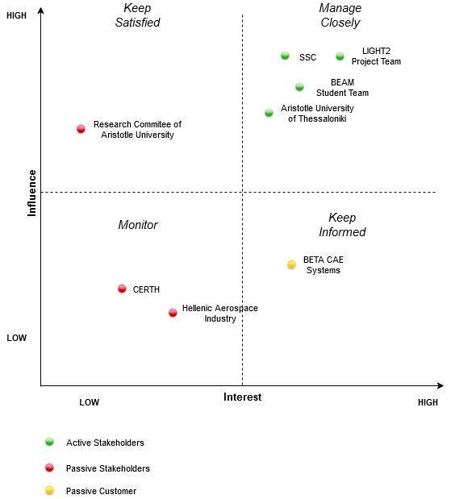

|  |  |  |  |  |
| --- | --- | --- | --- | --- |
| Name | Organization | Type | Role | Expectations |
| Aristotle University of Thessaloniki | Institution | Active | Partner | To provide a fruitful learning experience and career development opportunities to its students  Public Exposure |
| BEAM Student Team | Company | Active | Owner | To add a successful project in their portfolio  To gain experience as an organisation managing multiple project teams |
| LIGHT2 Project Team | Company | Active | Team Members | To gain experience working in collaborative team projects  To expand their scientific knowledge  To acquire technical knowledge about various tools and frameworks |
| Space Innovation | Institution | Active |  | To provide a fruitful learning experience and career development opportunities to the participants of IGLUNA To be presented with innovative ideas via a well-structured and well-documented project  To be presented with a working prototype of a project, open to visitors from the Industry and/or Academia, in the Field Campaign |
| Research Committee of Aristotle University | Company/ Institution | Passive | Sponsor/ Partner | Public Exposure |
| Hellenic Aerospace Industry | Company/ Institution | Passive | Sponsor/ Partner | To expand their influence network To be informed about potential future job candidates |
| CERTH (Center for Research and Technology Hellas) | Company/ Institution | Passive | Sponsor/ Partner | To be informed about potential future job candidates To expand their knowledge about AR applications |
| Beta CAE Systems | Company | Passive Customer | Sponsor | Public Exposure To actively train the new generation of engineers |
| Mobotix | Company | Passive Customer | Sponsor | To expand their influence network To be informed about potential future job candidates |
| Hellas Digital | Company | Passive Customer | Sponsor | To expand their influence network To be informed about potential future job candidates |
| ElectroBot | Company | Passive Customer | Sponsor | To expand their influence network |
| Alfakem | Company | Passive Customer | Sponsor | To expand their influence network |

## Project Goals and Objectives

|  |  |  |  |
| --- | --- | --- | --- |
| **Objective title** | **Area** | **Objective description** | **Relevance** |
| AR Helmet | Exhibition | Build a general assistance tool for use in real or analogue missions, based on AR technologies. | 1 |
| Weather Station | Test Bed | Build a fully functional, relatively small weather box, which will gather and transmit data from integrated sensors, in extreme weather conditions. | 1 |
| Integration of AR with External Interfaces | Exhibition | Demonstrate the synergy of AR technology with data collected from other devices or teams | 1 |
| Effective Outreach | Exhibition | Establish connections (faculty, Space Innovation, sponsors) useful in terms of scientific knowledge and technical feedback and demonstrate the practicality of AR technology to the broader audience. | 2 |
| Data Analysis | Control Room / Exhibition | Create useful analytics from sensor data and questionnaires regarding guest interaction with the AR helmet. | 3 |
| Clear presentation through project demo/video | VFC | Shoot an engaging video, highlighting the applicability of the software for an astronaut | 1 |

|  |  |  |
| --- | --- | --- |
| **Objective Title** | **Sub-objective Description** | **Milestone** |
| **AR Helmet** | Research about the capabilities needed and their implementation procedure. | PDR |
|  | Create a simplified version of each core functionality, integrated in a single prototype. | CDR |
|  | Test the AR functionalities designed in the PDR and complete their final version. | RR |
| **Weather Station** | Research and decide on all the different components and functionalities of the Weather Station. | PDR |
|  | Complete the data gathering software. | RR |
|  | Create a detailed weather box design. | CDR |
|  | Assembly and test the final version of the weather box. | RR |
| **Integration of AR with External Interfaces** | Communicate with other teams in order to find possible partnerships. | PDR |
|  | Complete the external data interface of the weather box. | CDR |
|  | Complete the networking system. | RR |
| **Effective Outreach** | Create a satisfactory list of partners and sponsors. | CDR |
| **Data Analysis** | Gather user satisfaction analytics in the form of a questionnaire, both in the FC and through the testing phase. | RR |
| **Presentation of Demo** | Find an appropriate space to test the final application and shoot a demo. | VFC |
|  | Research on the materials and equipment needed for the Demo setup and construct the lunar replica environment. | VFC |

## Project Top-Level Requirements

|  |  |  |
| --- | --- | --- |
| **Index** | **Title** | **Description** |
| Req-1001 | Effective AR Interfaces | Since AR technology is part of a recently introduced field, consensus regarding its use and safety measures has not been reached yet. Therefore, we reckon that the AR application we develop must be as easy and safe to use as possible. |
| Req-2001 | Task Assistance | One of the biggest advantages of AR technology is the intuitive presentation of information. We aim to use this by providing guidelines and tutorials which will help the astronaut in complex tasks as described in Fun-5.1. |
| Req-3001 | Navigation | The AR helmet should have the ability to project a map of the area and guide the astronaut to the requested destination as described in Fun-5.1.1 |
| Req-4001 | Networking and Communication | Any data produced by the Weather Station and AR helmet should be transmitted to the Server in the Control Room, thus creating a network between the three systems as mentioned in Per-1.3, Per-2.1 and Int-3. |
| Req-5001 | Resilient Mechanical Design | It is essential that the mechanical design of the Weather Station will be able to withstand extreme environmental conditions as described in Per-3 and Con-3. |
| Req-6001 | Data Collection and Display | It is essential that the Weather Station collects sensor data and camera feed (Per-1) which the Hololens displays to the user (Fun-4) |
| Req-7001 | Data Analysis | We shall gather user experiences analytics in the form of a questionnaire, in order to aid us in extracting useful feedback during the testing phase and FC. |

## Risk Analysis

|  |  |  |  |  |  |
| --- | --- | --- | --- | --- | --- |
| **Domain** | **Description** | **Initial Criticality** | **MA** | **MA Status** | **Final Criticality** |
| **Human** | Team member might leave | Low Risk (6) | Team building events, recruit extra-curricular students where/when needed. | 3 | Low Risk (3) |
| **Human** | Team member might contract Coronavirus. | Medium Risk (12) | Work remotely, possible recruitment of new member (already on standby) | 3 | Low Risk (3) |
| **Logistics** | City-wide lockdown | Medium Risk (12) | Relocation of workstations and equipment, work from home, video-call meetings regularly | 2 | Low Risk (6) |
| **Logistics** | Material might break during transportation. | Medium Risk (10) | Bring Spare Parts (thermistors/raspberry pi especially liable). Pack Separate Components properly | 2 | Low Risk (5) |
| **Logistics** | Loss of parts during shipping | Low Risk (5) | Have spare parts, ready for shipment, in our HQ. | 2 | Low Risk (3) |
| **Logistics** | Delay on components' shipping | Low Risk (4) | Plan orders early with delay margin | 3 | Low Risk (2) |
| **Test Bed** | Temperature going outside of range of the components. | Medium Risk (12) | Apply insulation between the sensors and the aluminium box, as well as the Raspberry Pi and the box | 1 | Low Risk (3) |
| **Test Bed** | Unexpected power loss will interfere with the experiment. | Low Risk (5) | Enable environmental pseudo-data script, in order not to interrupt the Exhibition. | 2 | Low Risk (2) |
| **Test Bed** | Unexpected data loss or corruption | Medium Risk (12) | Resend lost packages. | 2 | Low Risk (6) |
| **Control Room** | Unexpected power loss in control room | Low Risk (3) | Request a UPS | 3 | Low Risk (2) |
| **Control Room** | Control room computer crash | Medium Risk (10) | Use substitute computer, display server error on HoloLens and provide predefined navigation path and environmental data. | 2 | Low Risk (6) |
| **Exhibition** | Wi-Fi connection failure | Medium Risk (12) | Display server error on HoloLens and provide predefined navigation path and environmental data, until Wi-Fi connection is restored. | 2 | Low Risk (3) |
| **Exhibition** | Possible damage of HoloLens | Medium Risk (8) | Have spare HoloLens headset on the Exhibition. | 3 | Low Risk (4) |
| **Design -**  **Development** | Run out of funds. | Medium Risk (12) | Strong fundraising campaign | 3 | Low Risk (6) |
| **Design -**  **Development** | HoloLens battery deterioration during development due to overuse | Medium Risk (12) | Order a second device. | 3 | Medium Risk (8) |
| **Virtual Exhibition** | Inability to find appropriate space to shoot demo | Low Risk (5) | Search for multiple spaces or shoot inside the campus | 2 | Medium Risk (8) |

## IGLUNA Field Campaign Results

The LIGHT2 project is a continuation of last year’s project Light. Since all the members were new to the concept and the communication with the previous group was limited the difficulty of the operation increased significantly. Unfortunately, due to the obstacles that the outburst of the coronavirus caused, the work of the previous team was limited on both subsystems. In particular, the weather box had only reached a theoretical design that was meant to function on the test-bed, while not taking into consideration the conditions of the moon for future implementations. It was decided that the best approach would be to build a box that satisfies all the requirements of the testbed while approaching the final design for the moon as accurately as possible. Essentially, the design aims to be a hybrid.

On the software side the improvements were subtle, yet significant. Regarding the navigation module, the previous implementation of LIGHT depended on pre-calculated paths, resulting in a very static approach, unusable in many situations. In the current implementation we use a dynamic system, adaptive to spaces with existing 3d maps. We also arrived at the conclusion to not use any form of object detection in the current implementation in order to avoid the added complexity of the task. Lastly, we expanded the use of networking to include real-time communication with external interfaces in the form of remote camera feed and live streaming of multiple sensor data.

1. **Expected Results**

**Successful integration of the different modules**

It is essential that every piece of our software behaves as expected within the set specifications. The navigation module should calculate adequate and efficient paths for the user to follow. Every selectable option should commence and terminate when requested and any necessary information should be easily readable or displayed in a manner that any potential guest would understand.

**Successful data gathering and analysis**

Expanding on the previous thought process, it is also important that the sensor data (Fun-1) which we acquire be logically sound, with minimal noise. This will aid us in creating meaningful graphs, in order to properly analyse the collected data.

Field Campaign Goals (Impossible due to COVID)

**User familiarization with AR technologies**

It is our main objective both for the guests and the team itself to get familiar with the HoloLens Smartglasses as a form of AR technology. Therefore, we anticipate that after the exhibition each participant will have learned how to use basic gestures to control and manipulate holograms, as well as be able to effortlessly use the integrated capabilities of navigation. Lastly, they ought to recognize and consider the important information which is displayed.

**Cooperation with other teams**

In the field campaign we would like to exchange information and cooperate with at least one other team. We aim to share our technology and integrate or display parts of the partner project adequately.

**Safe environment and positive experience**

Most importantly, we would like to ensure the safety of every participant as described in 2.1.4 and provide a positive learning experience for anyone involved.

Virtual Field Campaign Goals

**Successful demonstration of the applicability of AR technologies in space exploration**

After watching our demo presentation, we anticipate that the viewer will adequately comprehend the mission objectives and the necessary steps for their accomplishment. Furthermore, we aim to demonstrate the positive impact that our AR interface provides for an astronaut’s workload in terms of speed and efficiency.

1. **Virtual Field Campaign Results**

During the Virtual Field Campaign all parts of the application functioned as expected, including the navigation system and the instruction visualization, the networking system (both the sensor and camera feed), and the weather station. As a result, we managed to showcase the different functionalities in a short video found in <https://www.youtube.com/watch?v=UNxE0y2D4qE> .

Given more experience, we would have paid more attention to the overall presentation and especially the cinematographic details of the video like the lightning, the sound and a more proper scenario which would better attract the people watching. In retrospect, we understood that a good narrative is very important to capture the attention of the viewers and successfully present our project in a way that people will want to dig deeper into our work.

## Business Model

In order to conceptualize LIGHT2 as a business model, current market conditions and expectations must be taken into consideration. Our primary aim is the application of AR technology to space exploration and moon habitation, bringing together AR technology’s traction in today’s business and investing climate with the space industry’s increasing potential.

To that end, a two-pronged approach is deemed necessary; adopting a short-term, research-oriented model focused on Earth applications in order to sustain a low budget, while concurrently preparing for the realization of our space vision further in the future.

With this in mind, we will be detailing our short-term plan and its importance in accomplishing our business’ envisioned goals.

<Short-term Plan>

By approaching the business’ early years as a preparation phase, our aim is to create and fortify the foundations of our intended long-term model by focusing on the following parameters:

* Collection of experience and knowledge; by establishing a Software Engineering team tasked with the development of AR applications and the creation of a repository for our AR software.
* Further evolution of said accumulated knowledge, achieved by being in constant touch with AR and space technology-related advancements and breakthroughs and adapting accordingly.
* Solidifying our company structure, with clear hierarchies and roles established, in order to ensure proper operational and communicational functions between departments and ranks.
* Branding, in order to ensure our presence in the industry.
* Ensuring fiscal viability, through the adoption of the aforementioned research-oriented model and the undertaking of contracting work.

<STRUCTURE>

The company will consist of four main departments:

Management, Software, Finance and Outreach.

1. Management

The Management department will oversee executive decisions required for the proper overseeing and functioning of the company’s other departments and its overall growth, in accordance with its needs over time.

1. Software

The Software department, consisting of software engineers and virtual design architects, will be split into two sub-teams, each focusing on different aspects of the program.

a. Current AR Development

This sub-team will be tasked with taking part in research programs and developing AR applications, the latter of which will be mainly achieved through the company’s contracting work.

b. Technology Adaptation

This sub-team will be tasked with integrating research data and developed applications to space-related projects in the form of mock missions, laying the foundations for our long-term goal in the process.

1. Finance

Thanks to our research-oriented business model, a portion of our expenses will be covered by grants earned through participation in research projects, while the company’s contracting work will further increase revenue. The finance department will be in charge of allocating grant money, ensuring the company is in line with its budget projections and taking care of employees’ payments and general expenses.

1. Outreach

The Outreach department will be responsible for ensuring our presence in the AR and space exploration industries by establishing a solid communication network between Academia, members of the industry, clients, and us.

<Current Market Possibilities>

AR technology has already seen both non-commercial and commercial application, ranging from pilot training programs to gaming software. While our long-term mission’s realization is still in the works, its core idea can be applied and tested on Earth-related projects and lunar training missions. To that aim, establishing our brand through participation in academic and research-oriented projects and cooperation with other members of the industry will be a deciding factor in our overall progress and sustainability.

<Future Business Model>

After this period of refinement and growth, the company will be able to transition into its final form; applying its technology in the space exploration field. Our aim is to introduce a software framework that can be integrated in any space suit, satellite or base. With minimum alterations to our products, we want to be able to service most demands brought forward by the space industry by providing solutions and laying the foundation for further innovation.

<Revenue>

The successful execution of our model, achieved by addressing the market’s demands and our ability to adapt to changes in trends, guarantees a steady income flow in its early stages and the potential for yearly revenue growth.

### Executive Summary

Thinking of LIGHT2 as a business model, we will need to examine the business idea and its relevance to the current market. Undeniably augmented reality (AR) is considered by many to be the future of technology, many companies have already invested vast amounts of resources into its research, despite the technology still being at its infant stage: the potential seems limitless.

The market for this technology is as big as anyone’s ambitions, where applications vary from everyday life to critical science fields.

LIGHT2’s angle to this technology is to adapt AR into space exploration, an equally discussed subject for future approaches. In macrospect we want to develop a product that will be adaptable to any needs due to the large database of environment recognition and AR software we aim to have until space travel becomes a reality.

Now looking at the current condition of the market, for many companies working on space applications the 10-year flurry between now and then can be intimidating, contrary to our business model this gap works as our technology refinement period. Our lean business model, mainly being academic and research oriented, will be funded by European research facilities where the cost is mainly the employment of software engineers. Our early focus will be structured mainly into 2 teams; general study of AR technology and integration to space missions. Generally speaking, the idea is to exploit all of the current development on AR and try to procure earth applicable projects for data mining and the development of AI applications. In the same time, we will continuously analyse and transfer this data developing space applications at a theoretical level.

### Canvas Model

|  |  |  |  |  |  |  |  |
| --- | --- | --- | --- | --- | --- | --- | --- |
| ***BUSINESS***  ***MODEL CANVAS*** | | Space Innovation –  IGLUNA 2021 | | Thanasis  Askitopoulos | | 09/11/2020 | |
| **Key**  **Partners** | **Key**  **Activities** | | **Value**  **Propositions** | **Customer**  **Relationships** | | **Customer**  **Segments** |
| 1. Aristotle University Research Community - Training of the new team members and development of key technical ideas when needed. 2. Labs of Telecoms - Labs and equipment needed for mechanical and electronics development. 3. BEAM’s Marketing Team - Responsible for the promotion of the product and approach of possible partners. 4. BEAM’s Fundraising Team - Responsible for the management of the financial entities. 5. Companies selling Mixed Reality Headsets (Microsoft, Varjo, etc.) 6. Space Innovation, ESA and other space agencies | 1. Acquisition of Domain Knowledge for specific applications in Industry, Education, Medical field through R&D. 2. Development of AR systems for diverse platforms (cross-platform, agile development for Hololens, Magic Leap One, Google Glass as well as mobile) 3. Integration of innovative technologies and methodologies such as advanced data mining of user-hologram interactions and sentiment analysis, AI assistant (through reinforcement learning) tailored to astronaut needs and application of modern UX/Human-Computer Interaction (HCI) design principles | | 1. Short Term   Space agencies/Infrastructure:   * Provides a structured, low-cost approach to navigation and route-planning in harsh environments and the completion of manual tasks, in time-limited situations. * Provides intuitive interfaces readily adaptable to training regimes and appropriate safety measures for specialized personnel.  1. Long Term  * Accelerate time-consuming tasks, opening possibilities for scale-up of diverse processes. * Create Database for Task performance metrics. * Facilitate back-up systems for communication and rescue.  |  | | --- | | **Channels** | | 1. Linked-in 2. Facebook 3. Conference booths | | 1. Database with customer preferences/behavioral data in order to facilitate effective communication strategy. 2. Feedback strategy    1. Send short questionnaires (via a mailing list) to gauge the applicability of the existing AR solutions or discover domain-specific suggestions and/or improvements.    2. Gather analytics (with the proper permission) for existing features. 3. Communication Strategy    1. Special In-Person events    2. Newsletters  |  | | --- | | **Key Resources** | | 1. Human capital in software developers and designers for R&D 2. Machines: AR Mask – HoloLens, equipped electronics lab, equipped mech lab (biggest part of the mech construction is going to be held from external partners) 3. Marketing and promotion resources | | | 1. Customers concerned with space-related activities and the mitigation/reduction of associated risks (Space Agencies Names 2. Customers concerned with low-cost training of personnel (Space Agencies, Infrastructure, Medical field) 3. Customers looking for AR-enabled experiences [Educational (Schools, Technology Centers, Museums), Research Environment]  |  | | --- | | **Cost Structure** | | 1. Hardware upgrades. 2. Employee salaries. 3. Promotional expenses. 4. Traveling expenses. | |
|  | |  |
|  | |

# DETAILED PROJECT DESCRIPTION

## Complete Project Requirements

The following requirements concerning the weather box refer to the prototype that will be presented at the exhibition and not the product that would be sent to the moon if this were to become a start-up. However, some of the requirements (gamma-ray measurement, extreme temperature measurement, cosmic ray protection) remain unchanged as proof of concept.

### Functional Requirements

|  |  |  |  |
| --- | --- | --- | --- |
| **`** | **Title** | **Description** | **Value / Range** |
| Fun-1 | Sensors Measurements | The sensors shall measure temperature and radiation | - |
| Fun-1.1 | Data transmission | The data shall be transmitted from the testbench location to the control room through E-link connection | - |
| Fun-1.2 | Data transmission to exhibition sector | The data collected shall be retransmitted to the HLS through WiFi connection | - |
| Fun-2 | Camera | The camera shall record live footage of the box’s surroundings | - |
| Fun-2.2 | Data Transmission | The data shall be transmitted from the testbench location to the control room through E-link connection | - |
| Fun-2.3 | Data transmission to exhibition sector | The data collected shall be retransmitted to the HLS through WiFi connection | - |
| Fun-3 | Thermal insulation | The weather box shall be thermally insulated | - |
| Fun-3.1 | Weather proofing | The weather box shall not be affected or damaged in case of a storm. | - |
| Fun-3.2 | Cosmic ray protection | The electronics of the box shall be protected in such a way that radiation cannot damage them or alter the data | - |
| Fun-3.3 | Humidity protection | The box shall be built in a way that allows no humidity to enter the interior | - |
| Fun-4 | Remote Data Visualization | HLS shall visualize the collected data into its graphic environment | - |
| Fun-5 | Graphical Environment | The HLS shall provide the user with different capabilities through a graphical environment | - |
| Fun-5.1 | Passive Capabilities | The HLS shall provide some capabilities which require limited or zero user interference | - |
| Fun-5.1.1 | Navigation Capability | The HLS shall suggest possible routes and guide the user through them | - |
| Fun-5.1.2 | Exploration Capability | The HLS shall automatically track the user’s path and allow the creation of new routes | - |
| Fun-5.1.3 | Repair Capability | The HLS shall assist the user with the repair of faulty equipment | - |
| Fun-5.2 | Active Capabilities | The HLS shall provide some capabilities which require user interference | - |
| Fun-5.2.1 | Map | The HLS shall be able to project a map of the area as well as the position of the user and the holograms | - |
| Fun-5.2.2 | Hologram Placement | The HLS shall allow the user to place holograms which are able to contain information (e.g. route waypoints) | - |

### Performance Requirements

|  |  |  |  |
| --- | --- | --- | --- |
| **No.** | **Title** | **Description** | **Value / Range** |
| Per-1 | Sensors Measurements | The sensors shall measure the following phenomena within range:  Temperature: 95-395K  Radiation: 5-1000 keV | - |
| Per-1.1 | Weather Box data storage | The raspberry Pi shall be equipped with SD card, with the capacity of 36GB | - |
| Per-1.2 | Weather Box data transmission | The data shall be transmitted with the speed of less than 10 Kbps | < 10 Kbps |
| Per-1.3 | Weather Box data transmission to exhibition sector | The data shall be transmitted from the control room to the HLS through WiFi, with the speed of les than 5 Mbps | < 5 Mbps |
| Per-2 | Camera data transmission | The data shall be transmitted with the speed of less than 290 Kbps | < 290 Kbps |
| Per-2.1 | Camera data transmission to exhibition sector | The data shall be transmitted from the control room to the HLS through WiFi, with the speed of less than 290 Kbps | < 290 Kbps |
| Per-3 | Thermal insulation | The temperature inside the box shall always be between -20 to 40C | -20 -40Cₒ |
| Per-3.1 | Weatherproof | In case of a storm the box shall not be affected |  |
| Per-3.2 | Cosmic ray protection | The box shall be reinforced with enough aluminum to block the lunar cosmic radiation levels |  |
| Per-3.3 | Humidity protection | The box shall be completely waterproof |  |
| Per-4 | Remote Data Visualisation | The HLS shall visualise the transmitted data within 3 sec to the user | <3sec |
| Per-5 | HLS Graphic Environment | The graphical interface and various holograms shall be renewed in the HLS with the frame rate of 60 frames per sec | 60fps |

### Interface Requirements

|  |  |  |  |
| --- | --- | --- | --- |
| **No.** | **Title** | **Description** | **Value / Range** |
| Int-1 | Dimension | The student project Shall fit into the dimensions inside the habitat defined by the Space Innovation | - |
| Int-1.1 | Dimension of control room setup | Team’s control room setup shall fit the dimension requirements defined by the Space Innovation | - |
| Int-1.2 | Dimension of Exhibition sector setup | Team’s exhibition setup shall fit the dimension requirements defined by the Space Innovation | - |
| Int-2 | Test Bed Soil | The soil on the test bed shall be penetrable for the weather box to be mounted on it | Not rocky |
| Int-3 | E-link Communication | The E-link setup shall fit the data budget and speed specifications given by Space Innovation | 300 Kbps |
|  |  |  |  |

### Safety Requirements

|  |  |  |  |
| --- | --- | --- | --- |
| **No.** | **Title** | **Description** | **Value / Range** |
| Saf-1 | Prevention of epilepsy and other conditions | The guest should be asked about any underlying medical conditions that might prove harmful by the HLS experience | - |
| Saf-1.1 | Physical Boundaries | The guest shall be properly supervised and notified in order to avoid collisions with physical boundaries and other items of the specified space | - |
| Saf-2 | Power | The raspberry’s power supply shall not exceed the suggested value | 15W |
| Saf-2.1 | Overheating | The PoE’s hat fan shall turn on if temperature exceeds 45C | -40-85Cₒ |
| Saf-3 | Pandemic protection measures | Due to the COVID-19 pandemic certain general purpose virus prevention methods will be available like hand sanitizers, masks and latex gloves | - |
| Saf-3.1 | Informing of participants | The guests will be notified beforehand for the corresponding risk of participating in the experience. | - |
| Saf-3.2 | Disposable protective materials | Participants will be required to wear a mask and gloves during the whole experience. | - |
| Saf-3.3 | HoloLens Disinfection | The HoloLens will be disinfected properly after each use. | - |
| Saf-3.4 | HoloLens protective materials | The HoloLens will have removable protective pads on the areas which touch human skin. These pads will be replaced after each use. | - |

### Constraint requirements

|  |  |  |  |
| --- | --- | --- | --- |
| **No.** | **Title** | **Description** | **Value / Range** |
| Con-1 | Budget limit | The maximum project budget is 6000 euros | < 6000 euros |
| Con-2 | Time schedule | The experiment shall be completed within the timeline set by the team and Space Innovation organization | <June 4 |
| Con-3 | HLS Holograms | The holograms shall be displayed between 0.85-6m | 0.85-6m |

## Trade - Offs

**Software**

The implementation decision of the software features (mapping, navigation, communication and repair) as well as the decision for the main menu is shown in the Annex Section 7.4.5.

**Mechanical**

When deciding on the way to open the box for repairs the initial intention was to detach the upper surface. In our effort to make the box waterproof though, and the need for a thermistor on the upper surface, the wiring did not allow us such a design. As a solution, we concluded on attaching all the electronics to the top of the box, while moving the separating point to the lower surface as shown on the schematics of the mechanical design.

**Electronics**

|  |  |  |  |  |
| --- | --- | --- | --- | --- |
| **Radiation Sensors** | Temperature Range (ºC)  [Weight: 1] | Cost (€)  [Weight: 0.8] | Weight (g)  [Weight: 0.6] | **Total Points** |
| SEN-14209 | -20 to 70 | 69.75 | 10 | 12.4 |
| 5 | 4 | 7 |
| Geiger Counter Kit | -20 to 55 | 116.81 | 12 | 9.2 |
| 4 | 2 | 6 |

|  |  |  |  |  |  |  |  |
| --- | --- | --- | --- | --- | --- | --- | --- |
| **Camera** | Temperature Range (ºC)  [Weight: 1] | Cost (€)  [Weight: 0.6] | Weight (g)  [Weight: 0.4] | Night vision  [Weight: 0.8] | Data transfer  [Weight:1] | Angle(º)  [Weight:0.8] | **Total Points** |
| PR700 | -30 to 70 | 33.3 | 265 | Yes | Complicated | 120 | 29.6 |
| 7 | 7 | 4 | 10 | 4 | 6 |
| S16B Dual Thermal Image System Camera | -40 to 60 | 697.54  (sponsored) | 430 | Yes | Easy | 360 | 39.2 |
| 7 | 10 | 3 | 10 | 9 | 10 |

|  |  |  |  |  |  |  |
| --- | --- | --- | --- | --- | --- | --- |
| **PoE Hat** | Temperature Range (ºC)  [Weight: 0.8] | Cost (€)  [Weight :0.6] | Weight (g)  [Weight: 0.5] | Cooling Fan(Y/N)  [Weight :0.8] | Display Screen  (Y/N)  [Weight :0.8] | **Total Points** |
| WavesharePOE HAT | No information | 8,59 | 79,9 | Yes | Yes | 27,2 |
| 5 | 7 | 6 | 10 | 10 |
| DSLRKITPoE HAT | -10 to 75 | 16,53 | 19,9 | No | No | 21,6 |
| 6 | 8 | 8 | 5 | 5 |

## Project Management

### Work Packages Overview

Project LIGHT2 is divided into several work packages which are going to be integrated one by one during the timeline provided. Each work package shall be completed by a sub team containing one or more members. This work breakdown structure only shows a general overview of the whole team structure. More details on work packages and planning are shown on the Gantt chart.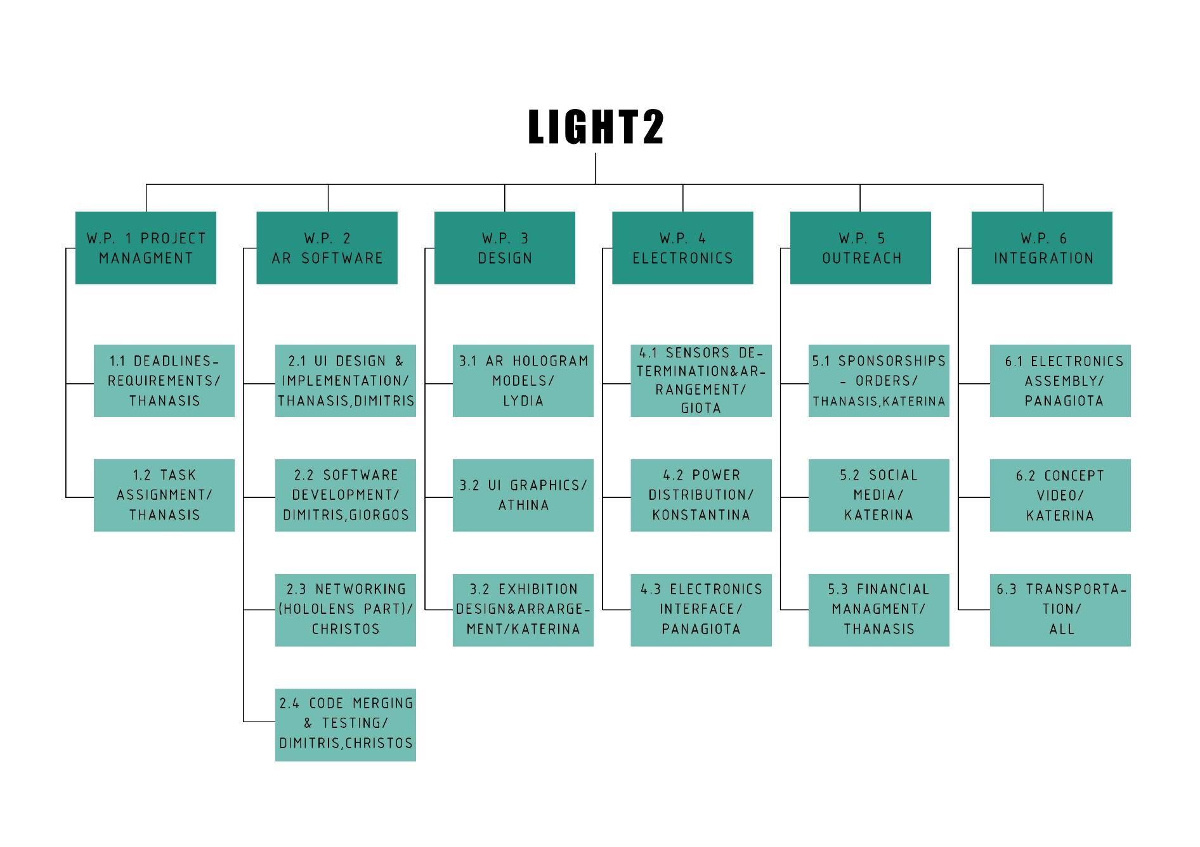

### Project Plan

The project plan is described in Annex 7.3.2.

### Collaboration Tools

For team cooperation and communication we used a combination of Slack, Trello and Facebook Messenger. We used Trello to organize general tasks, deadlines and project milestones. Most important discussions were conducted in Slack as well as meeting schedules, links and other sources of vital information. Lastly, for last minute changes or quick responses we used a Facebook Messenger group chat or phone calls.  
  
For sharing project progress, important documents, graphics and any other files we mainly used Google Drive.  
  
Lastly, GitHub was a vital tool for the software team, both for version control and team collaboration. Without its use, the entirety of this project would be impossible.

## Resources

|  |  |  |  |  |
| --- | --- | --- | --- | --- |
| Workgroup | Main Tasks | Members | Maximum Time Estimate  (hours) | |
| **Software *SBS01*** | UI/UX Design and Development  Data Management  Feature Implementation  Software Testing | Thanasis Askitopoulos | 520 |
| Christos Kagkelidis | 501 |
| Giorgos Papadopoulos | 200 |
| Dimitris Tolias | 548 |
| **Electronics *SBS02*** | Power Distribution  Power Budget  Electronics Interface | Panagiota Boskou, | 300 |
| Giota Chita | 433 |
| Konstantina Vasileiadou | 695 |
| **Graphics *SBS03*** | AR graphics / animations / effects  Environment set up | Katerina Kolovou | 600 |
| Lydia Terkenli | 747 |
| Athina Athanasiadou | 695 |
| **AIT**  ***SBS04*** | Mechanical and Electrical Assembly  Cabling  Electronics and Software Integration  Verification and Testing | Christos Kagkelidis | 300 |
| Dimitris Tolias | 200 |
| Panagiota Boskou | 353 |
| Giota Chita | 300 |
| **Outreach *SBS05*** | Fundraising and Sponsorships  Outreach  Recruitment and Training | Katerina Kolovou | 202 |
| **Management *SBS06*** | Project planning  Mission Analysis  Risk Analysis  Cost Analysis  Documentation | Thanasis Askitopoulos | 369 |

### Manpower

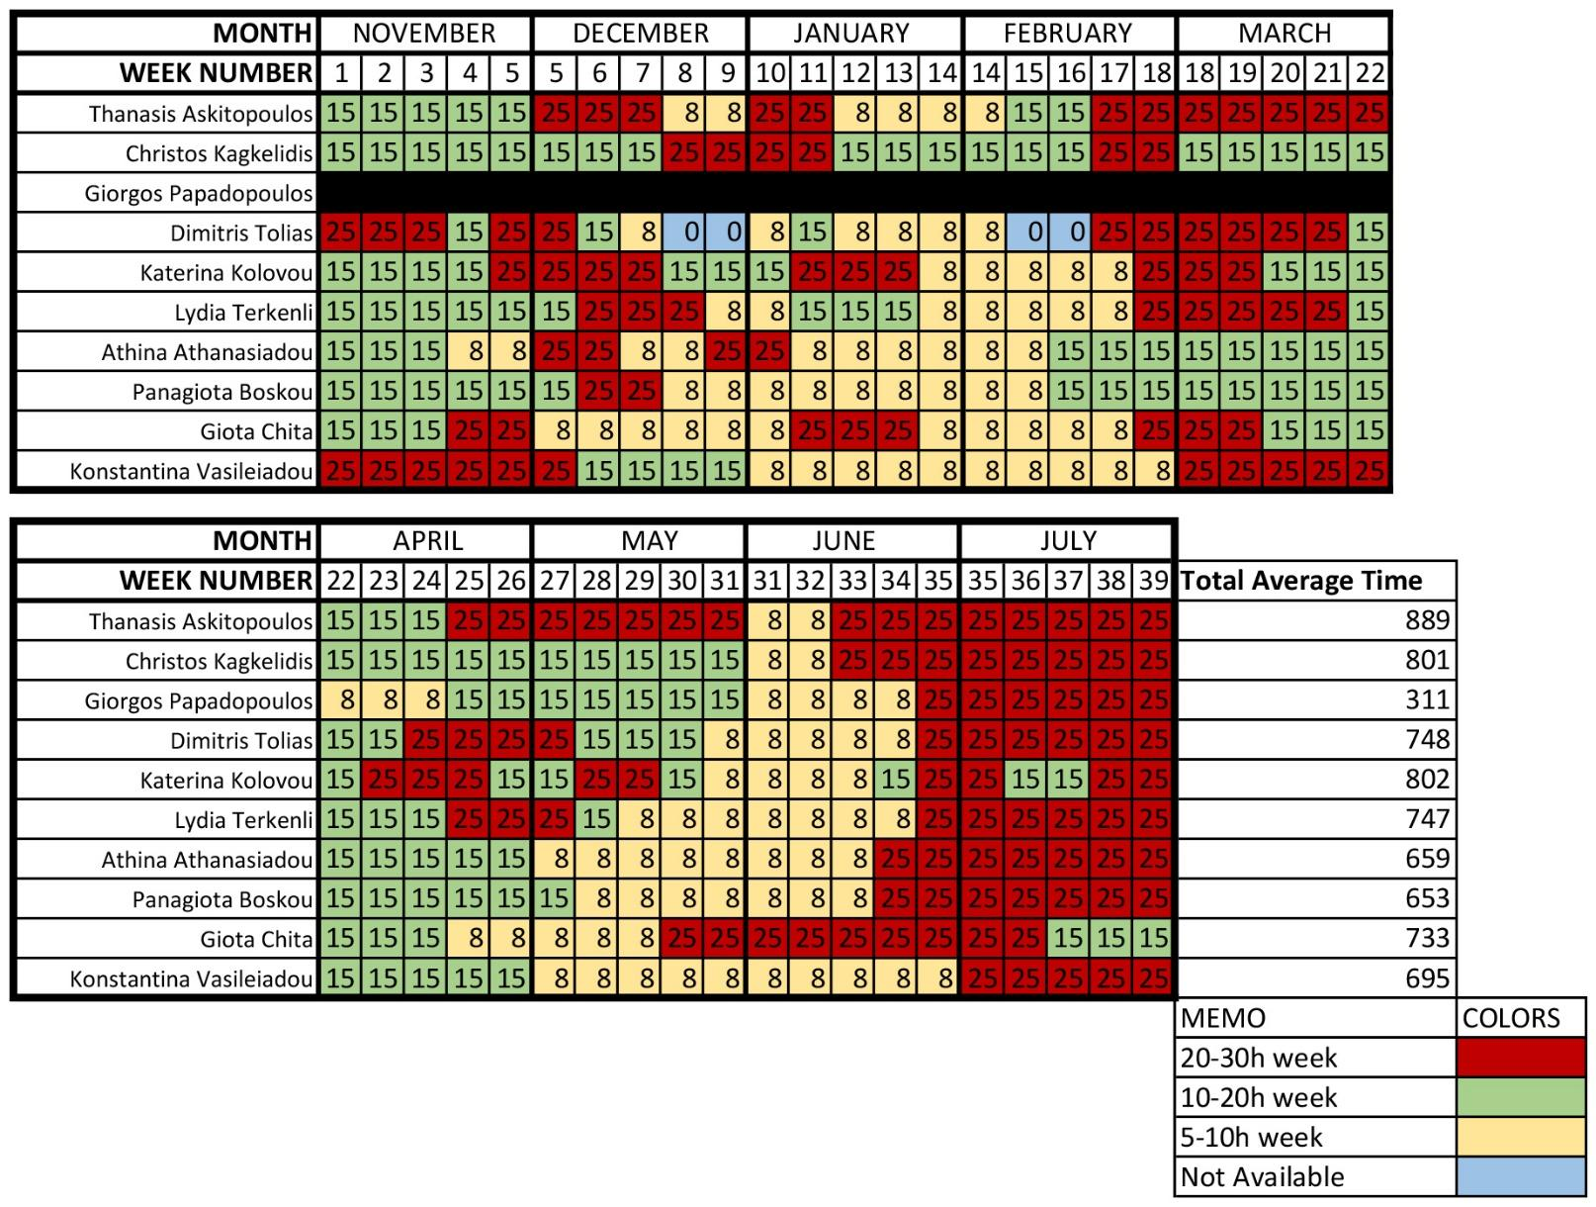

### Budget

|  |  |  |  |  |  |  |
| --- | --- | --- | --- | --- | --- | --- |
|  | Financial Projections | | | |  | |
| Time Periods | Phase I  Kick Off - PDR  Sept 9 - Nov 20 | | Phase II  PDR - CDR  Nov 21 - Feb 19 | | Phase III  CDR - Field  Campaign  Feb 20 - Jul 31 | |
| Currency | EUR | | EUR | | EUR | |
| Type of Value | Cash In Kind | | Cash In Kind | | Cash In Kind | |
|  |  | | | |  | |
| Sponsoring Revenues |  |  |  |  |  |  |
| Founding Capital | 3000 | - | 0 | - |  |  |
| University | 2000 | - | 0 | - |  |  |
| Industrial Partner | 1000 | - | 0 | - |  |  |
| Total Revenues | 6000 | - | 0 | - |  |  |
|  |  | | | |  | |
| Hard & Software Costs |  |  |  |  |  |  |
| Sensors & Raspberry | 0 | - | -587.53 | - | 0 |  |
| Camera | 0 | - | 0 | - | 0 | 300 |
| Networking | 0 | - | 0 | - | -30 |  |
| Exhibition Set up | 0 | - | -200 | - | -400 |  |
| Total Costs | 0 | - | -787.53 | - | -430 |  |
|  |  | | | |  | |
| Operational Expenses |  |  |  |  |  |  |
| Communication /  Marketing | 0 | - | 0 | - | 0 | - |
| Virtual Field Campaign / Filming | 0 |  | 0 |  | - 290 |  |
| Total Expenses | 0 | - | 0 | - | -290 | - |
|  |  | | | |  | |
| Period Profit = Revenues -  (Costs + Expenses) | 6000 | 0 | -787.53 |  | -720 |  |
| Total Profit = Previous  Period Profit + Period  Profit | 6000 | 0 | 5212.47 |  | 4492.47 |  |

*Table 2.4.2-1*

## Project Set-Up

The project is divided into two basic subsystems the **AR Helmet** and the **Electronics Weather Station** and a third support system in the control room.

**AR Helmet:** The AR Helmet will be presented in the exhibition area where a lunar-like environment will be deployed, and the users will have the opportunity to test the AR Helmet by completing an analogue lunar mission. The AR software will be implemented into Microsoft HoloLens I glasses and during the mission the user will be provided with a set of capabilities and features:

**Core Features**

* Navigation Assistance
* Map
* Hologram Placement
* Biometrical Data (or Biometrics)
* Repair Sequence

**Network Capabilities**

* Environmental Data (or Sensor Data)
* Camera View

**Software Assistance**

* Mission Checklist
* Visual Guides and Tooltips

Regarding the **Navigation Assistance**, the user is provided with a network of traversable paths connecting major points of interest and locations related to their missions. These static paths are pre-computed as to be the most efficient, time and energy-wise for travel between the various mission objectives. If the user chooses a certain destination in the area (see Map section below), a new path is dynamically computed and highlighted, to ensure their efficient arrival. The computation of those paths will be executed by a variant of the A* algorithm, on grid version of the Exhibition Room and the location of the user in the space will be found through “dead reckoning” (a starting location will be known and calibrated).

A basic **Map** feature will offer an extended view of the whole area, complete with areas of interest and the positions of equipment and placed holograms. Static paths and navigation instructions will also be visible.

The **Hologram Placement** utility contains an inventory (in this project only two) of different holograms allowing the user to choose and place any of them in their immediate environment. These holograms are interactable and can store information about the area: the location of an interesting geological finding, a plateau ideal for the installment of specialized machinery, a note to themselves or other astronauts and, for the purposes of the Exhibition, a flag.

Due to time, visibility and complexity issues regarding the user experience in the exhibition there will be only two different holograms marking geological sampling and site-screening, respectively. The site-screening hologram would be used by the astronaut to provide a contextual survey of a location site, designated as important in the planning phase of the mission. In the context of the exhibition, the user will be asked to log the name and a predetermined text description of the area and take a photo of the area.

Similarly, the geological sampling hologram would serve as both a location marker and a reporting tool for the sampling of interesting geological material, found on the Moon. In the exhibition, the user, after collecting a small sample of rocks, will be asked to record the name of the sample, take a photograph and log the number and color of the material collected.

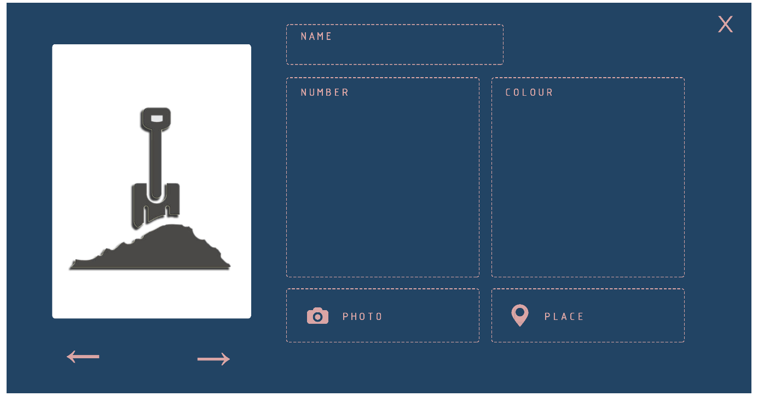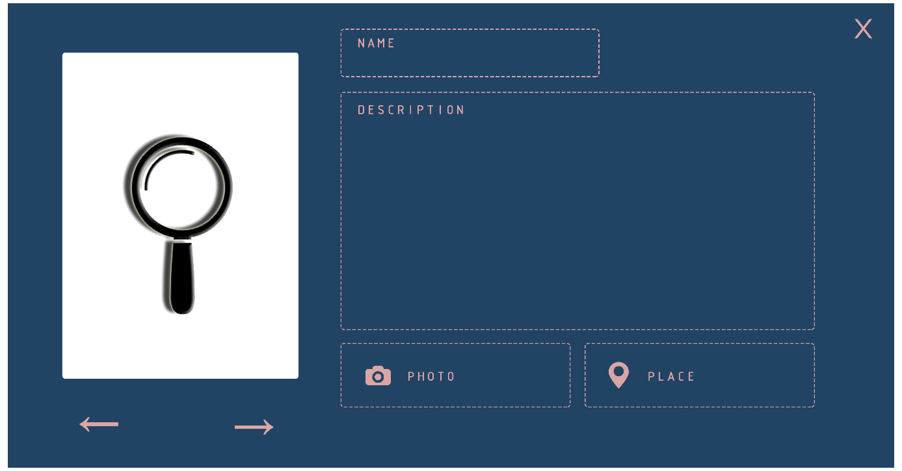

The **Mission Checklist** is responsible for tracking the astronaut’s missions and ensuring their completion. Each mission is briefly described and is further separated in sub-tasks with corresponding instructions to complete them. Lastly, each task and mission have a completion status (In Progress / Done).

At the start of a “Repair Mission”, the user is obliged to pick up a certain tool and should they enter a certain radius from the weather station, the **Repair Sequence** is activated. The Repair Sequence provides animated instructions which will aid the astronaut in complicated repair tasks. Upon following said instructions, the mission is completed, and the Mission Checklist is updated.

The **Camera View** capability offers the user a live video feed from the weather box (located in Mt. Pilatus. By viewing the weather box’ area, the user can scout the location before initiating an EVA walk or possibly monitor the nearby astronauts’ rovers and equipment.

Finally, non-interactable, hovering holograms will follow the user and display real-time information about the user’s health and environmental conditions. The **Environmental Data** will be gathered from the weather station (see Weather Station section below). The **Biometrical Data**\* will consist of metrics of heart rate variability, oxygen levels , metabolic rate and suit pressure, necessary for gauging stress ,activity and consumables’ levels.

*\* Biometrics’ sensors are not going to be used on people in IGLUNA for ethical reasons. To offer a more realistic experience random data will be projected. Thus, we will not use real sensors in our project*.

**Exhibition Set-Up**

 During the Field Campaign a lunar-like environment will be set-up, in order to make the experience for the visitor as immersive as possible. This will be accomplished by enclosing the space with 2x2 panels that will hold stretched, printed fabric. A special surface will also be made to resemble lunar soil, while outside the enclosed space, an information desk will be set up to provide information about the project and prepare the visitors for the mission.

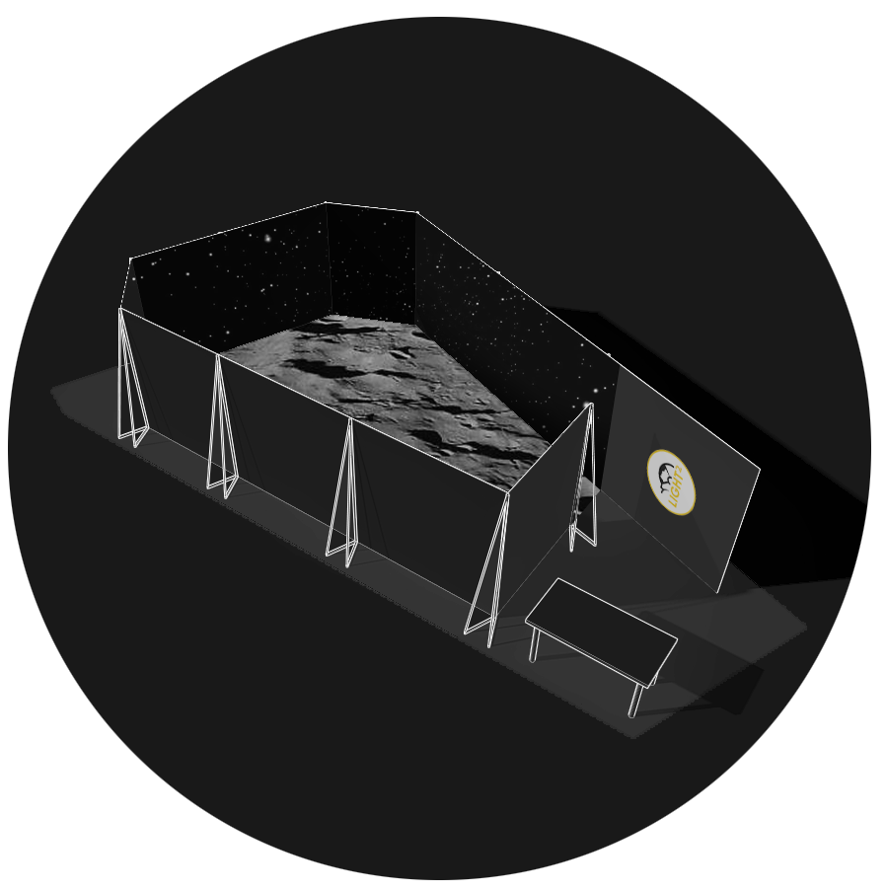

*Exhibition space – 3D model*

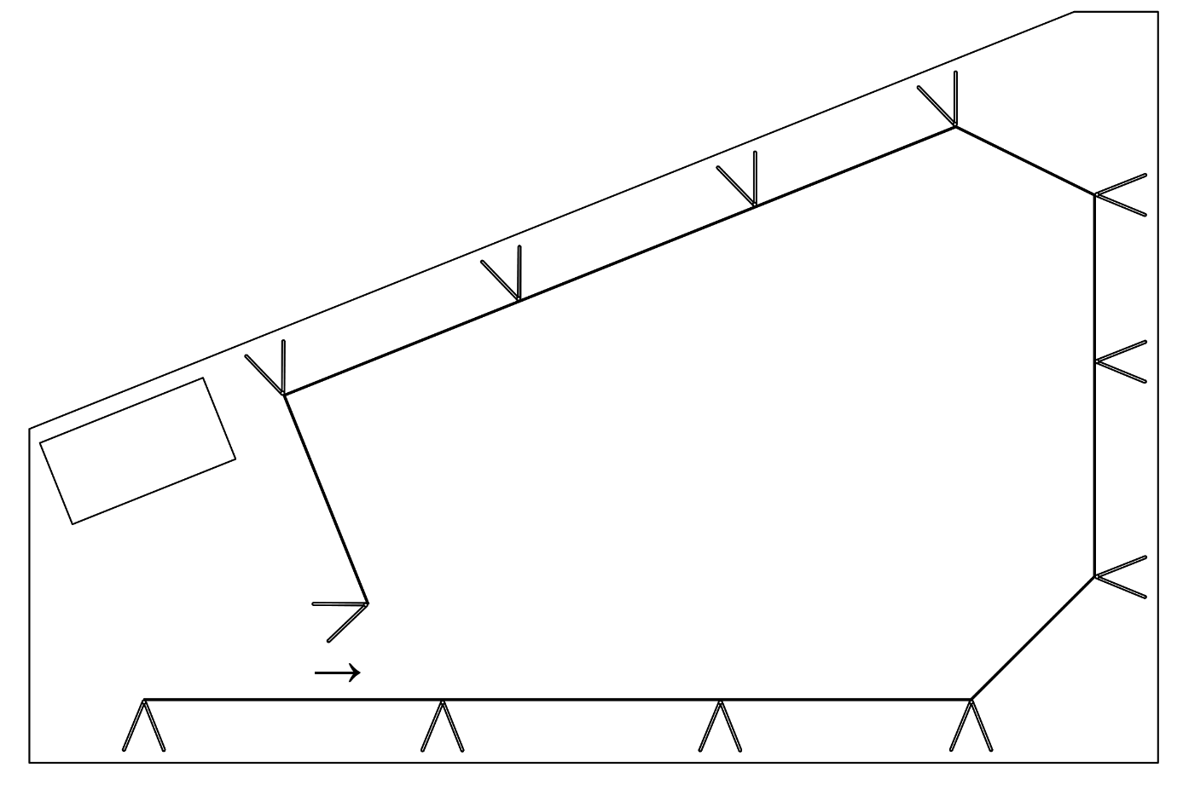

*Exhibition space - Plan*

For the purpose of the exhibition the user experience will be divided in three phases. The general learning phase, the mission phase and the free exploration phase.

During the general learning phase, the guest will receive a showcase of the different functions and capabilities. This phase will partly take place before the actual participation, through educative videos which will be projected on the front-desk. The rest of the showcase will be through a general-purpose basic tutorial. The focus of this tutorial will be the interaction with the different menus.

In the Mission Phase there will be a total of two missions further detailed into different tasks. These two missions will be named “Repair” and “Geological Sampling”. Firstly, the guest will embark in their repair mission, following a static path to a marked region, where they complete a simple repair sequence. Next, during the Geological Sampling mission the guest needs to open the map and navigate towards a different pre-specified region, where a couple of rocks will be bound. Then, once arrived, they will need to fill the required details of the Hologram Placement module in order to place a geological sampling hologram, marking the end of the mission.

Once every mission is successfully cleared the guest will be able to freely interact with the holographic environment in the free exploration phase.

**Virtual Field Campaign**

The limitations imposed by the coronavirus epidemic on the project’s successful and timely completion has made the participation of our team in the Field Campaign at the Lucerne museum extremely difficult. Therefore, we have decided to participate in the Virtual Field Campaign by preparing a demo presentation as faithful to the experience of the visitor in the Field Campaign as possible.

The negotiations with the film school about acquiring a space to shoot unfortunately, fell through. The space provided had pillars obstructing the free passage of the actor, long windows that were too reflective and too many pipes running down the walls. Covering the walls with fabric would prove to be very time consuming and expensive, while creating the feel of an open space would be impossible due to the specific room setup.

Consequently, we decided to rent a van, borrow the necessary equipment, including two kino flo lights, some cameras, reflective polyesteryne to soften the lights and a huge 6KW generator. Then we went to an abandoned mining area at Asvestochori, an environment that resembles the great regolith of the lunar surface.

Although, we faced many challenges during the shooting, like a complete power failure, the footage was adequate and we are happy with the result.

**Mission Scenario**

1)The astronaut stares into the lunar sky, opens the main menu and selects the Mission Checklist option.

2) The checklist lists the steps to complete the first EVA walk, the Repair of the Weatherbox. After reading the instructions, the astronaut closes the checklist and selects the Map option.

3) After locating the Weatherbox and the path connecting the base to it, the astronaut closes the Map and proceeds to follow the green, static path to it.

4) After entering inside a fixed radius of 0.5 meters from the Weatherbox, the repair sequence is initialized, and the astronaut follows the instruction to repair it.

5) Confirming that the repair procedure is finished, the astronaut re-opens the Mission Checklist, detailing the next EVA walk, a geological survey. They then proceed to open the Map and locate an area with numerous rock formations suggested for geological fieldwork.

6) The astronaut places a waypoint at the center of the area, closes the Map and follows the dynamic, purple path to the desired destination.

7) After locating an interesting pile of moon rocks, the astronaut uses a plastic bag to collect a sample, opens the Hologram placement module to place a geological sampling hologram with a photograph, the number and color of rocks attached.

8) Upon completing the sampling process, the astronaut decides to check his vitals by opening the Metrics menu. The oxygen levels are depleting rapidly and soon, a warning is issued to return to the base station.

## Concept of Operations

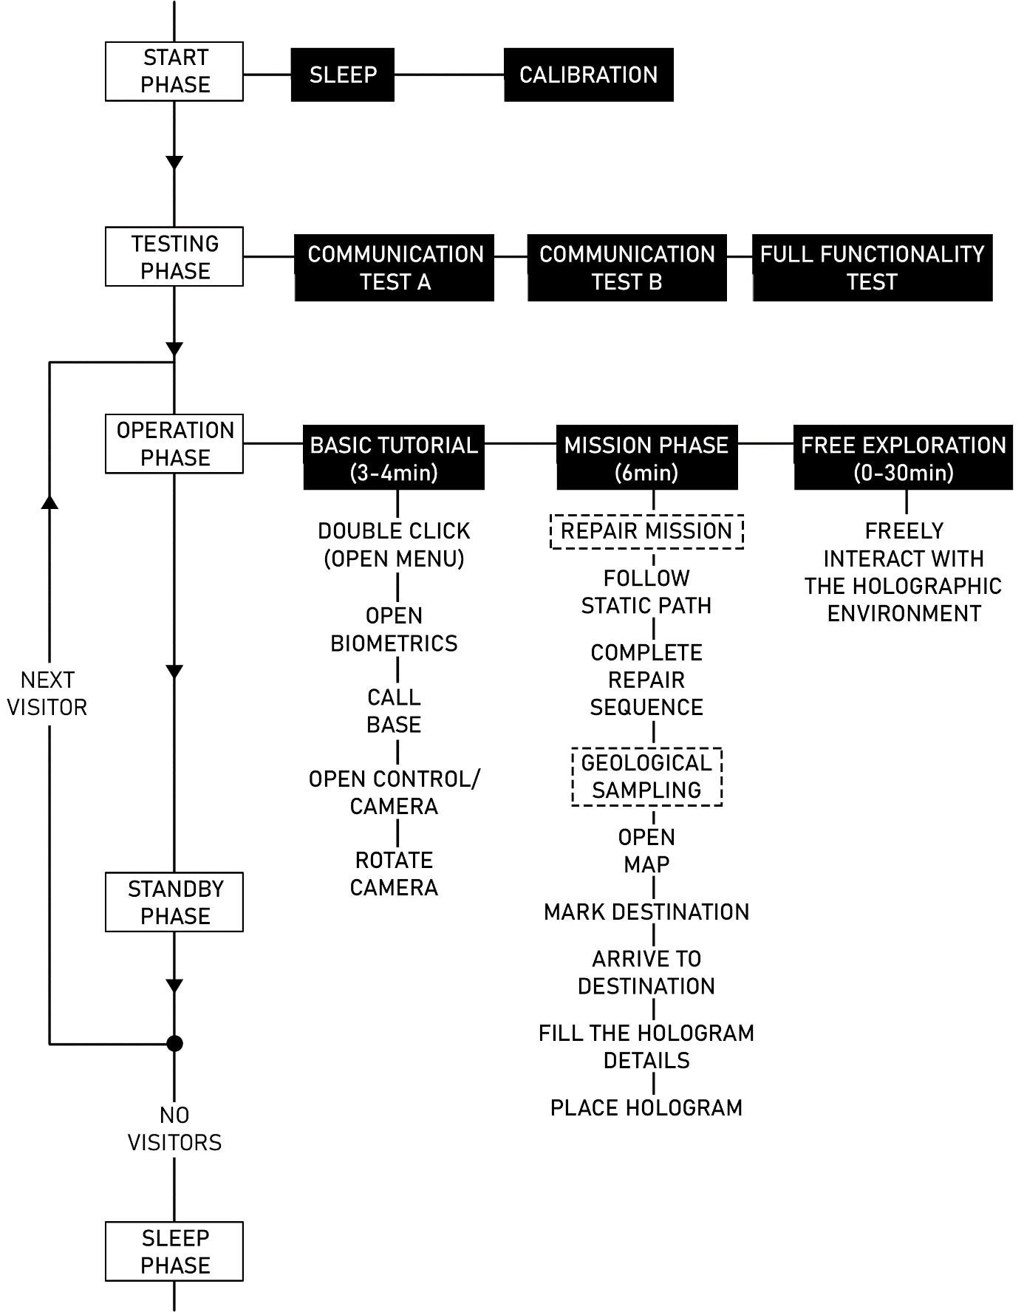

**1 / 2**

|  |  |  |  |  |  |
| --- | --- | --- | --- | --- | --- |
| ***Phase*** | **Sleep** | **Calibration** | **Communication Test A** | **Communication Test B** | **Full Functionality Test** |
| Duration | - | 5-10min | 15min | 15min | 15min |
| Description | System in sleeping mode overnight. | Functional testing and sensor calibration upon final assembly and integration in the Test Bed. | Establish network connection between the Test Bed and the control room and verify the correct transfer of data packets. | Establish network connection between the AR helmet and the control room and verify the correct transfer of data packets. | A member of the team wears AR helmet imitates the behaviour of a guest trying it for the first time. They test every capability and give feedback in case of malfunction. |
| Networking | No | Yes, partial | Yes | Yes | Yes |
| Supervision | No | 2 persons | 2 persons | 2 persons | 3 persons |
| Subsystem 1:  **AR Helmet** | Off, charging | On | Off | On | On |
| Subsystem 2:  **Control Room Laptop** | Off | On, if needed manual interception by supervisor | On, if needed manual interception by supervisor | On, if needed manual interception by supervisor | On, if needed manual interception by supervisor |
| Subsystem 3:  **Weather Station** | On | On, if needed manual interception by the guest | On | Off | On, if needed manual interception by the guest |

**2 / 2**

|  |  |  |  |  |  |
| --- | --- | --- | --- | --- | --- |
| ***Phase*** | **Full Operation** | **Standby** | **Basic**  **Tutorial** | **Mission**  **Phase** | **Free**  **Exploration** |
| Duration | 8-12 hours | ~ | 3-4min | 6 minutes | 0-30min  (Depending on number of guests) |
| Description | The AR helmet is fully functional and is exhibited to different guests showcasing its capabilities. At the same time, sensor data are transmitted to the control room and re-transmitted to the helmet. | System in sleeping mode before and after exhibition. | The user learns to interact with the holographic environment. Different functions of the application are showcased. | Various objectives are presented to the guest which they will have to complete. | During this time the guest will be able to use every function of the application. |
| Networking | Yes, partial | No | Yes | Yes |  |
| Supervision | 2 persons | 1 person | 2 persons | 2 persons |  |
| Subsystem 1:  **AR Helmet** | On, controlled by the guest | Off, charging | On | On, controlled by the guest |  |
| Subsystem 2:  **Control Room Laptop** | On, if needed manual interception by supervisor | On | On | On, if needed manual interception by supervisor |  |
| Subsystem 3:  **Weather Station** | On, if needed manual interception by the guest | On | On | On, if needed manual interception by the guest |  |

### Guest Safety

Since our project relies heavily on guest interaction with the newly developed technology of AR, it is of utmost importance to follow the safety requirements described in Saf-1 to guarantee the guest’s well-being. Furthermore, it is strongly advised that during the Operation Phase described in Chapter 2.6, an adequately trained member of the team closely supervises the guest’s actions. Special care must be taken to avoid their collision with the physical terrain (Saf-1.1).

+

### Operations and Test procedures

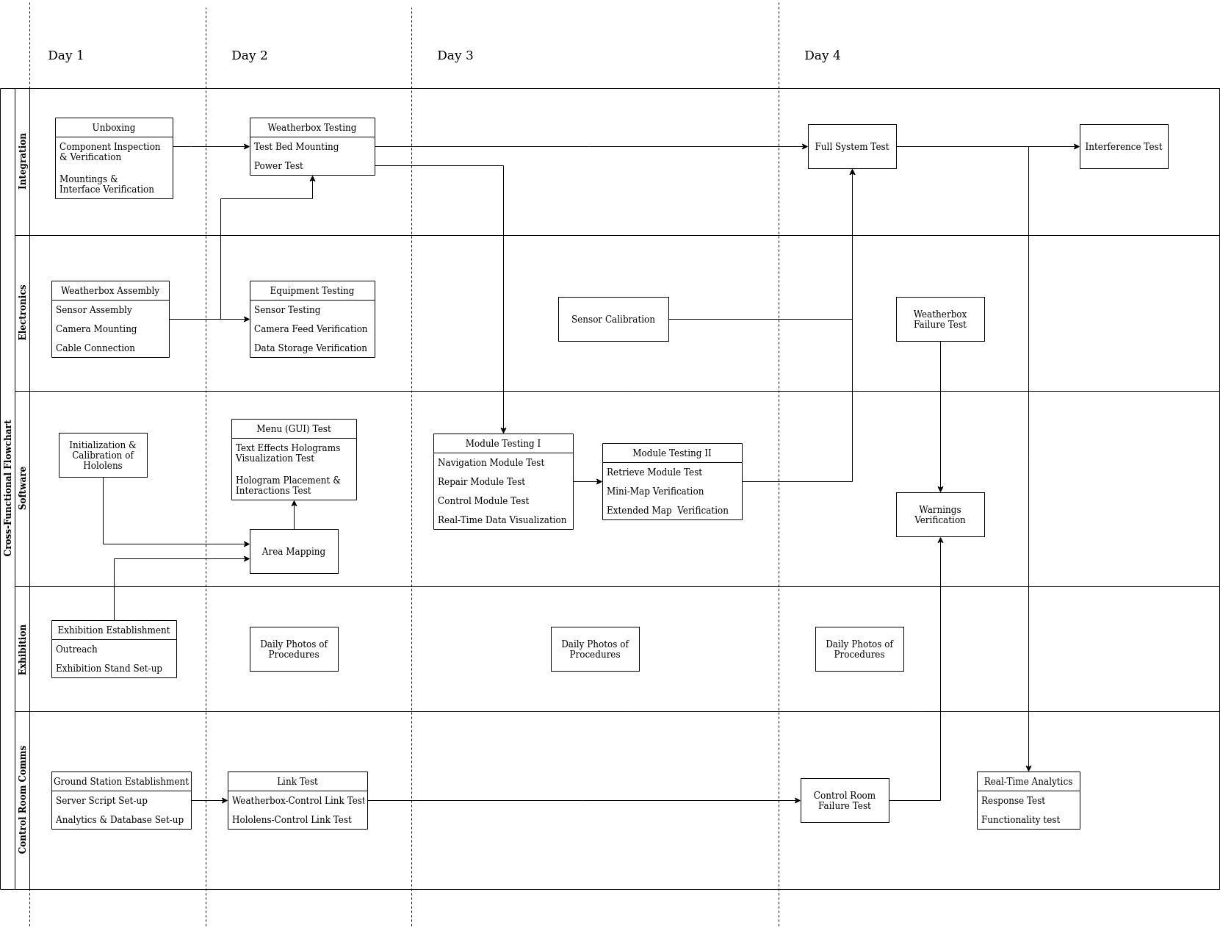

## Project Interfaces

### Mechanical Interfaces

The weather box will be mounted to the terrain of the mountain using a metallic base. The base itself will have a simple design that will allow it to attach to both soil and rocky environment as demonstrated below. 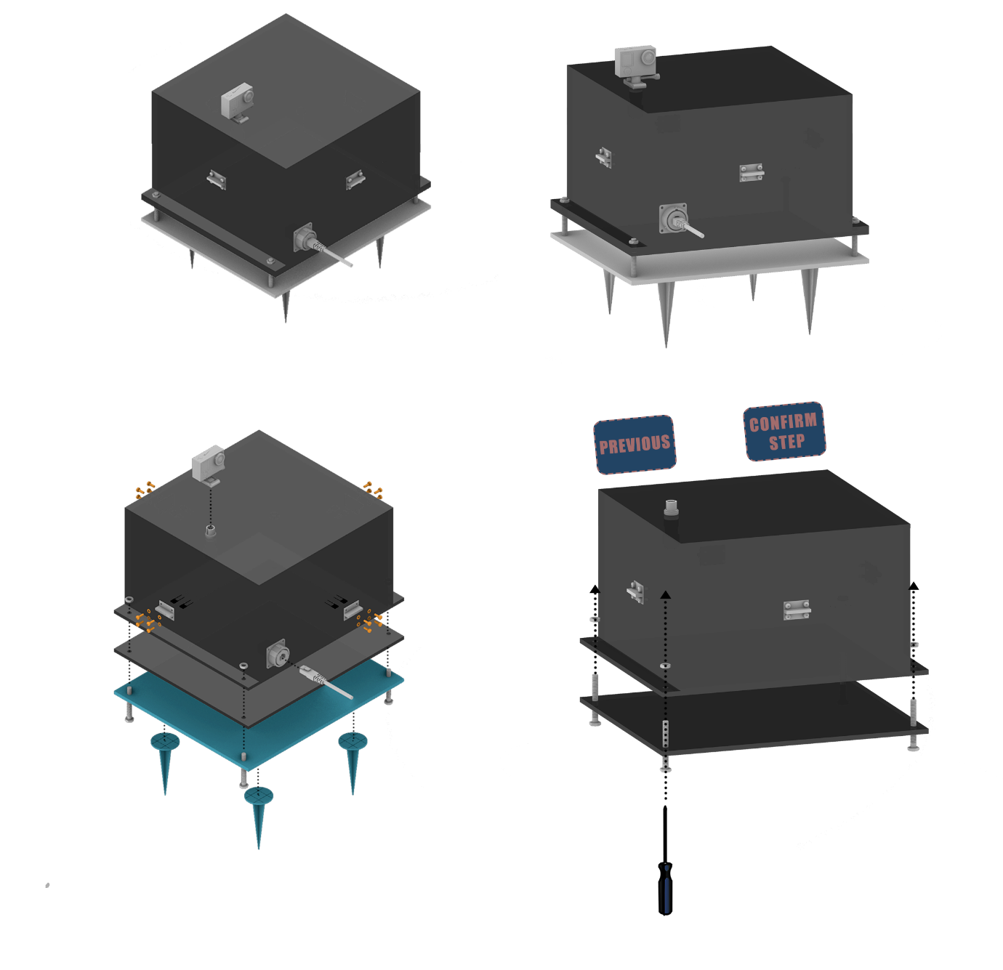

In particular, a square aluminum plate with four screws will be mounted to the ground while the actual box will then be placed above ground level using these screws. That way the positioning of the box can be adjusted regardless of the orientation of the slope.

### Power and Data Interfaces

The weather box will communicate with the environment through one simple LAN connector that will be used for both data transfer and power supply. To achieve that we will be using a PoE adaptor (Power over Ethernet) that will connect with the raspberry pi and the camera.

## Project Overview Summary

### List of Components *Table 2.8.1-1*

|  |  |  |  |  |  |  |  |  |
| --- | --- | --- | --- | --- | --- | --- | --- | --- |
| Part  name | Cost (€) | Spon  sored | Supplier | Expected lead time | Num  ber | Weight  (g) | Reason | Status |
| Raspberr y Pi 4B | 52.34 | 50% | Digital Hellas | Feb | 2 | 46 | Reliable micro computer | Delivered |
| SD card 32GB | 8.60 | 50% | Digital Hellas | Feb | 2 | negligent | To store data in the raspberry pi | Delivered |
| Temp. sensor PT100 | 7 | 50% | Digital Hellas | Feb | 15 | negligent | Sensor with a range of -200 to 300C degrees | Delivered |
| Camera S16 | 1200 | Yes | Mobotix | Feb | 1 | 430 | 360 angle view | Delivered |
| Radiation sensor SEN14209 | 69.95 | 50% | Digital Hellas | Feb | 2 | negligent | The only microchip gamma ray sensor | Delivered |
| ADS1115 ADC | 18.89 | 50% | Digital Hellas | Feb | 5 | negligent | To connect the temperature sensor to the raspberry | Delivered |
| DHT22 | 5.42 | 50% | Digital Hellas | Feb | 2 | negligent | Humidity sensor for the interior of the box | Delivered |
| PoE Hat | 38 | No | EasyPC | May | 2 | 200 | To convert the voltage into 5V to be connect it with Raspberry Pi | Delivered |
| PoE Injector | 20 | No | EasyPC | May | 2 | 345 | To power and transmit data over Ethernet | Delivered |
| RJ45 jack | 12 | No | EasyPC | May | 2 | negligent | To connect the E-cables | Delivered |
| Carbon Fiber | 40 | Yes | Alfakem | April | 1mx1.20m | 200 | To insulate and renforce the box | Delivered |

**Raspberry Pi 4 Model B/4GB**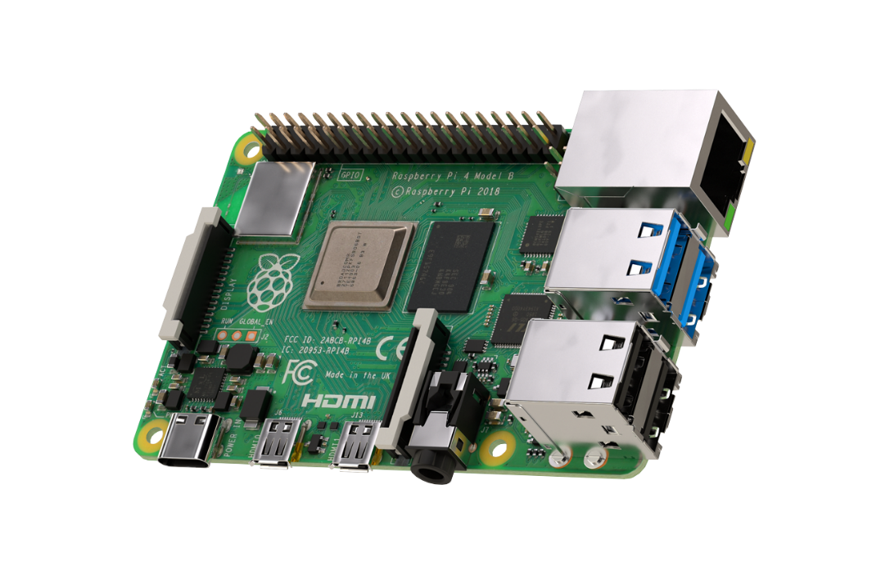

|  |  |
| --- | --- |
| **Processor** | Broadcom BCM2711, quad-core Cortex-A72 (ARM v8) 64-bit SoC @ 1.5GHz |
| **Memory** | 4GB |
| **Connectivity** | 2.4 GHz and 5.0 GHz IEEE 802.11b/g/n/ac wireless |
|  | LAN, Bluetooth 5.0, BLE |
|  | Gigabit Ethernet |
|  | 2 × USB 3.0 ports |
|  | 2 × USB 2.0 ports |
| **GPIO** | Standard 40-pin GPIO header(fully backwards-compatible with previous boards) |
| **Video & Sound** | 2 × micro HDMI ports (up to 4Kp60 supported) |
|  | 2-lane MIPI DSI display port |
|  | 2-lane MIPI CSI camera port |
|  | 4-pole stereo audio and composite video port |
| **Multimedia** | H.265 (4Kp60 decode) |
|  | H.264 (1080p60 decode, 1080p30 encode) |
|  | OpenGL ES, 3.0 graphics |
| **SD card support** | Micro SD card slot for loading operating system and data storage |
| **Input power** | 5V DC via USB-C connector (minimum 3A) |
|  | 5V DC via GPIO header (minimum 3A) |
|  | Power over Ethernet (PoE)–enabled (requires separate PoE HAT) |
| **Environment** | Operating temperature 0–50ºC |

**P0K1.202.3K.B.010(PT100)**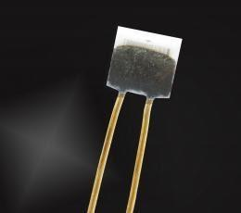

|  |  |
| --- | --- |
| **Operating temperature range** | -200 ºC to +300ºC |
| **Nominal restistance** | 100 Ω at 0ºC |
| **Characteristics curve** | 3850 ppm/K |
| **Long-term stability** | < 0.04 % at 1000 h at maximal operating temperature |
| **Tolerance class (dependent on temperature range)** | IEC 60751 F0.3 B (IST AG reference) |
| **Connection** | Ni-wire Au-coated, 0.2mm, 10mm long |
| **Dimensions** | 2 x 2 x 0.65 / 1.3 (L x W x H / H2 in mm) |
| **Tolerance (chip)** | L ± 0.2 mm, W ± 0.2mm, H ±0.1mm, H2 ±0.3mm |

**ADS1115 16-Bit ADC – 4 Channel with Programmable Gain Amplifier**

|  |  |
| --- | --- |
| **Wide supply range** | 2.0v to 5.5v |
| **Low current consumption** | Continuous mode: only 150µA |
|  | Single-Shot Mode: Auto Shut-Down |
| **Programmable Data Rate** | 8SPS TO 860SPS |
| **Internal low-drift voltage reference** |  |
| **Internal oscillator** |  |
| **Internal PGA** |  |
| **12C Interface** | Pin – Selectable Addresses |
| **Four single-ended or two differential inputs** |  |
| **Programmable comparator** |  |
| **12C 7-bit addresses** | 0x48-04B, selectable with jumpers. |

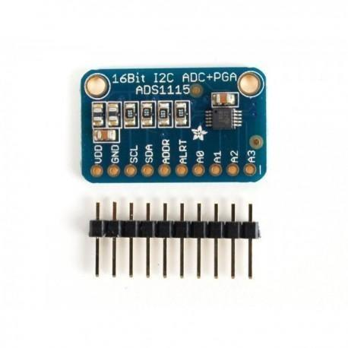

**DHT22.AM2302 Digital Temperature and Humidity Sensor**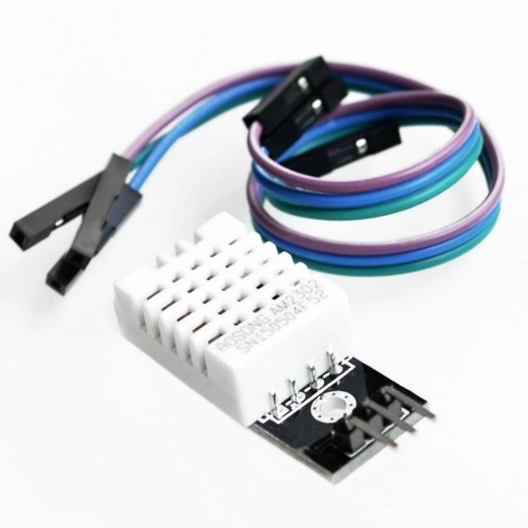

|  |
| --- |
| With fixing screw hole, convenient to install and fixed |
| Single-bus digital signal output, bidirectional serial data |
| Type: DHT22 temperature and humidity sensor |
| Operate voltage: DC 3~5.5V |
| Temperature range: -40 to 80 degree Celsius |
| Temperature measurement accuracy: ±0.5 degree Celsius |
| Humidity measuring range: 0~100%RH |
| Humidity measurement accuracy: ±2%RH |
| Working voltage: DC 5V common  Size: 28 x 12 x 10 mm (L / W / H) |
| Screw hole diameter: 2.6mm |
| Weight: 4g |

**Pocket Geiger Radiation Sensor – Type 5 (SEN-14209)**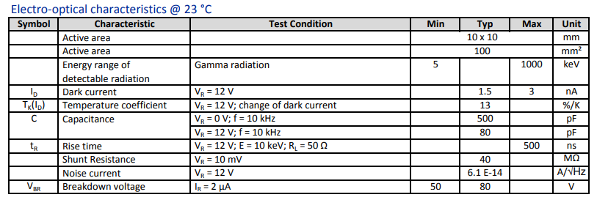

|  |
| --- |
| 100 mm² PIN detector |
| Light blocking encapsulant |
| Low dark current |
| Low capacitance |
| High shunt resistance |
| Small quantities: Foam pad, boxed (12 cm x 16.5 cm) |
| High sensitivity |

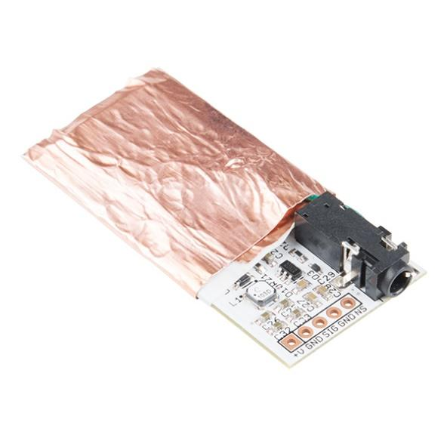

**Camera MOBOTIX S16B DualFlex**

S16 camera module (body) for connecting one or two S16/S15 sensor modules

 • ONVIF-compliant Mx6 system platform (2nd generation) with H.264, MxPEG+ and M-JPEG

• Image sensor options (via sensor module): 6 megapixels, color (day) and/or B/W (night) and/or thermal

• Lens options (via optical sensor module): horizontal image angle from 180° to 8°

• IP66/IK06, -40 to 60°C (-40 to 140°F)

• Internal DVR: 4 GB microSD

• System components: temperature sensor, MxActivitySensor, shock detector

• Ethernet patch cable 0.5 m/1.65 ft

• Interfaces: 2x connection for MOBOTIX sensor module (Cam1/Cam2), Ethernet 10/100 (RJ45 and LSA), MxBus, USB, Audio (I/O); RS232 via MX Interface Box

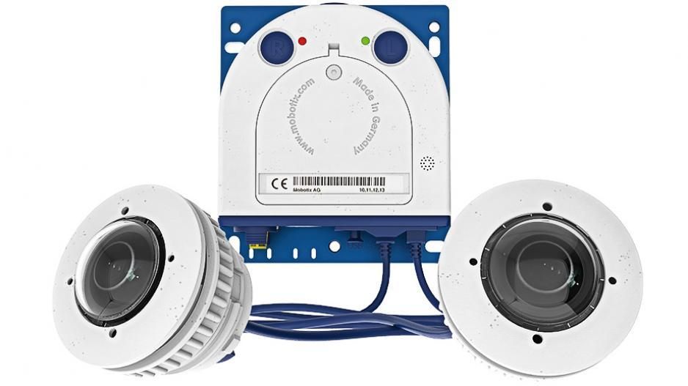

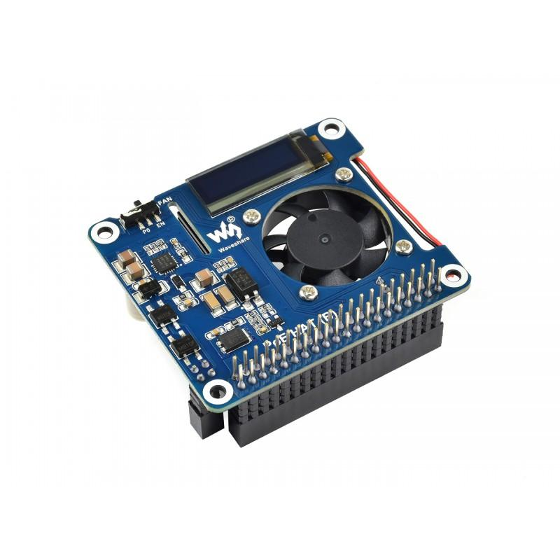

**PoE Hat for Raspberry Pi 3B+/4B**

* Standard Raspberry Pi 40PIN GPIO header, supports Raspberry Pi 3B+/4B
* PoE (Power Over Ethernet) capability，802.3af-compliant
* Fully isolated switched-mode power supply (SMPS)
* 0.91" OLED, for monitoring processor temperature, IP address, and fan status in real-time
* Onboard cooling fan, allows auto running on powerup OR programmable control, configured by switch
* Integrates PCF8574 IO expander for I2C bus, providing pin P0 for directly fan control, and more spare IO pins

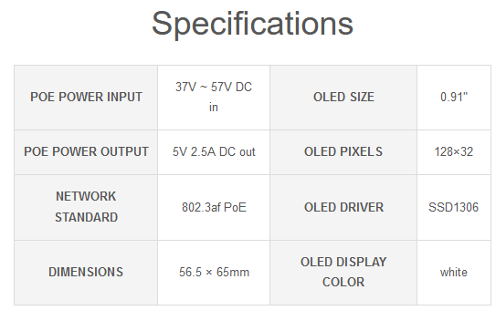

### Project Overview Summary

**Weather Box:**

|  |  |
| --- | --- |
| Mass (kg) | 4,25 |
| Standing area (m^2) | 0,0625 |
| Volume (m^3) | 0,0125 |

## Project Design

### Mechanical Design

The mechanical design of the weather box was made to withstand the conditions of the testbed, while still taking under consideration the difficulties that the lunar environment would present. That being said, not all features will be essential for the test bed’s environment.

When taking under consideration only the requirements of the test-bed there is no need for thermal insulation, as all of the components have an operating temperature range that does not exceed the mountain’s conditions (-10 to 12 C). However, humidity, wind, and rain are all important factors, leading to the need for a waterproof and durable design.

When considering the requirements of the lunar environment, a minimum of 2 mm aluminum is required to block the cosmic radiation that would damage the electronics of the box. Therefore, the body of the box is built out of aluminum. Furthermore, a passive cooling system is essential, as the temperatures on the moon reach up to 120 C. Lastly, the temperature on the moon could not be measured with standard methods as explained in following paragraphs. Everything mentioned in this paragraph is not essential for the operation of the device on the test-bed, the project itself though is proof of concept, therefore calculating as many parameters as possible for the final design is crucial.

To create a cooling system, all of the upper sides of the cube -meaning the ones that are usually facing the sun- will be insulated with carbon fiber while the bottom side of the box -that never faces the sun- will work as a radiating surface through which the heat will be released.

Regarding the thermometers: As there is little to no atmosphere on the moon, we cannot measure its temperature. To fix this problem the thermistors will be coated with 2mm of aluminum. This way, the sensors will reach thermal equilibrium with the chosen material, indicating in each moment the temperature the aluminum would have on that particular spot. We will then be able to calculate the fluctuation of the temperature of any other material, but not the exact temperature. This was one of the reasons aluminum was chosen as the coating material, for it is commonly used in space missions. An ideal alternative would be to cover the thermistors with the material of the astronaut’s suit, though we could not obtain it.

The lack of atmosphere on the moon would also cause the temperature of a sensor facing the sun to be very different from one that is not. To extract more accurate data, 2 sensors will be placed on each side of the box- one serving the purpose of back-up in case the first is damaged- making a total of 10 sensors. From a mechanical point of view, this will be achieved by laser cutting 4 small holes on each side, just for the ends of the thermistors to pass through, while the actual sensor will stay outside of the box as shown on the schematic below.

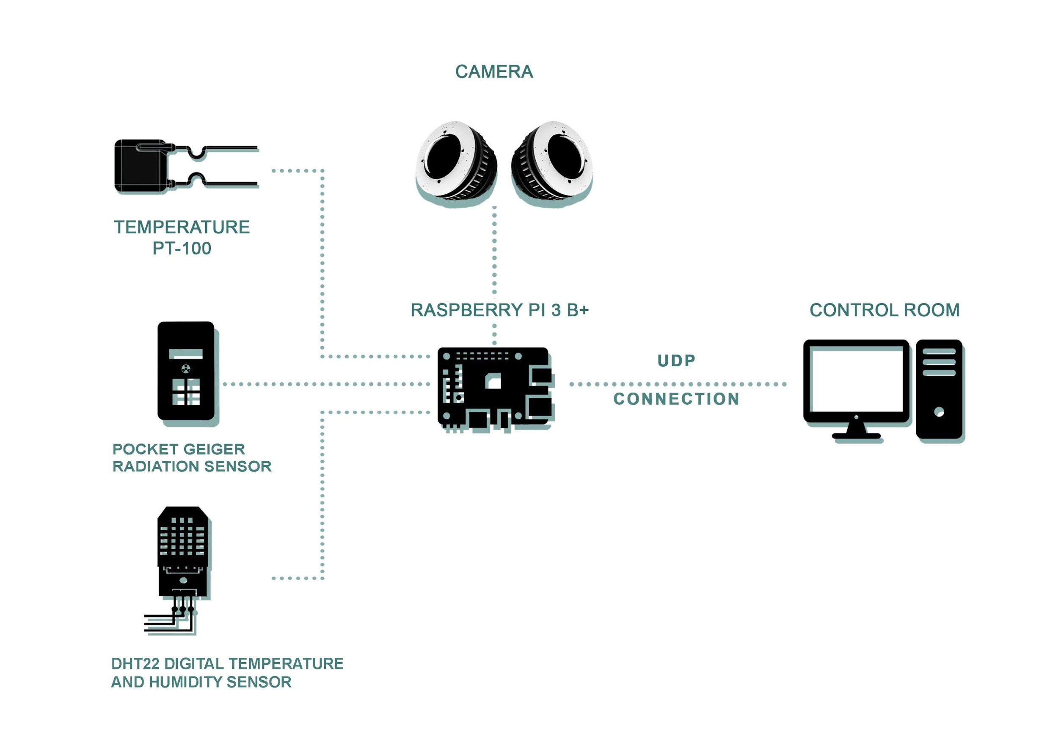

To protect the electronics from the mountain’s humidity and rain the box needs to be waterproof. For the connections -ethernet and camera cables- we will be using watertight mil connectors as demonstrated below. For the connection to the base of the box, we will be using weatherstrips while also screw the two parts together.

For extra protection against humidity, all the electronics (excluding the sensors) will be coated with silicone conformal coating, while an extra humidity and temperature sensor (DHT22) will be placed inside the box to gather data and ensure the indications stay within the operating range.

|  |  |  |  |  |
| --- | --- | --- | --- | --- |
| **Subsystem** | **Mass [g]** | **Margin [%]** | **Growth factor [%]** | **Sub-total** |
| **AR helmet** | 250 | 5 | 1 | 265 |
| **Weather station** | 4.203,1 | 1 | 1 | 4.245,131 |
| **Summary** | 4.453,1 | - | - | 4.495,131 |

### Mass Budget

### Electronics Design

In this section the electronics design of the weather station is presented, the general concept is to collect the data from sensors, such as humidity-temperature sensors inside the box, humidity-temperature into the soil, thermistors, radiation sensor, and taken images or videos from a camera located at the top of our box and then transmit them from Pilatus to the control room through an Ethernet cable given by Space Innovation. The block diagram of the electronics box/weather can be seen below (it shows the data connections between each module of the electronics):

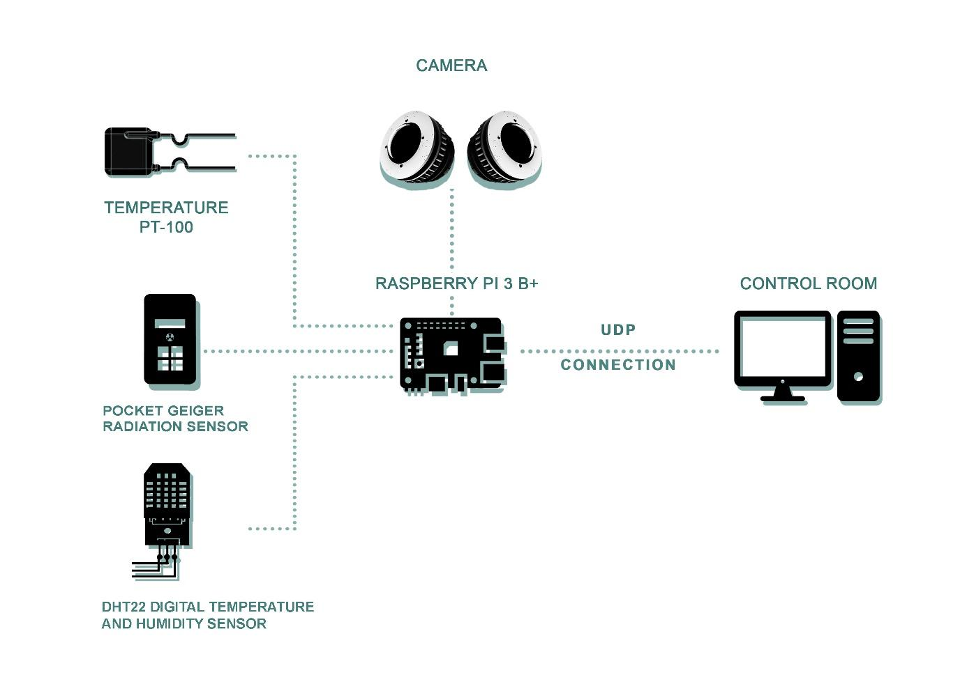

**Data Remote Control**

The Weather Station needs to transmit the data it collects to a control room in the exhibition area and then through Wifi to the headset. Thus, the Space Innovation provides us with an Ethernet cable that is going to connect the Test Bed with the Control Room, so the second connector would be a simple LAN connector.

**Power Distribution**

Regarding the power supply, we are going to use an Ethernet cable, thus we will combine data and power on the same cable. Power over Ethernet (PoE) supplies power to network devices over the same cabling that carries the data.

In order to use power over Ethernet, an injector, a splitter and a PoE hat will be used. The injector’s purpose is to provide power to the LAN cable, therefore it will be connected to a power socket and the two ends of the cable. In order to power both the raspberry and the camera, a splitter will be used to separate the PoE LAN cable to two similar ones.

The camera support Power over Ethernet, however, if we connect the power ethernet cable from the injector power supply to Raspberry Pi we find 48 Volts on 2 pins of the PoE header. To prevent this, we will need a buck converter to reduce the 48 V to 5 V and then feed the Raspberry, this is done by a PoE HAT.

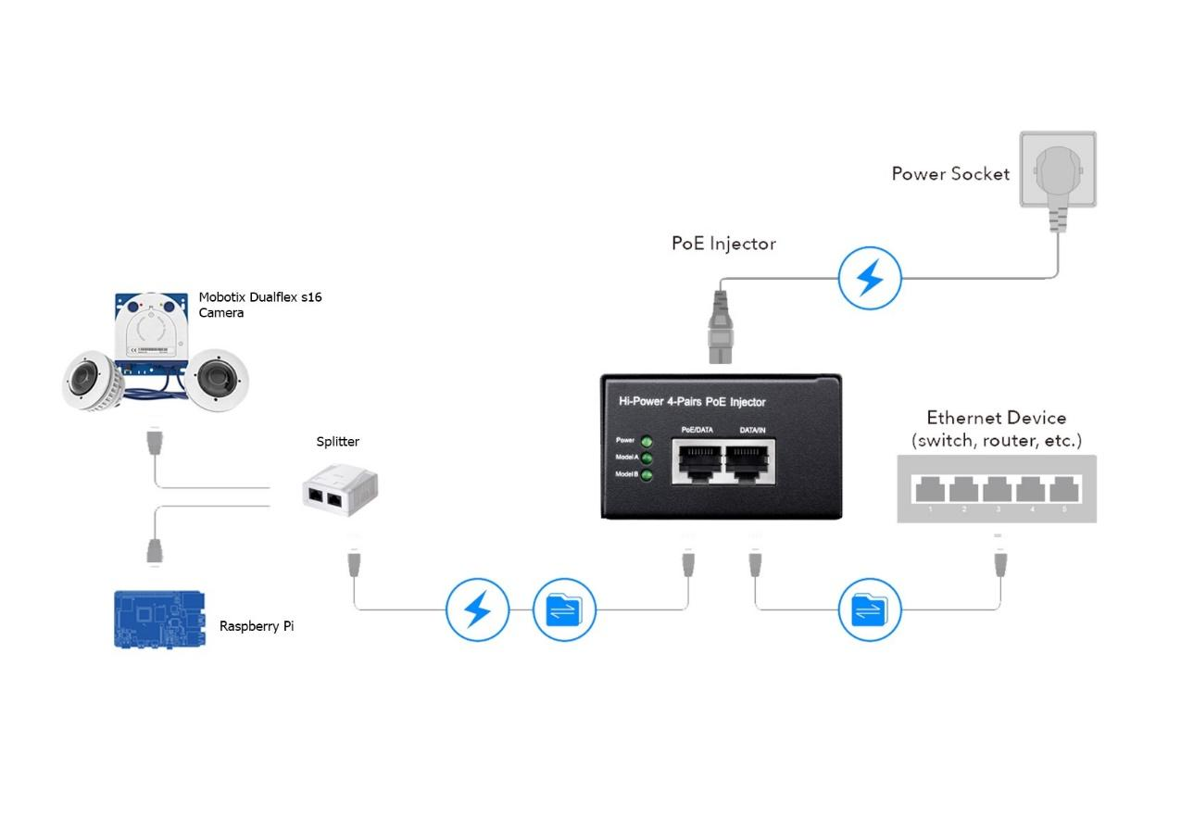

**Connection Raspberry Pi - DHT22/AM2302 Digital Temperature and Humidity Sensor**

DHT22 sensor consists of two components for measuring: Humidity sensing component and the NTC temperature sensor (or a thermistor). There is an IC on the back side which makes the readings to be able to read by Raspberry Pi.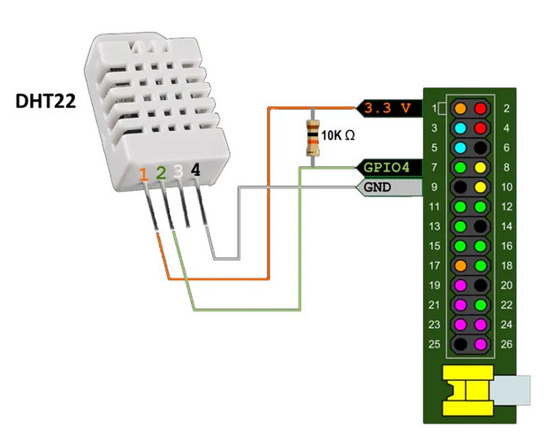

The DHT-22 (also named as AM2302) is a digital-output relative humidity and temperature sensor, with an inbuilt analog to digital converter so in order to connected with the Pi it does not require any additional chips.

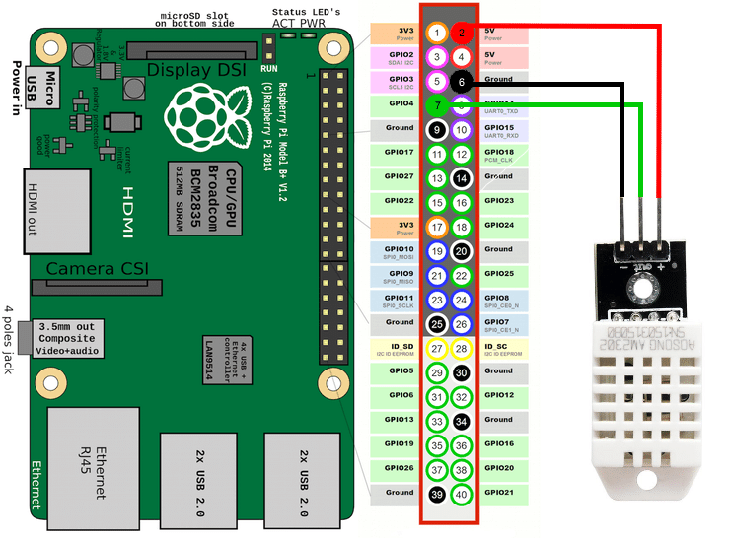

**Connection raspberry pi – ADS1115 – PT100(P0K1.202.3K.B.010)**

When we connect our analog to digital converter to the raspberry pi, we would be ready to add the thermal sensor PT100 as the image depicts

(The ADS1115 will also incorporate a PGA and a digital comparator) *(Figure 2.9.3-2)*

PT100 has a resistance of 100 ohms at 0 °C and 138.4 ohms at 100 °C. The relationship between temperature and resistance is approximately linear over a small temperature range.

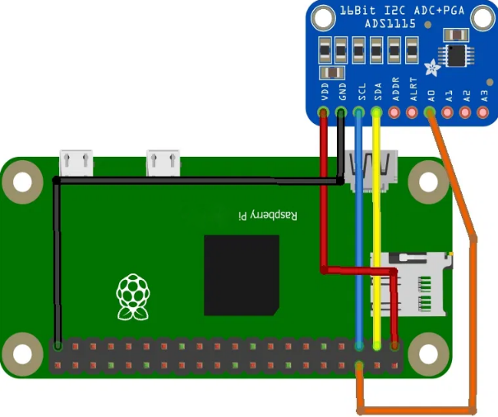**.**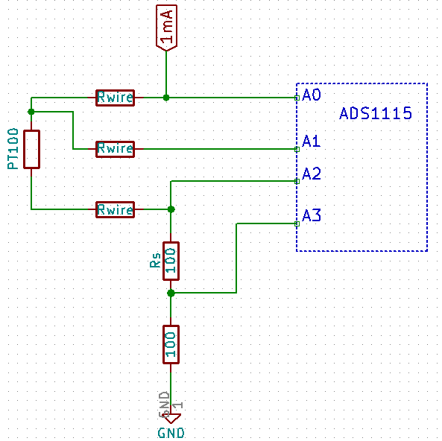

**Camera (MOBOTIX S16B DualFlex)**

We are going to use the S16B Duaflex modular camera, which integrates 2 sensor modules. These hemispheric cameras capture a 180°- hemispheric image of the surrounding, thus we will connect the first one to the one size of the box while the second one will be mounted on the opposite side in order to conceive a 360° view of the area around the weather box.

In addition, it has low power consumption in accordance with the PoE Standard, typically 4,5 watt.

As the below image depicts, both for the power supply of the camera and the gathering/transmission of the data will use the same cable (Ethernet) :

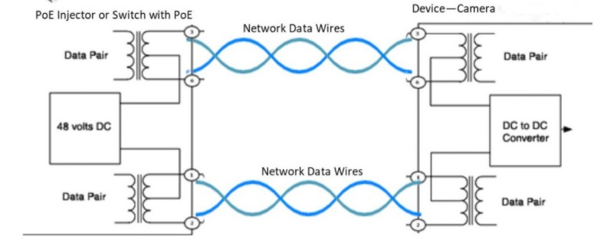

**Connection Raspberry Pi - Pocket Geiger Radiation Sensor – Type 5 (SEN-14209)**

This sensor is capable of detecting Gamma and Beta radiation, it has a simple pulsed output that can be used with any microcontroller. Moreover, the Pocket Geiger has an onboard DC boost circuit, so the board can be supplied with a friendly 3V to 9V. 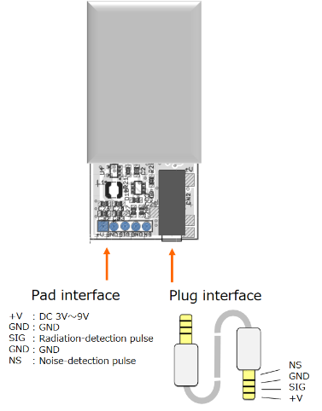

The detector outputs a negative (LOW) pulse when radiation has been detected at SIG. Pulse width t changes depending on pull-up resistor R, which should be 10kΩ〜22kΩ. Additionally, maximum output voltage falls off because of an internal resistance, for about 0.6V. It also outputs a positive (HIGH) pulse when vibration noise has been detected at NS. Pulse width differs depending on vibration pattern and regardless of pull-

**Protection**

We pay attention also to grounding and lighting protection, we will have already grounded all the components at the base of the box to avoid potential electronic problems. On the moon surface we are not going to face similar situations, however it is a parameter that we should bear in mind because the weather station will be placed on Pilatus and to ensure the safety if lightning happens to hit it directly, we will manufacture the weather box from aluminum, which is a good conductor, so it will attract the lightning. Lightning usually follows the path to the ground to reach a better-grounded conductor. This way we will give it a better, safer path to ground preventing fire and appliance damage.

### Power Budget

|  |  |  |  |  |
| --- | --- | --- | --- | --- |
| **Item** | **Power [W]** | **Margin**  **[%]** | **Growth factor [%]** | **Power with Margin [W]** |
| 1 Weather Station | 22,5 | 5.8 |  | 23.81 |
| 1.1 Raspberry Pi | 15 | 5 |  | 15,81 |
|  |  |  |  |  |
| 1.2 Camera(MOBOTIX S16B DualFlex) | 7,5 | 6.66 |  | 8 |

### Heat release

|  |  |  |
| --- | --- | --- |
| Part name | Lowest operating Temp (Cₒ ) | Highest operating Temp. (Cₒ) |
| Raspberry Pi 4B | -40 | 85 |
| Temp. sensor  PT100 | -200 | 300 |
| Camera (MOBOTIX S16B DualFlex | -40 | 60 |
| SEN-14209 | -20 | 70 |
| DHT22/AM2302 | -40 | 80 |

As demonstrated above, most of the components do not operate on the full temperature range of the moon (-130 Cₒ  to 120 Cₒ). The temperature fluctuations on the test bed though are within the limits of every component. Considering the difficulty of acquiring equipment for such extreme conditions and their cost, it was decided to focus on the test bed’s requirements, as this is a prototype and will not be sent to the moon.

Regarding the raspberry pi, although the datasheet indicated the temperatures above, further testing has proven that it can function at temperatures as low as -180C. Durability like that cannot be guaranteed for every raspberry, so it should not be taken into account for our calculations. However, it is surely worth mentioning.

Quoting the official raspberry pi documentation:

*“All Raspberry Pi models perform a degree of thermal management to avoid overheating under heavy load. The SoCs have an internal temperature sensor, which software on the GPU polls to ensure that temperatures do not exceed a predefined limit; this is 85°C on all models. As the device approaches the limit, various frequencies and sometimes voltages used on the chip (ARM, GPU) are reduced. This reduces the amount of heat generated, keeping the temperature under control.”*

Although most of the components were chosen with the test bed’s conditions in mind, it was crucial that the temperature sensors could operate on both the lunar and the earth’s environment. When measuring temperature on earth we practically measure the temperature of the atmosphere. The thermometer reaches thermal equilibrium with the molecules of air surrounding it and therefore measures their temperature. When measuring temperature on the moon, there is little to no atmosphere therefore we cannot measure its temperature. To resolve this problem, we coated the thermistors with aluminium, as explained in 2.9.1

### Software Design

There are three areas requiring software development in our project:

#### AR Helmet (HLS)

**a) Purpose**

An especially important aspect of our project is the software developed for the HoloLens. Through a holographic environment, its purpose is to provide the user with navigation instructions and assistance in performing certain tasks, as well as a network interface which allows streaming of real time data. The capabilities being offered will be integrated through a corresponding User Interface (UI).

**b) Block Diagram**

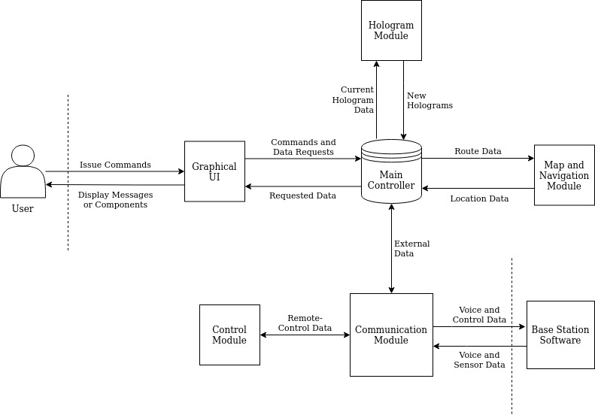

**c) UI**

*Note: The following images are real footage captured inside the application.*

There will be five different ways to interact with the holographic environment as described below.

**1)** **Air-Tap** (sometimes also described as “click”): The user “gazes” (looks towards) at a hologram, then they hold their hand straight out in front of them in a loose fist and point their index finger straight up toward the ceiling. Lastly, they tap their finger down, and then quickly raise it back up again.

**2) Hold (and Drag):** The user air-taps and then holds their finger down for a specified short duration of time or moves their whole hand while still holding down their finger.

**3) Double Air-Tap** (or double click): The user performs to consecutive air-taps within a short time frame.

**4) Focus:** The user gazes at a hologram for a specified duration of time.

**5) Voice:** The user utters a predetermined voice command. The command is shown as a visual tooltip when the user gazes at a clickable target.

**Menus/Modules**

Each menu or module described below will have the following characteristics unless otherwise described.

1) Itself and all its options are accessible both by air-tap and voice.

2) It “loosely” (within some degrees) follows the user’s gaze.

3) It includes a “Close” button or option.

**Main Menu UI**

By using a double air-tap with no holographic target a menu with five different modules appears. The different modules included are named **Map**, **Hologram Placement**, **Camera View** and **Mission Checklist** and will be further described below.

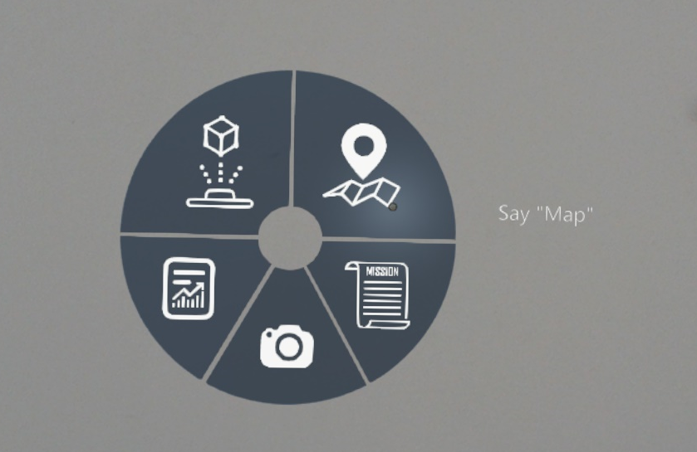

**Map**

This module is accessed via the main menu and shows the position of any hologram relative to the position of the user, while also providing the possibility to zoom in and out by continually pressing the “plus” and “minus” signs respectively. Furthermore, by dragging their finger, the user may move the map to observe different areas of the landscape. Lastly, by air-tapping at a point we are able to get its real-world coordinates. This feature is currently used for the provision of directions to the given coordinates by the **Navigation** module. 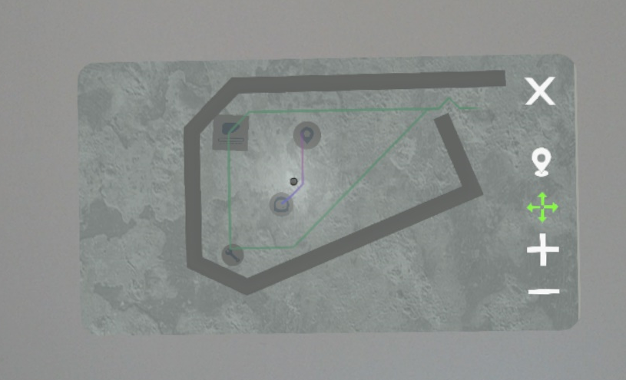

**Hologram Placement**Accessible via the main menu. Once clicked, an interactable ‘window’ appears, which provides the ability to select a specific hologram from a predetermined list. Next to the displayed hologram, there will be a list of attributes which will have to be filled before placement. These attributes include the Name of the Hologram, a text description of the surrounding area and a photograph taken from the HoloLens camera.

After filling the attribute list, the “Place” button will be enabled, which will lock the hologram to the astronaut’s gaze until they air-tap again to release the hologram on the desired position.

There will be two different holograms marking geological sampling and site-screening, respectively. The astronaut will be able to access them by air-tapping the “Next” and “Previous” buttons found in the menu. Finally, the placed hologram will be included in the navigation roadmap (see below).

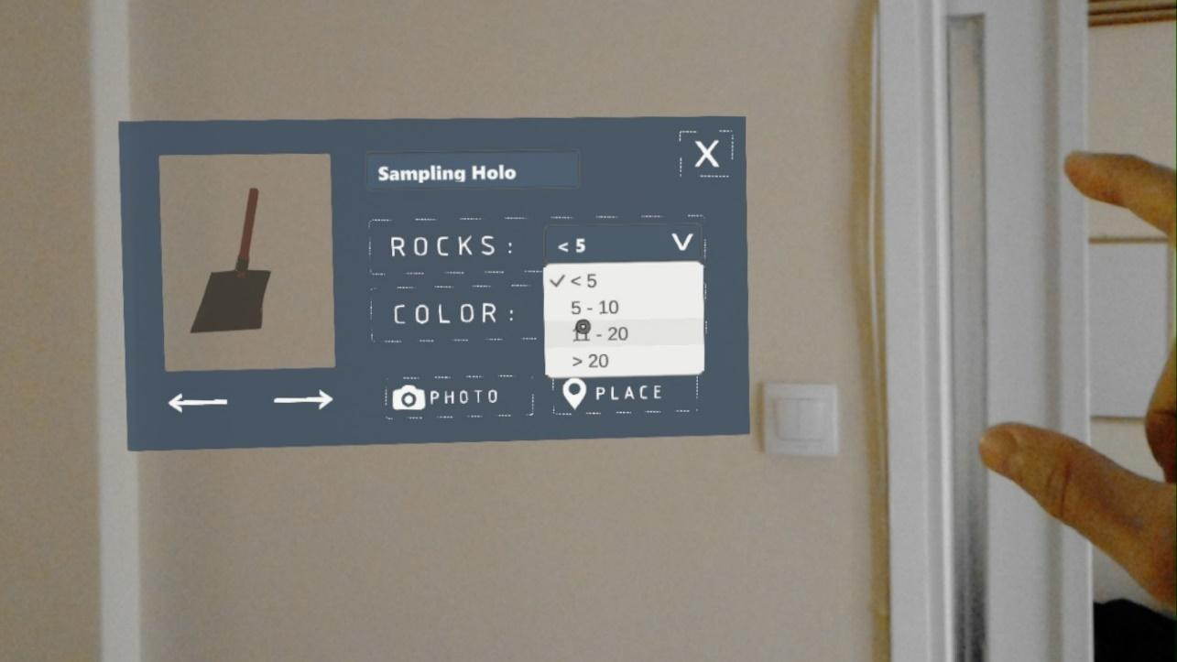

**Camera View**

This module is accessed via the main menu and includes a remote camera feed from the Test-Bed.

**Mission Checklist**

This module is accessed via the main menu and includes a set of predetermined missions, their descriptions and their completion status. The missions will then be divided in detailed sub-tasks with helpful information to complete them. This module will essentially be treated as a helper. Although the letters seem small, they are perfectly readable in the application.

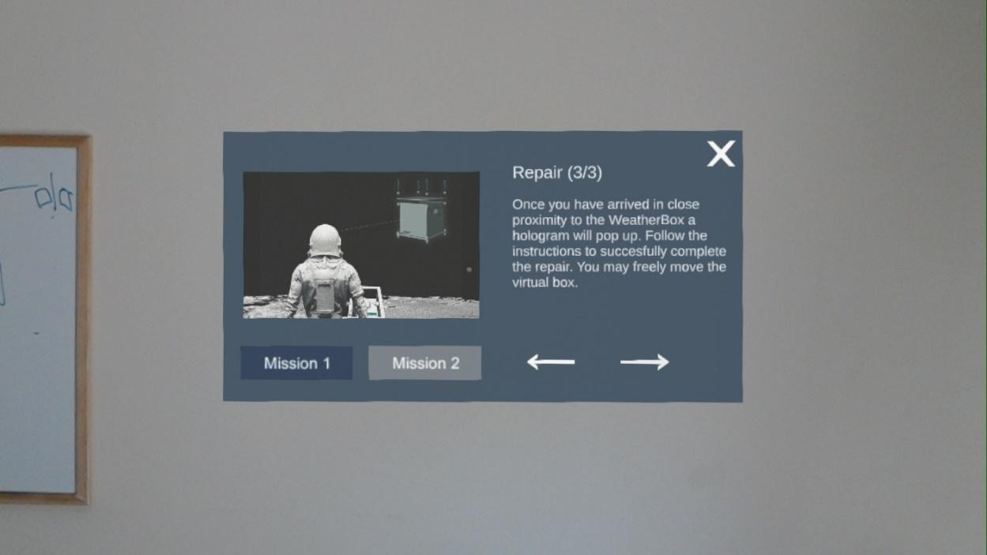

**d) Other Core Modules**

**Navigation**

The navigation module consists of three main entities, namely: Grid, Node and Pathfinding.

It is important to preemptively acknowledge the Node class, which stores positional data for the two-dimensional array from which the grid is derived as well as core components of the A* algorithm (F-cost, G-cost, H-cost) **[1].**

The Grid class serves the purpose of dividing the two-dimensional space that is to be navigated into a grid-like space with discrete cells of given features (such as sizes or in-between distances). It initializes the grid itself, accomplished by creating a node object for each cell within the grid.

The aforementioned process feeds into the Pathfinding class, which is responsible for dynamically calculating the shortest path from a starting to a target position. To start with, the shortest routes between given points of interest (such as the weather station) are calculated. The implementation is that of the A* shortest path algorithm, which will not be explained in-depth in this report as it is very well-documented **[2]**. The route between the user’s and the target’s position is calculated in short time intervals, updating the final path.

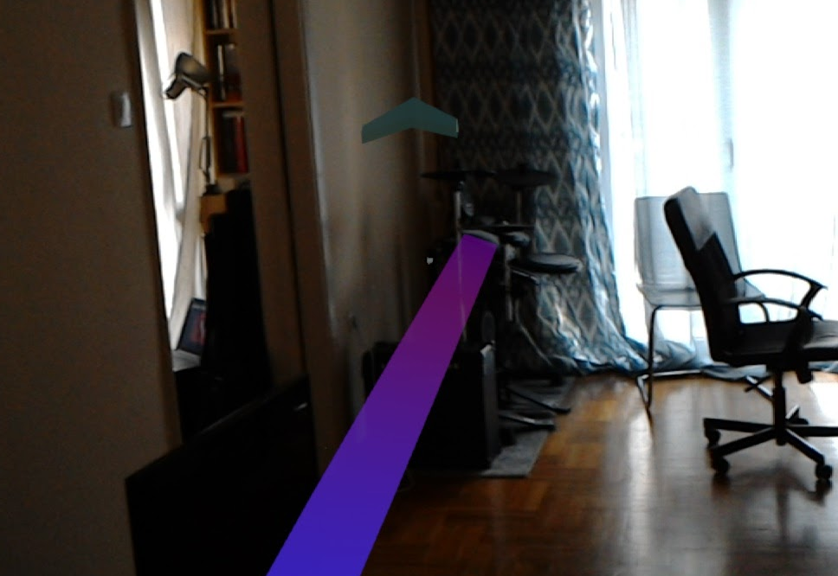

**Repair Sequence**

When the user enters a predetermined physical space, animated instructions will be projected in the top right corner of the HoloLens’ perspective. These instructions will aid the user to perform a simplified physical repair task such as screwing a couple of bolts, connecting cables in the right inputs, pressing buttons or flipping switches in the right sequence. Each step will have a “Next” and “Previous” button leading to the final “Finish” button confirmation.

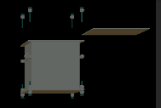

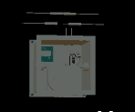

**Biometrics**

Accessible via the main menu. Once tapped, a non-interactable window appears, displaying information regarding the consumables and metabolic status as well the parameters of the EVA walk, vital to mission success. For the purposes of the Exhibition, the main Biometrics will be the Heart rate (measured in bpm), the O2 consumption status (in minutes), the suit pressure (in PSI) and the Metabolic Rate (J/s).

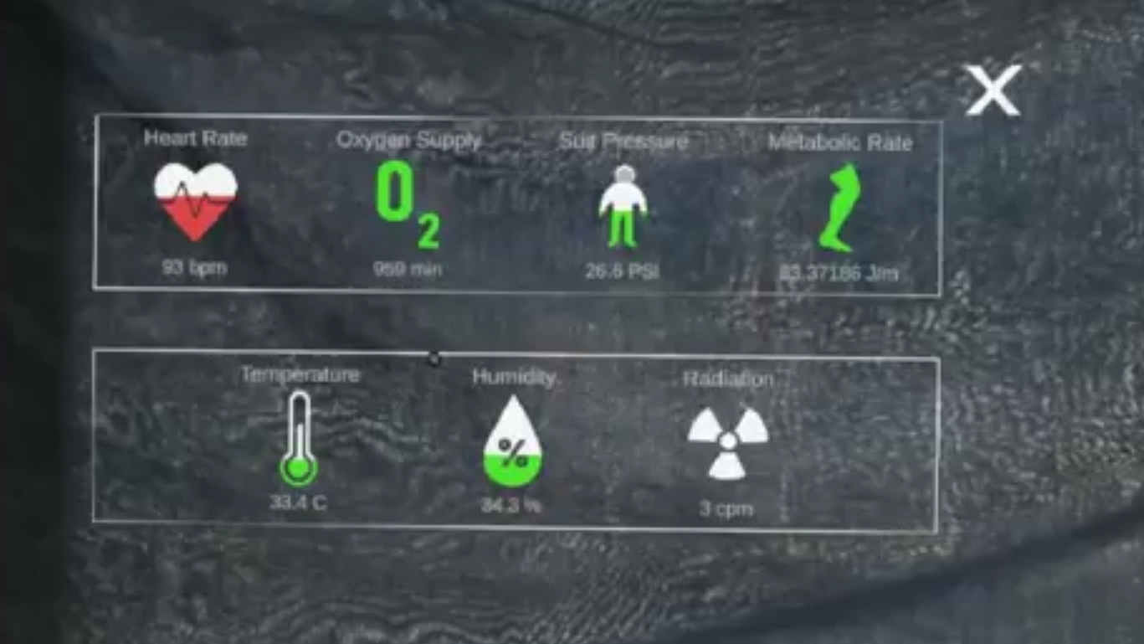

Accordingly, the main Traverse metrics will be the Time left (for the completion of the whole Traverse), the Cumulative Distance travelled (measured in km) and the Cumulative Energy Cost (GJ).

In parallel with the module’s display, the heart rate, the oxygen status as well as the time remaining will be passively displayed in the top right corner.

The sequence of calculations for the determination of the energy is detailed in Section 7.4.2.

**e) Safety Concept**

**1) Input / Interactions**

The user will be able to access most interfaces through either air-tapping or voice commands to increase accessibility.

**2) Networking**

The **“Camera View”** and **“Sensor Data”** modules all require network connection and as such need a backup solution in case of unforeseen problems. Although we could not find meaningful backups for the Call Base and Control/Camera modules, we will display realistic randomly generated sensor data for better user experience in the exhibition as a backup.

**f) External Interfaces / Networking**

The HoloLens will communicate with other devices via WiFi in order to enable the functionalities described in the **“Camera View”** and **“Sensor Data”** modules.

There will be 1 active HTTP-GET connection with a laptop in the control room which will act as a source of environmental data and camera pictures.

For the transmission of pictures the WebRTC package will be used.

More information for the WebRTC may be found in Section 7.4.3.

**h) Data Acquisition and Storing Concept**

Any data necessary for the function of the HoloLens will be stored locally using the internal disc of the device. The data from the Test Bed will not be stored locally.

**i) Implementation Concept**

The HoloLens software will be developed using Unity and Visual Studio. The code will be written in C# and everything will be developed for UWP. The most significant package which will be used is called MRTK (Mixed Reality Toolkit) which provides a set of components and features to accelerate cross-platform MR app development in Unity **[7]**.

**Learning Resources**

As our university does not have the necessary knowledge for MR development the sources below will be used for learning:

1) HoloLens Documentation and Tutorials **[8]**

2) MRTK Documentation **[9]**

3) Plenty of personal Blogs and Youtube Tutorials

4) HoloDevelopers Slack channel **[10]**

**Building Process**

Some general practices we used specifically for developing in HoloLens using Unity may be found in Section 7.1.1.

#### Server (Control Room Laptop)

The server will be running locally on a laptop installed in the control room. It will function as a back end with python and Django web framework. The system will operate as a node between the end user (HLS) and the weather box (raspberry pi) since all relevant data is transmitted through the server.

* 1. Purpose
* To receive the collected data from the raspberry pi in the test bed (camera feed + sensor data).
* To re-transmit the sensor data and the camera feed to the HoloLens.
* To provide useful analytics regarding astronaut’s health status and environmental conditions.

b) Modules

The server application consists of three modules:

**Streaming**: Re-transmits the stream from the camera mounted on the weather box.

**Analytics**: Provides the user with useful statistics and analytics regarding environmental conditions and more.

**Sensor Data API**: HTTP GET request implemented on the server side in order to provide the user with useful sensor data.

c) External Interfaces

The Laptop application will communicate with other devices via Ethernet and Wi-Fi. There will be several connections:

TCP/IP for:

* environmental data from the weather box

UDP/IP for:

* the camera view from the weather box

d) Data Acquisition and Storing Concept

The server is designed to collect data transmitted from the HLS and the weather box. Any data necessary for the function of the application will be stored in the database locally.

e) Database schema

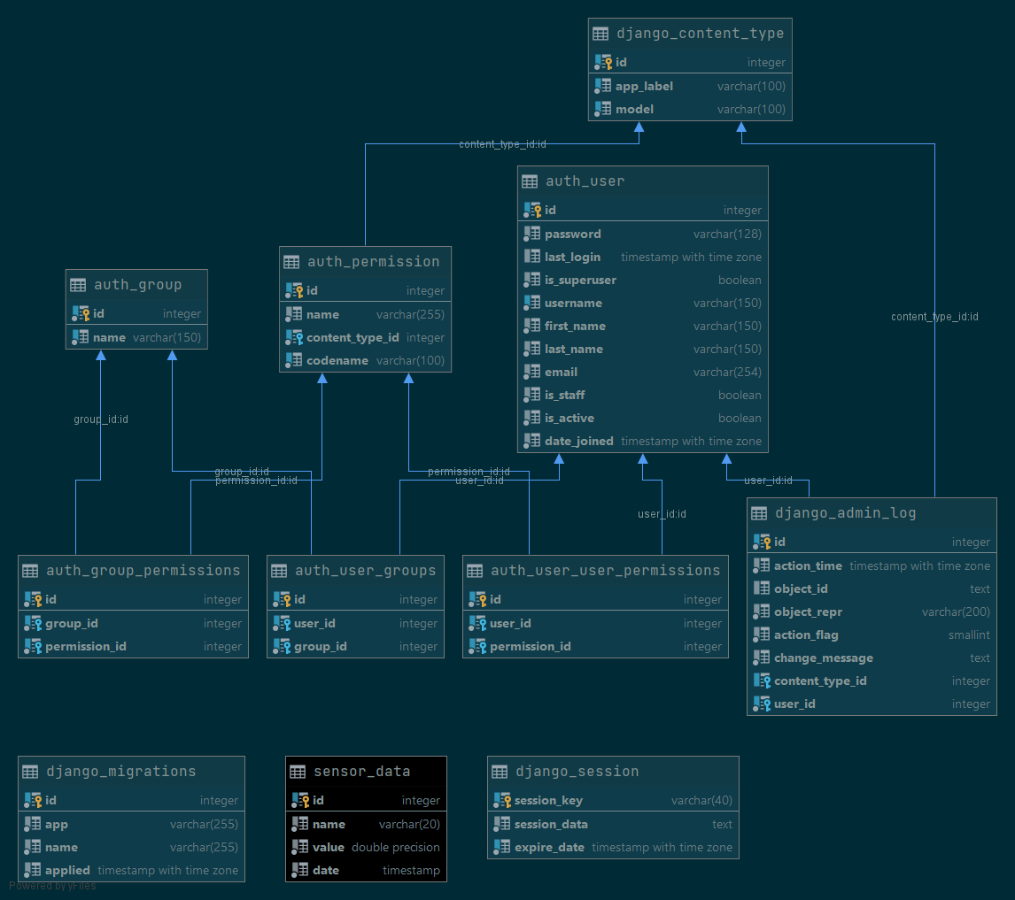

*Database schema visualization*

Apart from all the tables required for the proper function of the initialized Django app (cyan), the table <sensor_data> (black) is responsible for storing the metrics data and it is built according to the following structure: it has a primary key "id", the name of the sensor and the corresponding value, as well as the datetime (with precision of milliseconds) of measurement. The data types of the fields are displayed on the right column.

f) Implementation Concept

The application will be developed for the Windows10 OS

As mentioned before, the server will be implemented with the Django web-framework which is based on python. Thus, it enables the usage of essential libraries for data analytics purposes such as NumPy, pandas and matplotlib and web-based services are implemented with the Django rest-framework library, a powerful and flexible toolkit for building Web APIs.

The Django server starts with the command: **python manage.py runserver** <device_IP>:<port> (default values for IP and port are 127.0.0.1 and 8000 correspondingly).

The app which is responsible to handle the client’s http requests is called <api> and it was initialized with the command: **python manage.py startapp api.**

While the server is running, we can access the URL for this app on [**http://127.0.0.1:8000/api/**](http://127.0.0.1:8000/api/).

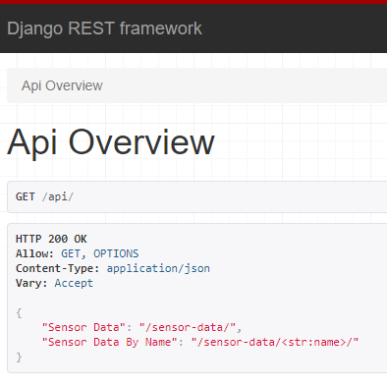

*http://127.0.0.1:8000/api/*

As shown in the image above, two services were implemented in order to handle incoming http GET requests from the client.

"Sensor Data": [**http://127.0.0.1:8000/api/sensor-data/**](http://127.0.0.1:8000/api/sensor-data/)

while the server is connected to the database, it queries the <sensor_data> table and fetches the last record stored.

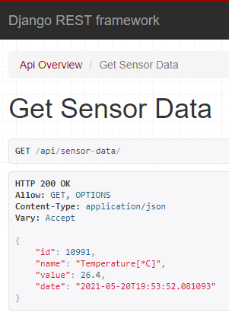

*http://127.0.0.1:8000/api/sensor-data/*

"Sensor Data By Name": [**http://127.0.0.1:8000/api/sensor-data/<str**](http://127.0.0.1:8000/api/sensor-data/%3cstr)**:name>/**

while the server is connected to the database, it queries the <sensor_data> table and fetches the last measurement of a given sensor (by name). For instance, the last measurement made by the humidity sensor can be displayed by accessing the following url: [**http://127.0.0.1:8000/api/sensor-data/Humidity/**](http://127.0.0.1:8000/api/sensor-data/Humidity/)

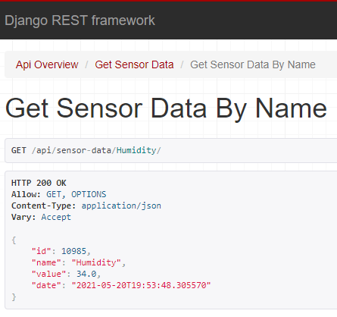

*http://127.0.0.1:8000/api/sensor-data/Humidity/*

Testing the API (Postman)

To test the API built on the server we are going to use Postman, a software designed for API testing and management. It offers a sleek user interface with which to make HTML requests, without the hassle of writing a bunch of code just to test an API's functionality.

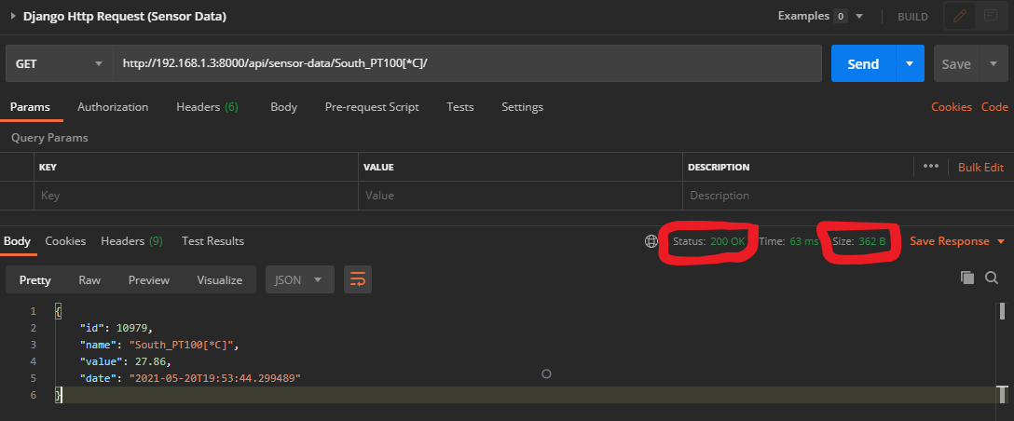

*Testing API on Postman*

As shown in the picture above, the response status code is 200, thus the http request is performed and served successfully with a response in JSON format, according to the model of the sensors, defined on the server and structured correspondingly in the database. The size of the response object is approximately 360 Bytes depending on the sensor name. The "id", "value" and "date" fields will always have the same fixed data size.

Testing inside Unity (client)

Now we are going to test the API from inside the Unity app itself. Thus, we created an interactive user interface where the user can modify the URL string for the http request. The response data is displayed as a JSON object on the canvas, as well as the http status code, for further troubleshooting in case of errors or unexpected network behaviours.

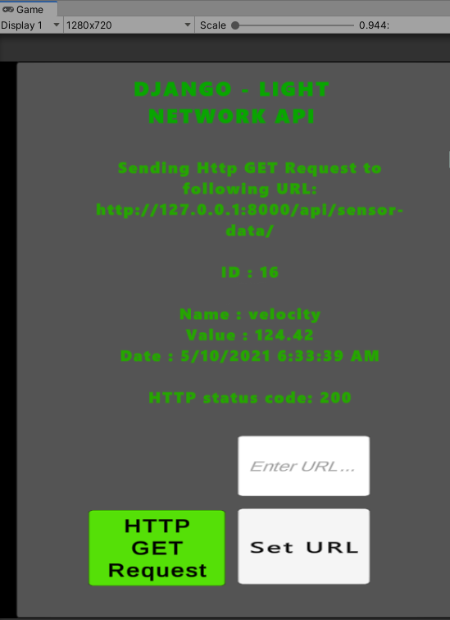

*Unity Game View (Testing Sensor Data API)*

As shown above, after testing the api on the client side, we receive the requested data and the http status code is 200, resulting to a successful http request.

Finally we can conclude that the unity client will be able to get updated sensor data with the expected rate (every 2 seconds).

All the software which is related to the server’s function can be found on the following link: [**https://github.com/Chris9292/Django-Light**](https://github.com/Chris9292/Django-Light)

#### Raspberry Pi

a) Purpose

* To continuously transmit the sensor data and camera view to the server
* To ensure the proper function of the sensors and report it in case of malfunction.

b) Block Diagram

The block diagram of the electronics box/weather station can be seen below. This specific diagram shows the data connections between each module of the electronics.

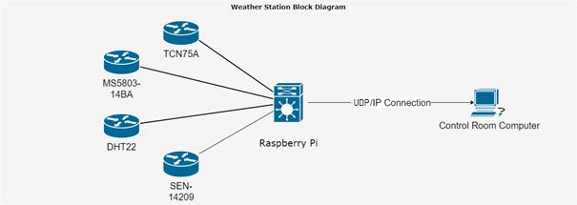

Another more detailed diagram is shown again, with the function of each sensor visualized:

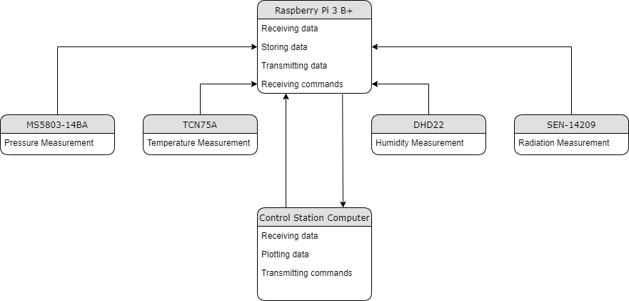

The control station server will be responsible for the initialization of the raspberry pi and the sensors.

c) External Interfaces

The Raspberry Pi software will communicate with other devices via Ethernet. There will be an active UDP/IP connection, which will stream the data from the sensors and the camera feed to the laptop in the control room.

The software will acquire data from the sensors through their respective cables.

d) Implementation Concept

The source code of the software will be written in python.

## Data Management

### Data Management Concept

The main source of data in our project is the weather station. It collects environmental data from sensors, specifically temperature, gamma radiation, as well as video feed from a camera. The sensor data are transmitted over UDP/IP to a Laptop in the control room, where they are stored locally for analytical purposes. Lastly, the data are retransmitted over UDP/IP to the HoloLens Smartglasses (HLS) in order to be displayed. The exact same procedure is followed for the camera feed.

### Data Budget

**1. Weather Station**

|  |  |  |  |
| --- | --- | --- | --- |
| **Item** | **Data [kbps]** | **Margin**  **[%]** | **Data with Margin [kbps]** |
| Temp. sensor  PT100 | 0.912 | - | 0.912 |
| Radiation sensor SEN-14209 | 0.888 | - | 0.888 |
| ADS1115 ADC | 3.664 | - | 3.664 |
| DHT22 | 0.888 | - | 0.888 |
| Camera MOBOTIX S16B DualFlex | 245.76 | 10 | 270.336 |
| **Total** | 252.112 | - | **276.688** |

The total estimated data rate generated by the operation of the Weather Station is approximately **277** kbps, which complies with the network constraints given by Space Innovation ( < 300 Kbps during testing phase).

**2. Server (Control Room Laptop)**

|  |  |  |  |
| --- | --- | --- | --- |
| **Item** | **Data [Kbps]** | **Margin**  **[%]** | **Data with Margin [kbps]** |
| Camera (Retransmission) | 720 | 20 | 864 |
| Sensor Data API | 3200 | 2 | 3264 |
| **Total** | **3920** | **-** | **4128** |

Control Room and Client estimated maximum data throughput: **4128** kbps

## Project Verification and Test Planning

For our project we will use the following four verification methods:

**1. Testing (T)**

The requirement is verified by performing a test.

**2. Inspection (I)**

The requirement is verified by only inspecting (=looking) at it

**3. Analysis of similarity (A)**

The requirement is verified by running it in a similar way to the real condition (e.g., running a simulation). If one subsystem is similar to another, one can state that if one was tested and works, the other one works as well.

**4. Review of design (R)**

The requirement is verified by design documents, such as technical drawings and schematics.

### Verification Matrix of the Requirements

At the following table one could see the tests that need to be done in order to verify the functionality of our system. Several requirements need to be met, for our system to operate adequately.

|  |  |  |  |
| --- | --- | --- | --- |
| **No.** | **Description** | **Verification by Status**  **(T, I, A, R)** | **Status** |
| Fun-1 | The sensors shall measure temperature and radiation | R | Done |
| Fun-1.1 | The data shall be transmitted from the testbench location to the control room through E-link connection | T, A | Done |
| Fun-1.2 | The data collected shall be retransmitted to the HLS through WiFi connection | T, A | Done |
| Fun-2 | The camera shall record live footage of the box’s surroundings | R | Done |
| Fun-2.2 | The data shall be transmitted from the testbench location to the control room through E-link connection | T, A | Done |
| Fun-2.3 | The video feed from the camera collected shall be retransmitted to the HLS through WiFi connection | T, A | Removed |
| Fun-3 | The weather station shall be operational in extremely low and high temperatures, be waterproof, and be able to withstand high levels of radiation | T | Done |
| Fun-4 | HLS shall visualize the collected data into its graphic environment | I | Done |
| Fun-5 | The HLS shall provide the user with different capabilities through a graphical environment | R | Done |
| Fun-5.1 | The HLS shall provide some capabilities which require limited or zero user interference | R | Done |
| Fun-5.1.1 | The HLS shall suggest possible routes and guide the user through them | T, A | Done |
| Fun-5.1.2 | The HLS shall automatically track the user’s path and allow the creation of new routes | T, A | Done |
| Fun-5.1.3 | The HLS shall assist the user with the repair of faulty equipment | T | Done |
| Fun-5.2 | The HLS shall provide some capabilities which require user interference/input | R | Done |
| Fun-5.2.1 | The HLS shall be able to project a map of the area as well as the position of the user and the holograms | I | Done |
| Fun-5.2.2 | The HLS shall allow the user to place holograms which are able to contain information (e.g., route waypoints) | T, A | Done |

|  |  |  |  |
| --- | --- | --- | --- |
| **Req. No.** | **Description** | **Verification by**  **(T, I, A, R)** | **Status** |
| Per-1 | The sensors shall measure the following phenomena within range:  Temperature: 95-395K  Gamma Rays: 5-1000keV | T | Done |
| Per-1.1 | The raspberry Pi shall be equipped with a 36GB SD card | I | Done |
| Per-1.2 | The data from the weather-box shall be transmitted with a <10 Kbps speed | T, A | Done |
| Per-1.3 | The data shall be transmitted from the control room to the HLS through WiFi, with the speed of <5 Mbps | T, A | Done |
| Per-2 | The video feed from the camera shall be transmitted with a speed of <290 Kbps | T, A | Done |
| Per-2.1 | The video feed from the camera shall be transmitted from the control room to the HLS through WiFi, with a speed of <290 Kbps | T, A | Done |
| Per-3 | The temperature inside the box shall always be between -20 to 40 degrees C | T | Done |
| Per-3.1 | The box shall be reinforced with enough aluminum to block the lunar cosmic radiation levels | T | Done |
| Per-3.2 | The box shall be completely waterproof | T | Done |
| Per-4 | The HLS shall visualise the transmitted data within 3 sec to the user | T, A | Done |
| Per-5 | The graphical interface and various holograms shall be renewed in the HLS with the frame rate of 60 frames per sec | T | Done |

|  |  |  |  |  |
| --- | --- | --- | --- | --- |
| **No.** | **Description** | **Verification by**  **(T, I, A, R)** |  | **Status** |
| Int-1 | The student project Shall fit into the dimensions inside the habitat defined by the Space Innovation | R |  | Removed |
| Int-1.1 | Team’s control room setup shall fit the dimension requirements defined by the Space Innovation | R |  | Removed |
| Int-1.2 | Team’s exhibition setup shall fit the dimension requirements defined by the Space Innovation | R |  | Removed |
| Int-2 | The soil on the test bed shall be penetrable for the weather box to be mounted on it | A |  | Done |
| Int-3 | The E-link setup shall fit the data budget and speed specifications given by Space Innovation | A |  | Done |

|  |  |  |  |
| --- | --- | --- | --- |
| **No.** | **Description** | **Verification by**  **(T, I, A, R)** | **Status** |
| Saf-1 | The guest should be asked about any underlying medical conditions that might prove harmful by the HLS experience | A | Done |
| Saf-1.1 | The guest shall be properly supervised and notified in order to avoid collisions with physical boundaries and other items of the specified space | A | Done |
| Saf-2 | The raspberry’s power supply shall not exceed the suggested value | T | Done |
| Saf-2.1 | The fan of the poe hat should go off if temperature exceeds 45 degrees C | T | Done |

### Test Plans

|  |  |  |
| --- | --- | --- |
| **Test number** | **Test name** | **Completed (Yes / No)** |
| Elec-1.1 | Temperature sensor test | Yes |
| Elec-1.2 | Radiation sensor test | Yes |
| Elec-1.3 | Raspberry Pi functionality test | Yes |
| Elec-1.4 | Camera functionality test | Yes |
| Elec-1.5 | Weather station component coordination | Yes |
| Elec-1.6 | Weather station data-transfer | Yes |
| Elec-1.7 | Weather station complete functionality test | Yes |
| Mech-1.1 | Weight verification | Yes |
| Mech-1.2 | Dimensions measurement | Yes |
| Mech-1.3 | Thermal insulation test | Yes |
| Mech-1.4 | Cosmic ray protection | Yes |
| Mech-1.5 | Waterproofing | Yes |
| Soft-1.1 | HoloLens nominal operation test | Yes |
| Soft-1.1.1 | HoloLens response test | Yes |
| Soft-1.1.2 | HoloLens calibration test | Yes |
| Soft-1.1.3 | HoloLens remote connection test | Yes |
| Soft-1.2 | Navigation module functionality test | Yes |
| Soft-1.2.1 | Path and guideline visualization test | Yes |
| Soft-1.2.2 | Static path calculation test | Removed |
| Soft-1.2.3 | Dynamic path calculation test | Yes |
| Soft-1.3 | Repair module functionality test | Yes |
| Soft-1.3.2 | Repair Guidelines test | Removed |
| Soft-1.4 | Main Menu complete operation test | Yes |
| Soft-1.4.1 | Holographic placement module test | Yes |
| Soft-1.4.2 | Map module test | Yes |
| Soft-1.4.3 | Mission Log module test | Yes |

*The complete description of each test can be found in Annex section 7.4.7*

### Test Results

As of the time of writing, there are currently no test results.

## Project Equipment Needed

The experiment equipment is separated into 3 different sections.

- The testbench equipment

- The control room equipment

- The equipment needed to shoot the Virtual Field Campaign

Regarding the testbench equipment, the team is going to need compatible power and E-link connection, as well as the Weather Box, which includes a RaspberiPi, two cameras, four temperature sensors, a humidity sensor and a radiation sensor.

Regarding the control room equipment, we need a computer for our database. Furthermore, E-link ports and a router with WiFi are crucial in order to achieve TCP connections.

Regarding the Virtual Field Campaign, we need several pieces of equipment in order to shoot a small clip. These include two kino flo lights, some cameras, reflective polyesteryne to soften the light and a 6W generator to power everything. Also a van is needed in order to transfer the equipment to the shooting area.

It would also be helpful to have access to tools like:

* Equipment for soldering (Soldering iron, solder past, flux, etc.
* Construction tools (electric drill, Screwdrivers, hammers etc.)

## Outreach

**Webpage**

Here anyone can find detailed information about the team’s project. It covers, in depth, the scientific principles behind the projects and the technological properties of our experiments. It contains information about the competitions and institutions we participate in. Furthermore, details about our faculty and team members are provided. Lastly, any interviews, reports and events with similar interest are to be included.

You can find the link here: <http://beam.web.auth.gr/>

**Facebook**

The Facebook page serves as a communication medium with the team’s followers. Content about the progress of our project as well as interesting posts, including news of aerospace innovations and events, are published. The goal is to keep the general public in touch with our progress, as well as broaden the interest of people in space science.

You can find the link here: <https://www.facebook.com/beamauth/>

**Instagram**

Within this platform the team focuses more on its progress through “instastories” and posts, providing a more “fun” and appealing view of the team’s experience throughout this process. Posts containing a more personal point of view shall guide them through the project, not only by its strictly scientific nature, but also through the whole journey behind it.

You can find the link here: [@beamauth](https://www.instagram.com/beamauth/)

**Articles and Mentions**

Some Greek media that have written articles about BEAM and its projects (such as LIGHT, LIGHT2 and more)

* *TITLE:* “AUTH students are strongly entering the field of space science”  
  [*https://www.voria.gr/article/fitites-tou-apth-mpenoun-dinamika-ston-choro-tis-diastimikis*](https://www.voria.gr/article/fitites-tou-apth-mpenoun-dinamika-ston-choro-tis-diastimikis?fbclid=IwAR0b2_-DXVWCgX_IWJKqwdLY1mSWik4U_Y3qoZAZVdCzRlXtFkPax2SnSgY)
* *TITLE:* “AUTH students are trying their capabilities in the field of space science” [*https://www.google.com/amp/s/www.skai.gr/news/technology/omada-veam-foitites-tou-apth-dokimazoun-tis-dynameis-tous-stin-texnologi%25CC%2581a-tis-diastimi/amp*](https://www.google.com/amp/s/www.skai.gr/news/technology/omada-veam-foitites-tou-apth-dokimazoun-tis-dynameis-tous-stin-texnologi%25CC%2581a-tis-diastimi/amp?fbclid=IwAR0eVagER-04-oaPFIBa9JgPKjAN_jcgCFryoydxb_Q_52SXDuvk59mG2bU)
* *TITLE:* “The student research team of AUTH students is innovating in space technology”
* [*https://www.google.com/amp/s/www.in.gr/2020/07/02/tech/veam-ereynitiki-omada-foititon-tou-apth-pou-kainotomei-sti-diastimiki-texnologia/amp/*](https://www.google.com/amp/s/www.in.gr/2020/07/02/tech/veam-ereynitiki-omada-foititon-tou-apth-pou-kainotomei-sti-diastimiki-texnologia/amp/?fbclid=IwAR3WrNNPVBr-KUNcxmAjjDzamT0tRLSbAZ-1oeNKN1PP_XZ2ZuLBEtHPFYw)
* *TITLE:* “AUTH students are strongly entering the field of research in space technology”  
  [*https://www.google.com/amp/s/www.pagenews.gr/2020/07/02/epistimi-texnologia/foitites-tou-apth-mpainoun-dynamika-ston-xoro-tis-ereunas-stin-texnologia-tis-diastimikis/amp/*](https://www.google.com/amp/s/www.pagenews.gr/2020/07/02/epistimi-texnologia/foitites-tou-apth-mpainoun-dynamika-ston-xoro-tis-ereunas-stin-texnologia-tis-diastimikis/amp/?fbclid=IwAR0cguQaJtGtJzYgPKLwjQvsZnUkjEY4jtSdjSZi79s7X8XJ_v9g8qPircU)

## Further Business Model Strategies

### SWOT Analysis

|  |  |  |
| --- | --- | --- |
|  | Positive factors | Negative factors |
| Internal Factors | **STRENGTHS**   * Continuation of IGLUNA2020 project LIGHT2 * Established relationships with sponsors * Sufficient number of team members in each department * Available working space and equipment in the university | **WEAKNESSES**   * Lack of AR/MR knowledge * Lack of excess free time due to university and work responsibilities |
| External Factors | **OPPORTUNITIES**   * Knowledge obtainment * CV advantage * Connection with experts * Acquirement of cooperation skills | **THREATS**   * Unpredictable restrictions due to Covid-19 * Inability to meet deadlines * Financial delays with sponsorships / Bureaucracy * Team mis-cooperation |

### Sponsoring and strategic partnership

As a team we act on working with sponsors which will provide us with the necessary components for our project. We have already established contact with some well-known companies in Greece, which support our work.

At the same time the university stands by our side by offering workshops and some financial resources.

### Academic Support

|  |  |  |  |
| --- | --- | --- | --- |
| **Partner** | 01 | **Date of signature** | General Partner |
| **Institution** | Aristotle University of Thessaloniki | | |
| **Type of support**  -Technical: We have access to the labs and equipment.  -Knowledge: We have established connections with professors working in different departments and fields.  -Outreach: We have good cooperation with the outreach department of the University in a way that benefits both parties.  -Work Space: We have already acquired a room and lab only for the needs of our projects. | | | |
| **Future support**  The nature of our relationship with the University benefits their party greatly, therefore the success of our experiment is essential to them as well. Additionally, there is constant communication in order to avoid and manage any potential problem. | | | |

|  |  |  |  |
| --- | --- | --- | --- |
| **Sponsor / Partner** | 02 | **Date of signature** | 15/02/2019 |
| **Company / Institution** | Research committee of Aristotle University | | |
| **Type of support**  -Financial: They are the 2nd Golden Sponsor of our team. | | | |
| **Future support**  Their support is only financial, and we have already established that they are going to continue sponsoring our team’s future projects. | | | |

### Industrial Support

|  |  |  |  |
| --- | --- | --- | --- |
| **Sponsor / Partner** | 03 | **Date of signature** | 18/03/2019 |
| **Company / Institution** | Hellenic Aerospace Industry | | |
| **Type of support**  -Knowledge: Their experienced personnel have already helped our team with various questions in different fields. | | | |

|  |  |  |  |
| --- | --- | --- | --- |
| **Sponsor / Partner** | 04 | **Date of signature** | 03/05/2019 |
| **Company / Institution** | CERTH (Centre for Research and Technology – Hellas) | | |
| **Type of support**  -Knowledge and equipment: We have already established connections with them in the past using equipment we needed. | | | |
| **Future support**  They already have multiple AR projects, mainly training programs focused on medicine. That being said, they might provide us with great knowledge support in the future. | | | |

|  |  |  |  |
| --- | --- | --- | --- |
| **Sponsor** | 05 | **Date of signature** | 01/02/2019 |
| **Company** | Beta CAE Systems | | |
| **Type of support**  -Financial: They are one of our 2 Golden Sponsors. Both of them provide us with a sufficient budget that covers more than the essential expenses in case of unfortunate miscalculations.  -Knowledge: Beta CAE systems is a company developing software with huge success. They value the work of teams like us and care for the next generation engineers. They have already provided us with seminars and they are always positive to share their knowledge. | | | |
| **Future support**  The company is going to keep supporting the team the same way. We hope that our proven trust and professionalism will continue to secure us their precious help. | | | |

# SD REVISIONS

## Preliminary Design Review [PDR]

**Comments/Solutions**

**C:** *“RID Concept for COVID19? - Desinfection of the Helmet after every use? (e.g. 2.1.4 Safety Requirements)” - Mr. Andreas Baumann-Ouyang*

**S:** Added safety Covid-19 safety requirements for the Field Campaign.

**C:** *“Make the expected results measurable. you could e.g. ask the participants to answer a short questionnaire after using your system. set your expected level of satisfaction for the user group already now and work towards that. also for the other expected results you can go more into detail.” - Mr. Manuel Gerold*

**S:** Created a questionnaire for the Field Campaign and Testing

**C:** *“FWIW, consider double-tap instead of tap and hold for toggling menu.” - Mr. Victor Luo*

**S:** Added double-tap interaction to open the main menu.

**C:** *“Consider a combination of gaze and voice for faster navigation of menu.” - Mr. Victor Luo*

**S:** Implemented a “focus” interaction.

**C:** *“Overall Abstract section too techy. What is 'hologram placement module', 'call base module'. Try to explain in common terminology so that someone who is not familiar with AR technology or this program can understand what it means.” - Mr. Victor Luo*

**S:** Redesigned the Abstract Section.

**C:** *“WaterProofing the test bed is not addressed and it could lead to huge issues.” - Dr. Sylvain Cardin*

**S:** Added waterproofing.

**C:** *“Have you thought about the redundancy for the sensors? What if one (or all) sensors is broken.” - Dr. Andrea Casini*

**S:** Included at least two sensors of each kind in the final build.

**C:** *“Add most important timestamps to your timeline” - Mr. Manuel Gerold*

**S:** Added multiple milestones from February through July.

**Other Changes**

Completely redesigned the Business Model Canvas.

Made various formatting changes.

## Critical Design Review [CDR]

**Comments/Solutions**

**C:** *“Will there by any form of user testing (outside your team) to measure usability and subjective satisfaction?”* *Ms. Nicole Majska*

**S:** Conducted a 10-15 people user testing with generally positive feedback.

**C:** *“Chap 2.1: Too many TBDs in your requirements for CDR stage.” Mr. Manuel Gerold*

**S:** All the TBDs are filled in the RR.

**C:** *“Team mis-cooperation => describe the collaboration tools you use in the team to stramline planning in more detail. Communication: Teams / Slack? Code: GitHub? Telephony: Teams / Zoom? Taskboard: Trello? Brainstorming: Miro?”* *Mr. Marko Bublic*

**S:** Added Team Collaboration Section.

**Other Changes**

Added information for the virtual field campaign.

Removed the call base functionality and changed the video feed to single image due to data budget constraints.

Added multiple pictures from development phase.

Made various formatting changes.

## Readiness Review [RR]

**Core Changes**

**C:** “*Please specify if using Microsoft HoloLens 1 or 2”* *Ms. Nicole Majska*

**S:** Cleared up the sections were Hololens 2 was mentioned, especially the SWOT section (2.14.1). It is now clearer that we are using Hololens 1.

**C:** *”Update the abstract: According to your presentation, you decided to join the virtual field campaign and not the on-site one. Clarify this in the abstract.”* *- Mr. Andreas Baumann-Ouyang*

**S:** Remoced the section about the physical Exhibition and replaced it with Virtual Field Campaign. Also cleared things up in other sections.

**C:** *“Finances: the numbers dont fit. the first three columns the total profit are consecutive, i.e. PDR. +6000, CDR -787.53 + PDR = 5212.47. however in CDR you only have -430.” - Mr. Andreas Baumann-Ouyang*

**S:** Fixed the budget calculations and added the cost of shooting the Virtual Field Campaign.

**C:** *“Clarify in the documentation which parts of the field campaign are still valid and which one are replaced with the virtual one. e.g. chapter 2.12 – equipment”* *- Mr. Andreas Baumann-Ouyang*

**S:** Updated the 2.12 Project Equipment section to better reflect the equipment we used.

**Smaller Changes / Clarifications**

**C:** *“Information on the first page was not updated:” Mr. Marko Bublic*

**S:** Updated in this document.

**C:** *“Virtual Field campaign: why is the "Aristotle film school of thessaloniki" in (...)?”Mr. Andreas Baumann-Ouyang*

**S:** Fixed typing error.

**C:** *“Chapter 1.10: You mentioned the decision to not include object detection and refer for more details to a "reference" which is not clarified.” Mr. Andreas Baumann-Ouyang*

**S:** Fixed typing error and split the paragraphs.

**C:** *“"The capabilities being offered will be integrated through a corresponding User Interface (UI) and User Experience (UX)." - UI is what the user interacts with, UX is how the user feels about the interaction. Make sure to understand and distinguish the difference.” Ms. Nicole Majska*

**S:** Cleared up sentences in section 2.9.6 were we hade erroneously used the term “UX”.

**C:** *“UX missing from list of abbreviations” Ms. Nicole Majska*

**S:** Added.

**C:** *“From a UX perspective, have you thought about including names in the main menu UI, as displaying just icons may not satisfy user UX needs and may be confusing.” Ms. Nicole Majska*

**S:** Clarification: There are tooltips when gazing at icons for a short duration as mentioned in 2.9.6.1 paragraph c bullet 5.

**C:** *“Clarification of the images: are these real visualizations as implemented in the hololens or drafts? a description of each figure would be good.” Mr. Andreas Baumann-Ouyang*

**S:** These are real images from the application. Added note at the start of the paragraph.

**C:** *“You state that: changes can be found in annex sec. 3.2 (could only find project management there). please clarify.” Mr. Manuel Gerold*

**S:** Removed the “annex” word to avoid mixup. Meant to reference this section (aka 3.2) and not the annex section 3.2 (aka 7.3.2).

# ABOUT THE TEAM

### Point of Contact

**Facilities address:**

Aristotle University of Thessaloniki, Faculty of Engineering

Str. Egnatia 147, 54124, Thessaloniki, Greece.

**In charge of communication:**

Name: Kolovou Katerina

Email: [katkolovou9988@gmail.com](mailto:katkolovou9988@gmail.com)

Phone number: +00306976810030

### Team Structure Overview

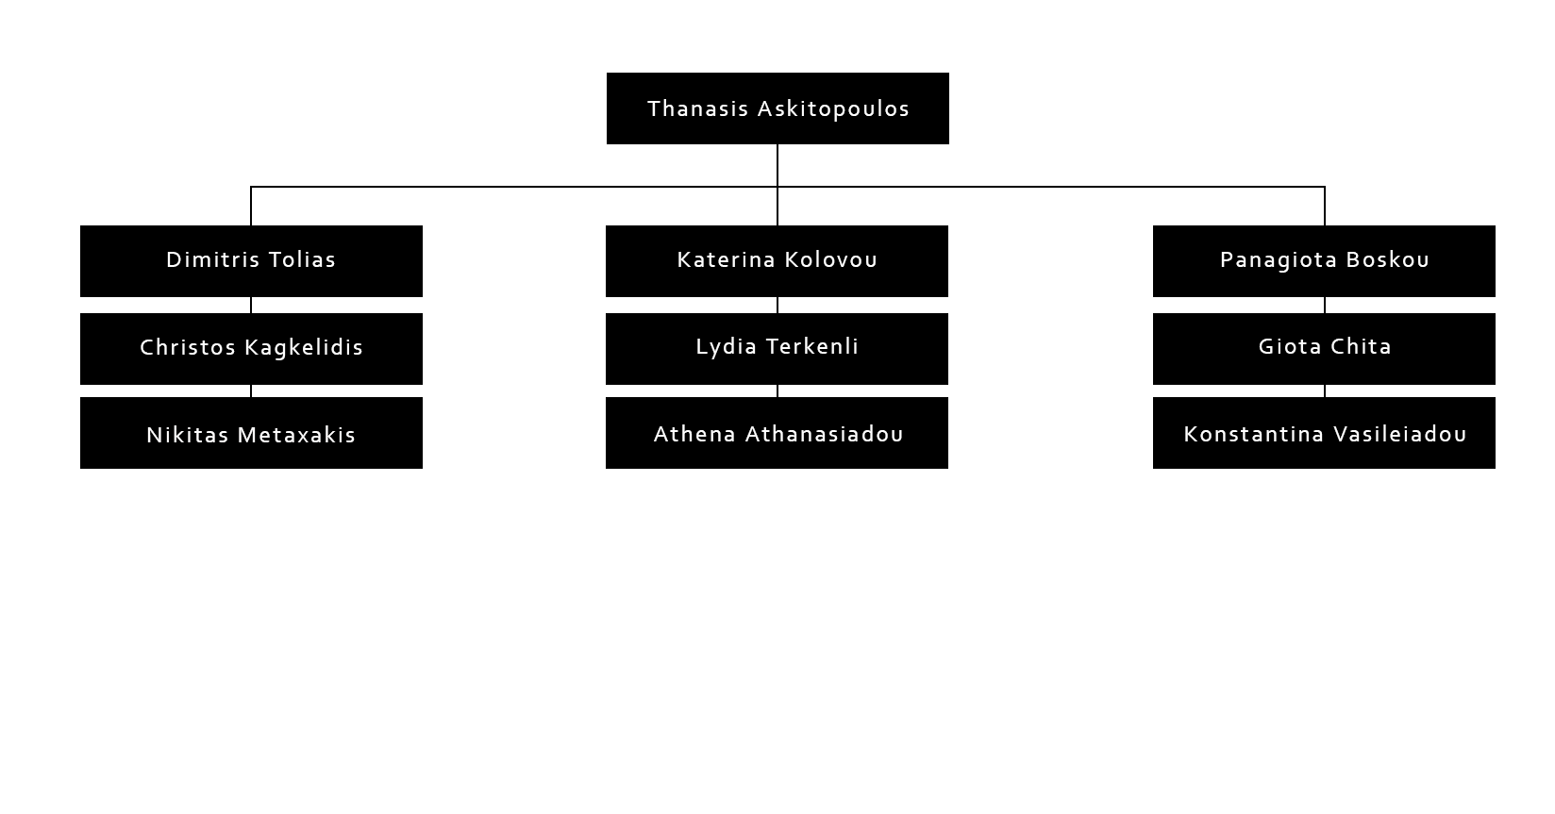

### Team Members

|  |  |  |
| --- | --- | --- |
|  | **Name:** | Thanasis Askitopoulos |
| **Mail:** | askhths97@gmail.com |
| **Responsibility:** | Project Management,Software Development |
| **Education reached:** | High School |
| **Current education:** | Meng Electrical Engineering |
| **Workload:** | 15h/week |
| **Thesis or course name:** | - |
| **Other interests:** | Cinema,Sci-Fi, Tennis |

|  |  |  |
| --- | --- | --- |
|  | **Name:** | Dimitris Tolias |
| **Mail:** | toliasdimitris@gmail.com |
| **Responsibility:** | Software Development |
| **Education reached:** | High School |
| **Current education:** | Meng Electrical Engineering |
| **Workload:** | 10h/week |
| **Thesis or course name:** | - |
| **Other interests:** | Guitar, Snowboarding, Reading |

|  |  |  |
| --- | --- | --- |
|  | **Name:** | Christos Kagkelidis |
| **Mail:** | xrh555@gmail.com |
| **Responsibility:** | Software Development |
| **Education reached:** | High School |
| **Current education:** | Meng Spatial planning and Development |
| **Workload:** | 10h/week |
| **Thesis or course name:** | - |
| **Other interests:** | Music, Programming |

|  |  |  |
| --- | --- | --- |
|  | **Name:** | Giorgos Papadopoulos |
| **Mail:** | Gpdc0021@gmail.com |
| **Responsibility:** | Software Development |
| **Education reached:** | High School |
| **Current education:** | Meng Electrical Engineering |
| **Workload:** | 6h/week |
| **Thesis or course name:** |  |
|  | **Other interests:** | Reading books, Music |

|  |  |  |
| --- | --- | --- |
|  | **Name:** | Panagiota Boskou |
| **Mail:** | pmposkou@physics.auth.gr |
| **Responsibility:** | Electronics engineering |
| **Education reached:** | High School |
| **Current education:** | BS Physics |
| **Workload:** | 10h/week |
| **Thesis or course name:** | - |
| **Other interests:** | Violin, Skiing |
|  |  |  |

|  |  |  |
| --- | --- | --- |
|  | **Name:** | Giota Chita |
| **Mail:** | xhgiota@gmail.com |
| **Responsibility:** | Electronics Engineer |
| **Education reached:** | High School |
| **Current education:** | Meng Electrical Engineering |
| **Workload:** | 10h/week |
| **Thesis or course name:** | - |
| **Other interests:** | track and field, travelling |

|  |  |  |
| --- | --- | --- |
|  | **Name:** | Konstantina Vasileiadou |
| **Mail:** | konstanvd@ece.auth.gr |
| **Responsibility:** | Electronics Engineer |
| **Education reached:** | High School |
| **Current education:** | Meng Electrical Engineering |
| **Workload:** | 10h/week |
| **Thesis or course name:** | - |
| **Other interests:** | Painting, Astronomy |

|  |  |  |
| --- | --- | --- |
|  | **Name:** | Katerina Kolovou |
| **Mail:** | katkolovou9988@gmail.com |
| **Responsibility:** | Exhibition Design, Graphics  Design |
| **Education reached:** | High School |
| **Current education:** | Meng Architectural engineering |
| **Workload:** | 10h/week |
| **Thesis or course name:** | - |
| **Other interests:** | Graphic Design, Music, Series |

|  |  |  |
| --- | --- | --- |
|  | **Name:** | Terkenli Lydia |
| **Mail:** | lterkenli@gmail.com |
| **Responsibility:** | Exhibition Design, Graphics  Design |
| **Education reached:** | High School |
| **Current education:** | Meng Architectural engineering |
| **Workload:** | 10h/week |
| **Thesis or course name:** | - |
| **Other interests:** | Cycling, Reading, Travelling |

|  |  |  |
| --- | --- | --- |
|  | **Name:** | Athena Athanasiadou |
| **Mail:** | Athanasiadouathena03@gmail.com |
| **Responsibility:** | Exhibition Design, Graphics  Design |
| **Education reached:** | High School |
| **Current education:** | Meng Architectural engineering |
| **Workload:** | 10h/week |
| **Thesis or course name:** | - |
| **Other interests:** | Dancing, Drawing, Travelling |

# LIST OF ABBREVIATIONS

|  |  |
| --- | --- |
| **Abbreviation** | **Description** |
| **AC** | Alternating Current |
| **ADC** | Analog-to-Digital Converter |
| **AR** | Augmented Reality |
| **ARM** | Advanced RISC Machine |
| **AI** | Artificial Intelligence |
| **AIT** | Assembly Integration Testing |
| **AUTH** | Aristotle University of Thessaloniki |
| **CDR** | Critical Design Review |
| **DC** | Direct Current |
| **E-link** | Ethernet Link |
| **EVA** | ExtraVehicular Activity |
| **FC** | Field Campaign (VFC: Virtual Field Campaign) |
| **GPU** | Graphics Processing Unit |
| **GUI** | Graphical User Interface |
| **HLS** | HoloLens Smartglasses |
| **HQ** | Headquarters |
| **IP** | Internet Protocol |
| **IPD** | Interpupillary Distance |
| **KO** | Kick Off meeting |
| **LAN** | Local Area Network |
| **PDR** | Preliminary Design Review |
| **PGA** | Programmable Gain Amplifier |
| **QR code** | Quick Response code |
| **RR** | Readiness Review |
| **Rev.** | Revision |
| **SD** | Student Documentation |
| **SD card** | Secure Digital card |
| **SDK** | Software Development Kit |
| **SWOT** | Strength, Weakness, Opportunities, Treats |
| **TBD** | To be determined / discussed / done |
| **TCP** | Transmission Control Protocol |
| **UDP** | User Datagram Protocol |
| **UI** | User Interface |
| **UPS** | Uninterruptible Power Supply |
| **USB** | Universal Serial Bus |
| **UWP** | Universal Windows Platform |
| **UX** | User Experience |
| **VFC** | Virtual Field Campaign |
| **VoIP** | Voice over Internet Protocol |
| **Wi-Fi** | Wireless Fidelity |

|  |  |
| --- | --- |
|  |  |

# REFERENCES

**[1]** <https://www.educative.io/edpresso/what-is-the-a-star-algorithm>

**[2]** <http://theory.stanford.edu/~amitp/GameProgramming/AStarComparison.html>

**[3]** Marquez J.J.,Human Automation Collaboration : Decision Support for Lunar and Planetary Exploration, Ph.D thesis, Massachusets Institute of Technology, 2007

**[4]** Waligora, J. M., and Horrigan, D. J., Section 2, Chapter 4: Metabolism and Heat Dissipation during Apollo EVA Periods,In R. S. Johnston, L. F. Dietlein, and C. A. Berry(Eds.),Biomedical Results of Apollo, NASA SP-368, Washington, DC: NASA, 1975, pp. 115-128.

**[5]** Santee, W. R., Allison, Blanchard, L. A., and Small, M. G., "A proposed model for load carriage on sloped terrain", Aviation, Space, and Environmental Medicine, 72(6), 2001.

**[6]** A. W. Johnson, J. A. Hoffman, D. J. Newman, E. M. Mazarico, and M. T. Zuber. An integrated Traverse Planner and Analysis tool for planetary exploration. In AIAA SPACE Conference and Exposition 2010, 2010. ISBN 9781600869662. doi: 10.2514/6.2010-8829.

**[7]** <https://github.com/microsoft/MixedRealityToolkit-Unity>

**[8]** <https://docs.microsoft.com/en-us/hololens/>

**[9]** <https://microsoft.github.io/MixedRealityToolkit-Unity/Documentation/WelcomeToMRTK.html>

**[10]** <https://holodevelopersslack.azurewebsites.net/>

# ANNEXES

## Lessons Learned

### Internal Lessons Learned

**Building Process**

During the development phase, we quickly identified the fairly slow process of building and deploying an application for testing. This task usually takes anywhere from 10 to 20 minutes and although this might not sound like a lot, one may easily recognize that if this is the only way of testing code it almost impossible to build any kind of application. Therefore, we used a built-in developer capability of HoloLens called Remote, which essentially feeds the Unity Editor solution to the Hololens via WiFi in real time. This comes with certain limitations though. First of all it is impossible to test an application without WiFi. Secondly, since the application is not built, we generally get a very poor performance resulting in bad frame rate and most importantly input lag. Thirdly, said capability oftentimes produces various bugs or behaves differently than the built solution.

All the above introduce another layer of development complexity. In order to confront these limitations, we decided upon a model where we separated the development of each functionality into three phases. During the first phase, we aim to completely develop the logic behind functionality, as well as make minor algorithmic optimizations. Testing during this phase is exclusively handled by the Remote capability. Moving on to the second phase, we aim to ensure that a built version of our application works as expected. During this time, we test various settings and search for troubleshooting guides, as most of the time a working Editor/Remote solution does not translate into the equivalent built solution. Lastly, when possible, we try to optimize our solution. Although building is the main focus of this phase, Remote is also used to quickly test any changes beforehand. Due to the time-consuming nature of this phase, it is seldom prioritized over more important core features.

### Lessons Learned with the Space Innovation

The single most important and almost life-changing lesson learned with the Space Innovation is the significance of good planning and meeting deadlines. Although, we generally managed to meet most of the deadlines, the ones we did not manage so well were the clearest indicators of things going south in the near future.

To our understanding, when a project gets larger both in the time scale (1 year in our case) and the people involved (10 people in the team + several other people via the Igluna organization, including coaches and experts), missing even a single deadline can cause an unfortunate domino effect which may take up to a month to get back in track. As a side-effect, during this time the need of constant communication is greatly amplified, causing unnecessary stress and frustration. Furthermore, everyone involved starts putting in extra time taken from other activities or personal time promoting a very unhealthy lifestyle and risking burnout. In this case, the whole experience becomes a lot less rewarding.

### Lessons Learned with other Project Teams

Unfortunately, we did not take the chance to work with other project teams, yet we now reckon that with better planning and communication a project may develop to something really extraordinary by taking advantage of the networking capabilities of the Igluna organization. If the Light project continues into the future this is something we would like to pay a lot more attention.

### Lessons Learned with sponsors

The most important lesson learned regarding the different sponsors we had throughout our journey, is that to our surprise individual people, companies and organizations were very eager to offer their help and at times even more than we could possibly have asked. This help would at times come in the form of free materials and devices and other times in the form of knowledge, advice, or very specific problem-solving skills.

### Lessons learnt during the Field Campaign

During the Virtual Field Campaign, we learned that the presentation of a project is almost as significant as the project itself. Without the proper presentation a team is unable to attract neither useful feedback nor new sponsors or team members and the continuation of its project may be put in jeopardy.

Consequently, given more experience, we would have paid more attention to the overall presentation and especially the cinematographic details of the final video like the lightning, the sound and a more proper scenario which would better attract the people watching. In retrospect, we understood that a good narrative is very important to capture the attention of the viewers and successfully present our project in a way that people will want to dig deeper into our work.

## General Output and Feedback

Through our testing phase we got the following feedback and ideas:

**Feedback**

No backgrounds in menus felt better than having backgrounds -> Removed backgrounds where it was possible

Navigation arrow was too big and its direction was not very clear

Some buttons and interactions were not very clear -> Added tooltips which appear after 2 seconds of staring

**Implemented Ideas**

Click to take photo instead of automatically taking photo after 3 seconds

Click to expand hologram photo (photo was too small to be seen by many)

## Project Management

### Work Packages Breakdown

### Project Plan

**Software**

**1 February – 10 April**

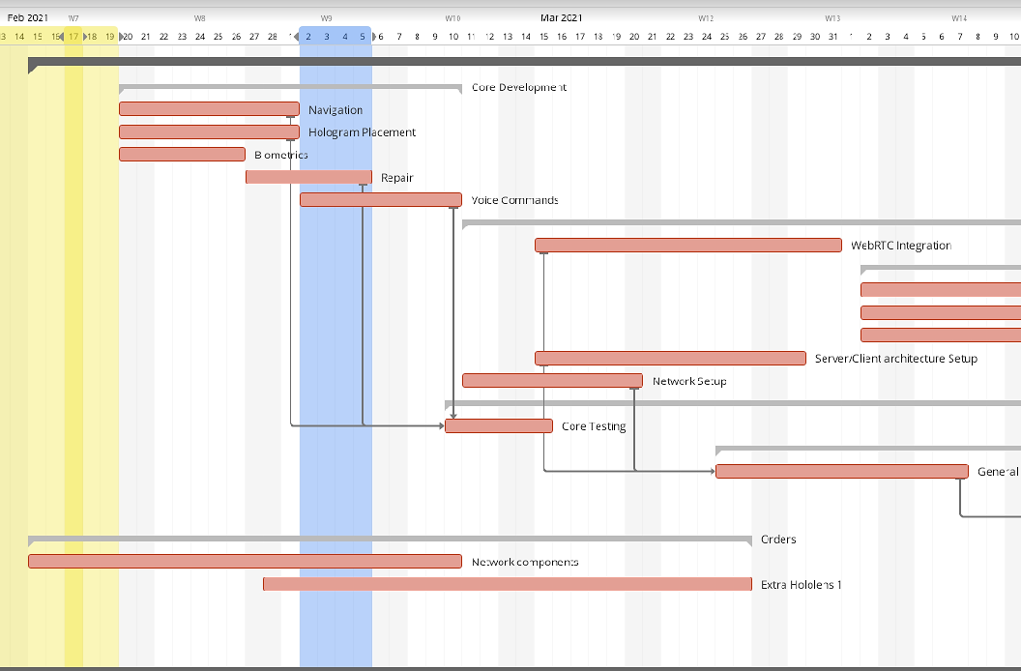

**10 April – 15 May**

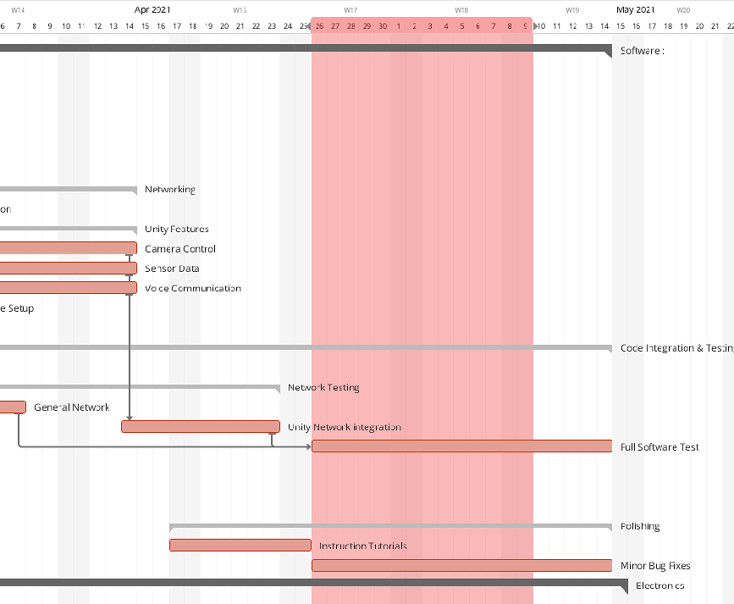

**Electronics**

**February 1 – March 15**

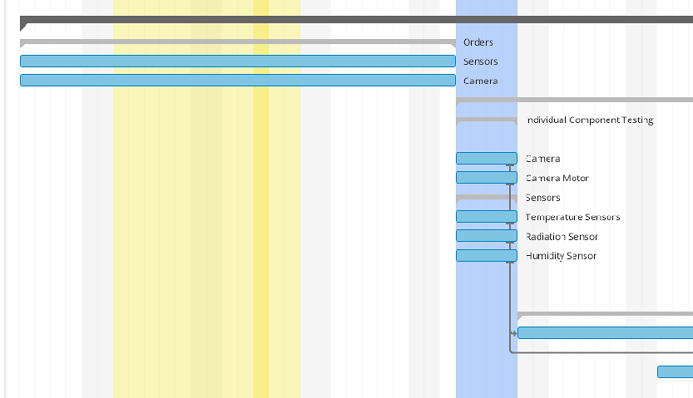

**March15 – May 1**

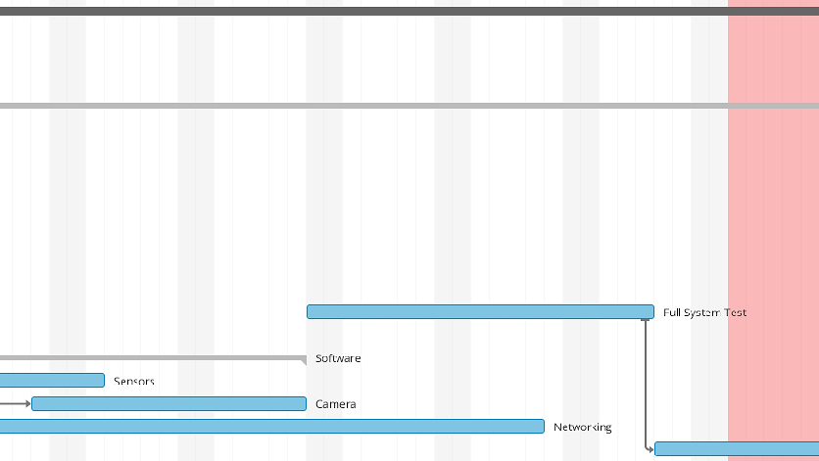

**May 1 – June 1**

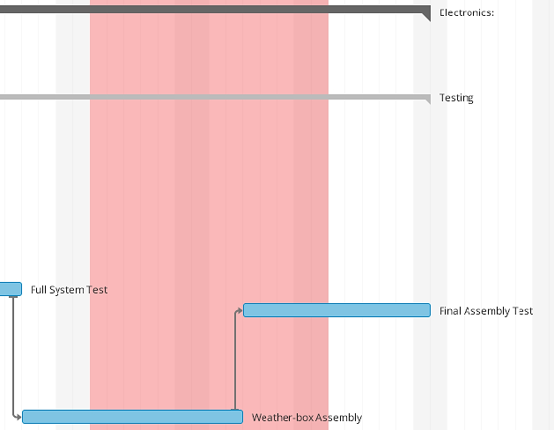

**Design**

**February 1 – 20 March**

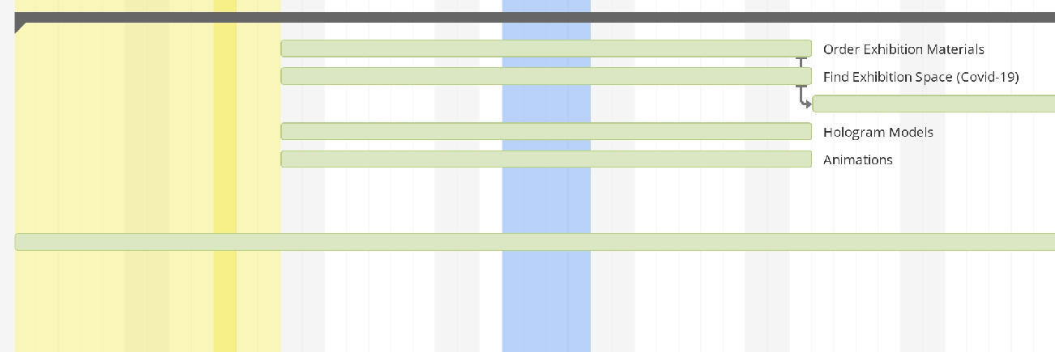

**20 March – 10 May**

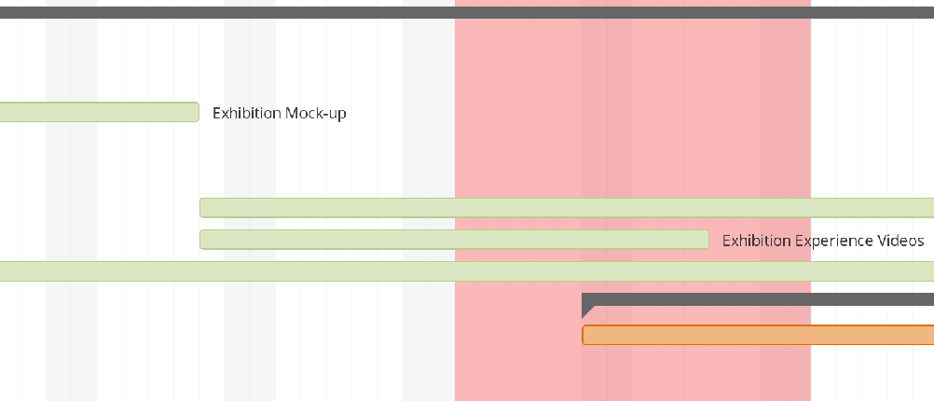

**10 May – 1 July**

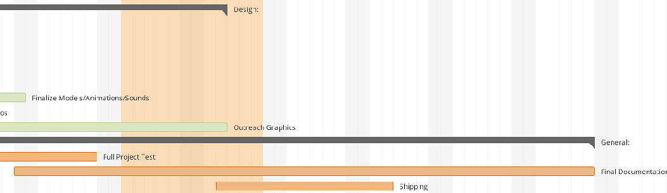

### SWOT Analysis

**STRENGTHS**

* Continuation of IGLUNA2020 project LIGHT

The fact that LIGHT2 is the continuation of the IGLUNA2020 LIGHT project, is giving us a head start in comparison to other teams. We already have feedback from experts and the Space Innovation, which has helped us shape LIGHT2 into a more completed and thought-out version of LIGHT.

* Established relationships with sponsors

The team already exists for two years and has completed projects for REXUS/BEXUS (Cycles 12 and 13) and IGLUNA2020, meaning that we have already found trustworthy sponsors, who are willing to continue supporting us.

* Sufficient number of team members in each department

Last year, the team was under-staffed even though they had set really ambitious goals. This year, we made sure to enlist enough members to ensure the accomplishment of our Field Campaign objectives.

* Available working space and equipment in the university

BEAM has its own workspace in the university, equipped with our own, high computing power PCs, thus providing LIGHT2 with a meeting space for the members and the technology required for the continuation of the project.

**WEAKNESSES**

* Lack of AR/MR knowledge

All of us are learning to work on AR/MR technology as the project goes on, which can be quite time-consuming.

* Lack of excess free time due to university and work responsibilities

All of us attend university courses and some of us are working, while also participating in LIGHT2. Tasks management should be carefully organized and take into consideration responsibilities non-related to LIGHT2.

**OPPORTUNITIES**

* Acquisition of space related knowledge and practical skills

Every new project is an opportunity to learn and challenge ourselves, in order to be more informed about technology and engineering, while developing soft skills. We understand the value of those experiences and want to make the most out of it.

* CV advantage

Participating in such a project is a great addition to our resumé, leading to more career opportunities in comparison to other students.

* Connection with experts

Despite the hands-on experience and theoretical knowledge, we also have the chance to meet experts of different scientific fields and learn from their experience. Advice from experts can motivate us to achieve better results in our projects and presentations.

* Cultivation of cooperation skills

Working in a team of 10 members will inevitably equip us with cooperation and communication skills which, otherwise, would be difficult to obtain.

**THREATS**

* Unpredictable restrictions due to Covid-19

Possible restrictions due to the pandemic is a threat that every team is facing. We are already trying to come up with solutions to potential problems, so that our project can keep running, even in unfavourable conditions.

* Inability to meet deadlines

Due to strict schedules and lack of free time, it is clear that the project’s deadlines are a threat. We tend to always have this in mind and organize ourselves as best as we can to avoid any delays.

* Financial delays with sponsorships / Bureaucracy

We work in a country where financial processes take longer than necessary. We have faced problems in the past when purchasing equipment or dealing with sponsors. It is a topic we are accustomed to and will face properly.

* Team mis-cooperation

This year’s team includes mainly new members who have not worked together before. It is possible that our cooperation will not go as smoothly as anticipated, but we are hopeful that we will overcome any communication and organization issues that might occur.

## Detailed Project Description

### List of Components

**Raspberry Pi 4 B+**

* Broadcom BCM2837B0, Cortex

-A53 (ARMv8) 64-bit SoC @ 1.4GHz

* Extended 40-pin GPIO header
* Gigabit Ethernet over USB 2.0

(maximum throughput 300 Mbps)

* USB 2.0 ports
* Micro SD port for loading your

operating system and storing data

* 5V/2.5A DC power input
* Power-over-Ethernet (PoE) support

(requires separate PoE HAT)

**P0K1.202.3K.B.010**

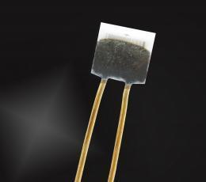

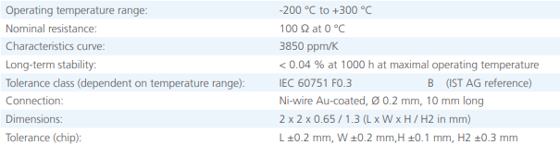

**ADS1115 16-Bit ADC – 4 Channel with Programmable Gain Amplifier**

* wide supply range: 2.0v to 5.5v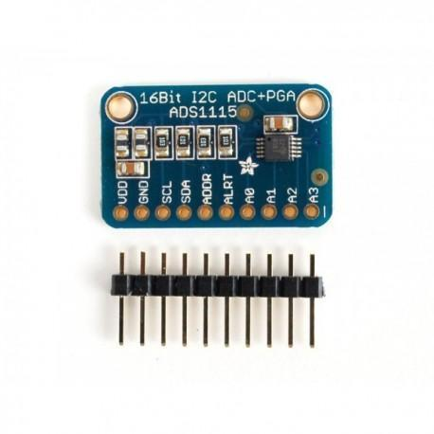
* low current consumption: continuous mode: only 150µA Single-Shot Mode: Auto Shut-Down
* programmable data rate: 8SPS to 860SPS
* internal low-drift voltage reference
* internal oscillator
* internal PGA
* I2C interface: Pin-Selectable Addresses
* four single-ended or two differential inputs
* programmable comparator
* this board/chip uses I2C 7-bit addresses between 0x48-0x4B, selectable with jumpers

**Camera PR700**

* Main Processor (Maximum HD Support): General Plus4247(720P/30FPS)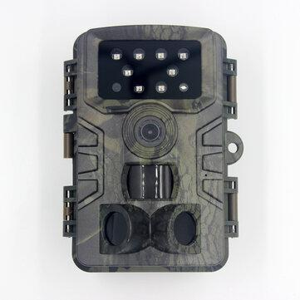
* Effective Megapixel: About 5MP
* Memory Card Type: MicroSD / TF
* Night Shot Function: Yes
* Screen Size: 2.0”
* Weight: 201g-300g
* Volume: 13.7*9.7*7.6cm
* Support: 32G
* Wide-angle: 120° HDMI
* Waterproof: Yes
* Sensor Size (inches): 1/3 inches
* Other Manual X 1, USB Cable X 1, Hunting camera X 1
* Operation Temperature: -30 – 70°C   
  Operation Humidity: 5% ~ 95%
* DC:12V-1A

**Nema 23 Stepper Motor**

* + Motor Length: 76mm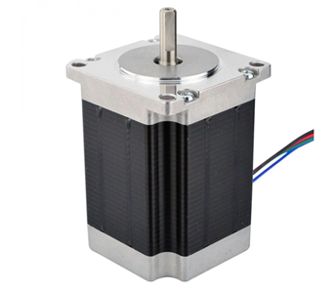
  + Rate Current: 2.8A
  + Voltage: 3.2V
  + Phase resistance: 1.13Ω
  + Phase inductance: 3.6mH
  + Holding Torque: 19kg.cm
  + Lead Wire NO.: 4
  + Detent Torque: 0.4kg.cm
  + Rotor Inertia: 300g.cm
  + Step Angle:1.8 degree
    - Maximum Temperature: 80℃
  + Ambient Temperature: -20℃~+50℃
  + Insulation Resistance: 100MΩ Min. 500.VDC

Dielectric Strength: 500VDC for 1 minute

**DRV8825 Stepper Motor Driver Carrier** 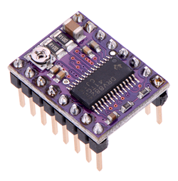

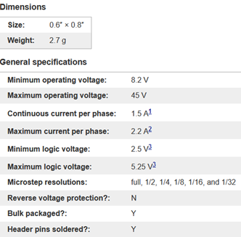

**Geiger Muller Tube(J305)**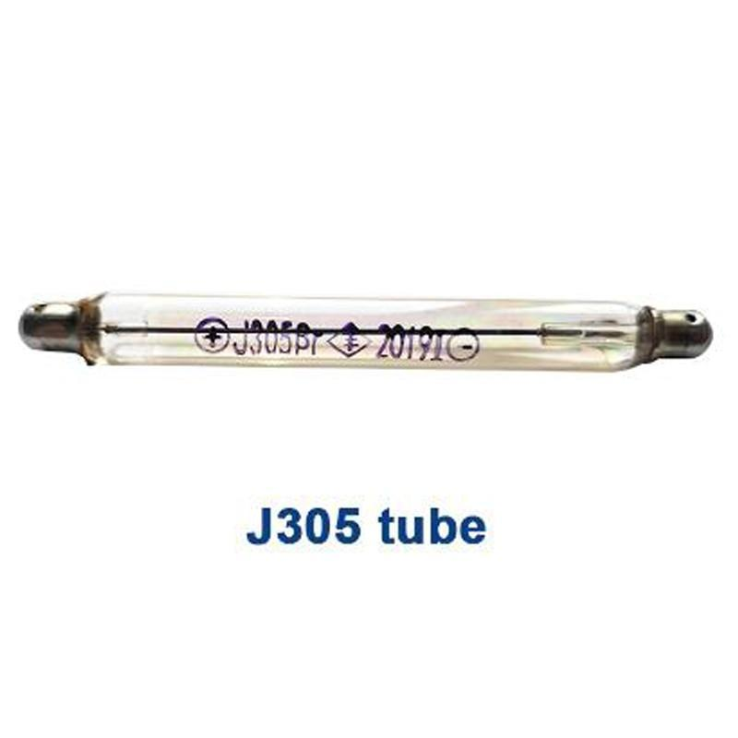

* Tin oxide Cathode, Coaxial cylindrical thin shell structure (Wall density 50±10cg/cm2),
* Application of pulse type halogen tube
* Application temperature: -40°C~55°C
* Can be used for: γ Ray 20mR/h~120mR/h and β Ray in range 100~1800 Changing Index/minutes·CM2 soft β Ray (Both beta and gamma radiation detection)
* Working Voltage: 380-450V
* Working Current: 0,015-0,02 mA
* Sensitivity to Gamma Radiation: 0.1 MeV
* Own Background: 0,2 Pulses/s
* Length:   90±2mm
* Diameter:  10±0.5mm

### Biometrics

The sequence of calculations for the determination of the energy cost is highlighted in the figure below:

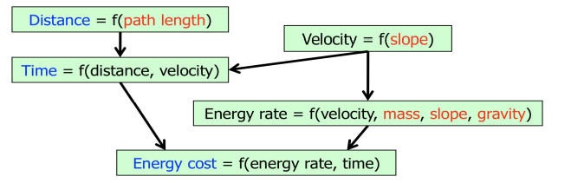

The velocity relation was developed by Marquez from data on the Apollo 14 mission compiled by Waligoria and Horrigan (Marquez 2008, Waligoria and Horrigan) **[3, 4]**:

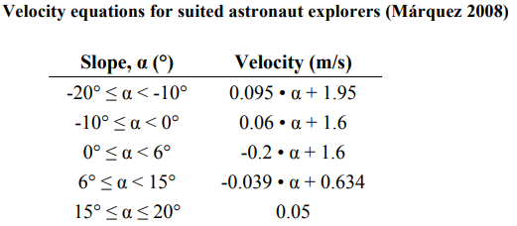

The figure below shows the astronaut velocity plotted against the terrain’s slope.

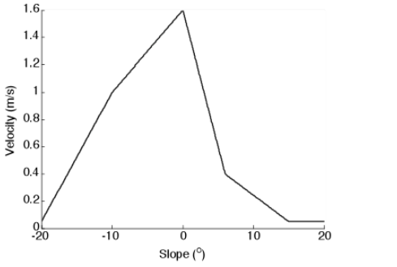

The traverse time is then calculated as distance divided by velocity. The astronaut energy rate(W) is a function of his velocity and mass(kg), as well as the terrain slope and planetary gravitational acceleration (m/s^2) (Santee et al.2001) **[5]**. The metabolic energy rate is related to these parameters by the equations in the Table below: 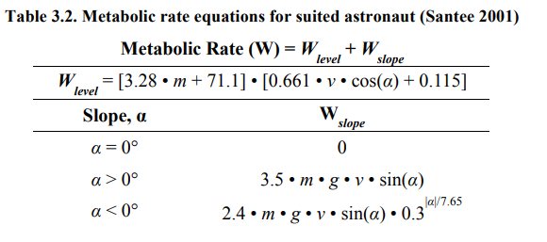

and the corresponding graph of the rate against the terrain’s slope.

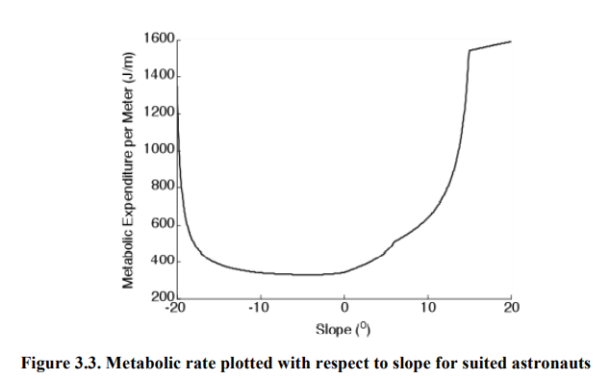

### WebRTC

WebRTC (RTC stands for Real Time Communication) is an open-source technology that provides real-time communication capabilities, by supporting communication with voice and video and allowing data transfer. On a high level, the WebRTC standard, covers two different technologies: media capture devices and peer-to-peer connectivity. More specifically, it assists developers and user with an API that delivers powerful voice and video communication solutions, as well as data transfer operations. All modern browsers support this technology, and it is available on all major platforms. For some native clients, such as Unity, Android, iOS, etc., a library is available with the same functionality.

*WebRTC architecture with a signaling server communicating necessary information between clients*

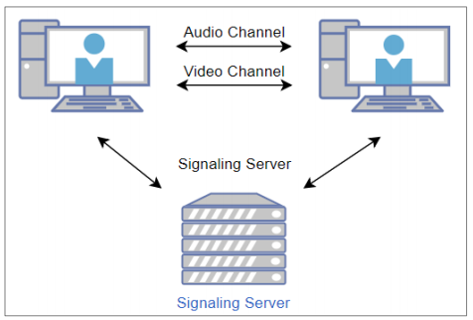

A typical and commonly used WebRTC application flow is the following: accessing the media devices, opening peer connections, discovering peers, and start streaming.

The relevance of WebRTC, for the purpose of this project, lies on the fact that it enables a user-friendly interface with high quality and decent reliability. Furthermore, it provides many essential functions, for this application, just out of the box. <<Call Base>>, <<Camera>> (HoloLens modules) from the client’s side and <<Call>>, <<Streaming>> (Control Room modules) from the server’s side could be implemented in coordination with the functions of this technology. Hence, it successfully enables real-time communication between the clients (Unity, Weather Box) via the server (Control Room).

*WebRTC interface accessed by control room via google chrome browser*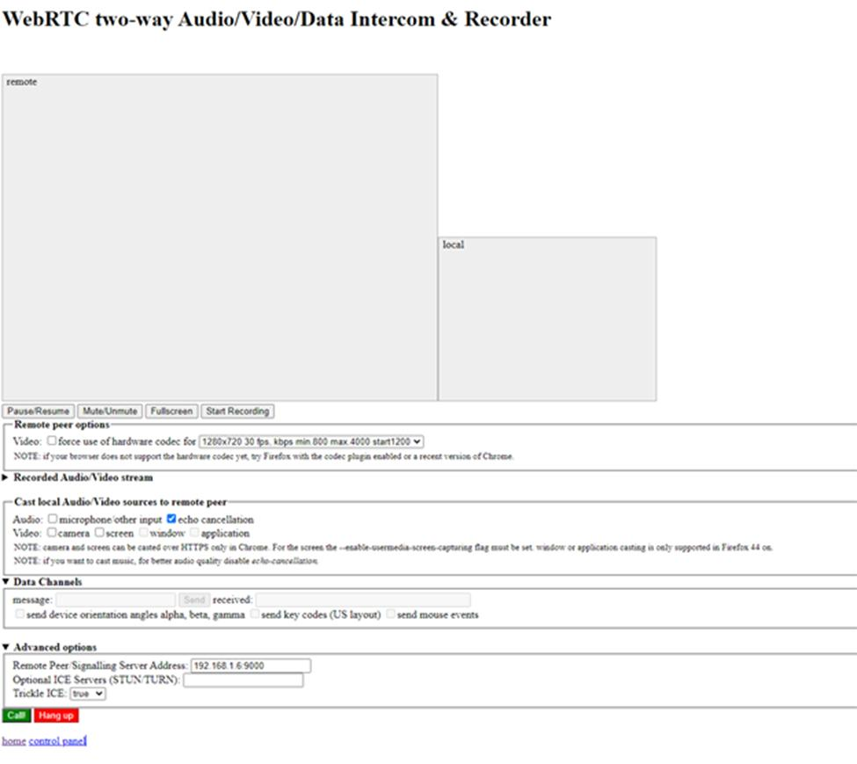

### Electrical Design Concepts and Trade-Off Analysis

|  |  |  |  |  |  |
| --- | --- | --- | --- | --- | --- |
| **Thermal Sensors** | Temperature Range (ºC)  [Weight: 1] | Cost (€)  [Weight :0.8] | Weight (g)  [Weight: 0.5] | Power (Watt)  [Weight: 0.2] | **Total Points** |
| PT-100 | -200 to 300 | 3.4(×6) | negligent | 0.55(×6) | 24.4 |
| 10 | 10 | 10 | 7 |
| TCN75A | -40 to 125 | 5 | 10 | 11×10-4 | 18.7 |
| 5 | 8 | 8 | 10 |
| Ladybug (Thermal Camera) | -20 to 50 | 2500 | 3000 | 13 | 3.7 |
| 2 | 1 | 1 | 2 |

*Table 7.4.8-1*

|  |  |  |  |  |
| --- | --- | --- | --- | --- |
| **Radiation Sensors** | Temperature Range (ºC)  [Weight: 1] | Cost (€)  [Weight: 0.8] | Weight (g)  [Weight: 0.6] | **Total Points** |
| Geiger-Müller tube  J305 | -40 to 55 | 16 | 8 | 19.6 |
| 7 | 9 | 9 |
| SEN-14209 | -20 to 70 | 69.75 | 10 | 12.4 |
| 5 | 4 | 7 |
| Geiger-Müller tube  J301γβ | -40 to 70 | 52 | 8 | 17.4 |
| 8 | 5 | 9 |

*Table 7.4.8-2*

|  |  |  |  |  |  |  |  |
| --- | --- | --- | --- | --- | --- | --- | --- |
| **Camera** | Temperature Range (ºC)  [Weight: 1] | Cost (€)  [Weight: 0.6] | Weight (g)  [Weight: 0.4] | Night vision  [Weight: 0.8] | Data transfer  [Weight:1] | Angle(º)  [Weight:0.6] | **Total Points** |
| GoPro Fusion | -10 to 40 | 300 | 220 | No | Hard | 360 | 16.6 |
| 3 | 2 | 5 | 3 | 2 | 10 |
| PR700 | -30 to 70 | 33.3 | 265 | Yes | Easy | 120 | 33.4 |
| 7 | 7 | 4 | 10 | 9 | 6 |
| PR600C | -14 to 158 | 22.2 | 110 | Yes | Easy | 60 | 31.8 |
| 6 | 8 | 7 | 10 | 9 | 2 |

*Table 7.4.8-3*

### Software Design Concepts and Trade-Off Analysis

|  |  |  |  |  |  |
| --- | --- | --- | --- | --- | --- |
| **UI Design** | Development Ease [Weight: 0.9] | Usability [Weight: 1] | Scalability [Weight: 0.5] | Visual quality [Weight: 0.8] | **Total Points** |
| Button surrounding gaze cursor | 3 | 8 | 7 | 9 | 21.4 |
| Static Panel | 5 | 7 | 9 | 6 | 20.8 |
| Head-up-display View | 8 | 2 | 4 | 9 | 18.4 |

*Table 7.4.10-1*

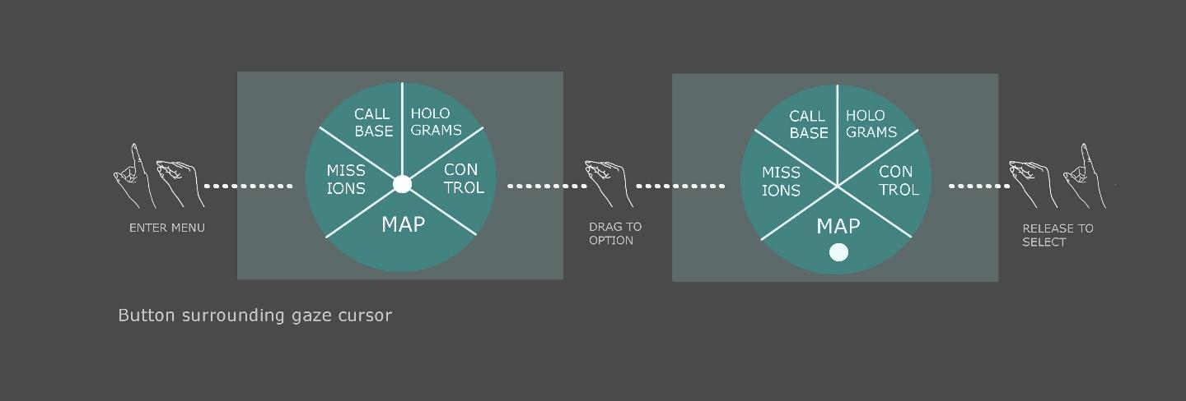

*Figure 7.4.10-1*

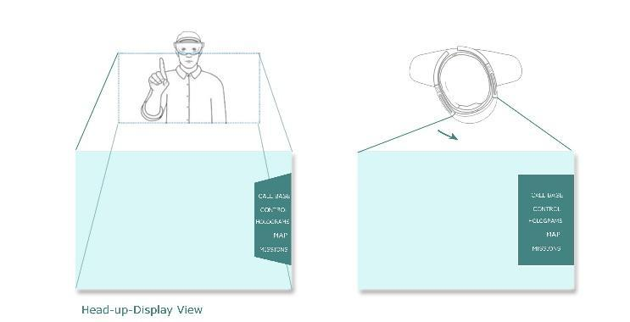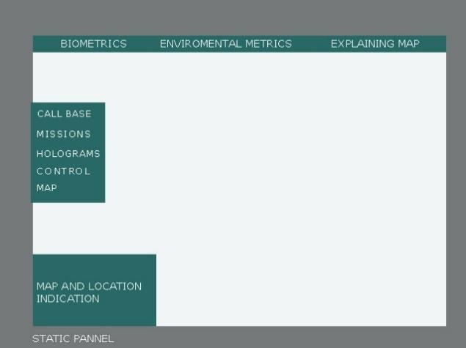

*Figure 7.4.10-2 (left)*

*Figure 7.4.10-3 (right)*

|  |  |  |  |  |  |
| --- | --- | --- | --- | --- | --- |
| Features | Development Ease [Weight: 0.9] | Usability [Weight: 1] | Scalability [Weight: 0.5] | Visual quality [Weight: 0.8] | **Total Points** |
| **Mapping** |  |  |  |  |  |
| Static Map | 9 | 9 | 5 | 8 | 26 |
| Dynamic Mapping | 1 | 9 | 9 | 8 | 28 |
|  |  |  |  |  |  |
| **Navigation** |  |  |  |  |  |
| Predefined routes | 9 | 6 | 3 | 6 | 20.4 |
| Algorithmic routing | 4 | 8 | 9 | 8 | 22.5 |
|  |  |  |  |  |  |
| **Communication** |  |  |  |  |  |
| Text-based | 7 | 2 | 5 | 3 | 13.2 |
| Voice-based | 4 | 8 | 7 | 5 | 19.1 |
| Streaming | 1 | 9 | 4 | 9 | 19.1 |
|  |  |  |  |  |  |
| **Repair** |  |  |  |  |  |
| Instructions through Hologram replica of the device | 5 | 6 | 6 | 7 | 19.1 |
| Instructions through on-device Hologram (Vuforia SDK) | 3 | 8 | 8 | 7 | 20.3 |

*Table 7.4.10-2*

### Test Plans

|  |  |
| --- | --- |
| **Test number** | **Elec-1.1** |
| **Test name** | **Temperature sensor test** |
| Description | The temperature sensor will connect with the Raspberry Pi and by inspection we will see if the measurements of the sensors are correct, using other verified sensors in our lab. |
| Parts to be tested | PT-100 |
| Test facility | Aristotle University of Thessaloniki |
| Material / equipment | Sensor, Raspberry |
| Persons needed | 1 |
| Date of test | 12/2020 |
| Test duration | 30 minutes |

|  |  |
| --- | --- |
| **Test number** | **Elec-1.2** |
| **Test name** | **Radiation sensor test** |
| Description | The radiation sensor will connect with the Raspberry Pi and by inspection we will see if the measurements of the sensors are correct, using other verified sensors in our lab. |
| Parts to be tested | SEN-14209 radiation sensor |
| Test facility | Aristotle University of Thessaloniki |
| Material / equipment | Sensor, Raspberry Pi |
| Persons needed | 1 |
| Date of test | 12/2020 |
| Test duration | 30 minutes |

|  |  |
| --- | --- |
| **Test number** | **Elec-1.3** |
| **Test name** | Raspberry Pi function Test |
| Description | Plug the raspberry pi to the power supply and test all ports and pins. |
| Parts to be tested | Raspberry Pi |
| Test facility | Aristotle University of Thessaloniki |
| Material / equipment | Raspberry Pi |
| Persons needed | 1 |
| Date of test | December |
| Test duration | 30 minutes |

|  |  |
| --- | --- |
| **Test number** | **Elec-1.6** |
| **Test name** | Camera function test |
| Description | Connect the camera to the Raspberry Pi and check if it stores live video. |
| Parts to be tested | camera |
| Test facility | Aristotle University of Thessaloniki |
| Material / equipment | Camera, Raspberry Pi |
| Persons needed | 1 |
| Date of test | December |
| Test duration | 30 minutes |

|  |  |
| --- | --- |
| **Test number** | **Elec-1.7** |
| **Test name** | Weather station’s component coordination |
| Description | Connect all components and test if all data is received correctly. |
| Parts to be tested | Weather box |
| Test facility | Aristotle University of Thessaloniki |
| Material / equipment | Weather box |
| Persons needed | 1 |
| Date of test | 01/2021 |
| Test duration | 60 minutes |

|  |  |
| --- | --- |
| **Test number** | **Elec-1.8** |
| **Test name** | Weather station data transmission |
| Description | Transmit data from the weather box to the server and rotate the camera using the HoloLens. Check if the data are accurate and if the motor responds correctly. |
| Parts to be tested | Remote control |
| Test facility | Aristotle University of Thessaloniki |
| Material / equipment | Weather box, PC, HoloLens |
| Persons needed | 1 |
| Date of test | 12/2020 |
| Test duration | 60 minutes |

|  |  |
| --- | --- |
| **Test number** | **Elec-1.9** |
| **Test name** | Weather Box Full functionality test |
| Description | Use a laptop as the control room and simulate the conditions of the Field Campaign. Test the functionality of the box on these conditions. |
| Parts to be tested | Weather box |
| Test facility | Aristotle University of Thessaloniki |
| Material / equipment | Weather box, HoloLens, pc |
| Persons needed | 1 |
| Date of test | 12/2020 |
| Test duration | 60 minutes |

|  |  |
| --- | --- |
| **Test number** | **Mech-2.1** |
| **Test name** | Weight verification |
| Description | Measure the weight of the box in total. |
| Parts to be tested | Weather box |
| Test facility | Aristotle University of Thessaloniki |
| Material / equipment | Weather box |
| Persons needed | 1 |
| Date of test | 04/2021 |
| Test duration | 30 minutes |

|  |  |
| --- | --- |
| **Test number** | **Mech-2.2** |
| **Test name** | Dimensions measurement |
| Description | Measure the dimensions of the box. |
| Parts to be tested | Weather box |
| Test facility | Aristotle University of Thessaloniki |
| Material / equipment | Weather box |
| Persons needed | 1 |
| Date of test | 04/2021 |
| Test duration | 30 minutes |

|  |  |
| --- | --- |
| **Test number** | **Mech-2.3** |
| **Test name** | Thermal insulation test |
| Description | Place the box in both vacuum and air, testing the temperature inside the box while changing the temperature of the environment. |
| Parts to be tested | Weather box |
| Test facility | Aristotle University of Thessaloniki |
| Material / equipment | Weather box |
| Persons needed | 2 |
| Date of test | 04/2021 |
|  |  |

|  |  |
| --- | --- |
| **Test number** | **Mech-2.4** |
| **Test name** | Cosmic ray protection |
| Description | Test the radiation levels inside the box when simulating the lunar radiation conditions. |
| Parts to be tested | Weather box |
| Test facility | Aristotle University of Thessaloniki |
| Material / equipment | Weather box |
| Persons needed | 1 |
| Date of test | 04/2021 |
| Test duration | 120 minutes |
| **Test number** | **Mech-2.5** |
| **Test name** | Waterproofing |
| Description | Dive the box into water and test if there are any leaks. |
| Parts to be tested | Weather box |
| Test facility | Aristotle University of Thessaloniki |
| Material / equipment | Weather box |
| Persons needed | 1 |
| Date of test | 04/2021 |
| Test duration | 30 minutes |

|  |  |
| --- | --- |
| **Test number** | **Soft-1.1** |
| **Test name** | **HoloLens Nominal Operation test** |
| Description | It consists of sub-tests which ensure the basic functionality of the HoloLens Smartglasses. It is essential that these tests are performed frequently. |
| Parts to be tested | HoloLens Smartglasses |
| Test facility | Aristotle University of Thessaloniki |
| Material / equipment | HoloLens Smartglasses |
| Persons needed | 1 |
| Date of test | 1st of each month and before the field campaign |
| Test duration | 5 minutes |

|  |  |
| --- | --- |
| **Test number** | **Soft-1.1.1** |
| **Test name** | **HoloLens Response Test** |
| Description | The HoloLens is booted up, its response to gestures and interactions with the Microsoft Menu and the ability to open apps are verified. |
| Parts to be tested | HoloLens Smartglasses |
| Test facility | Aristotle University of Thessaloniki |
| Material / equipment | HoloLens Smartglasses |
| Persons needed | 1 |
| Date of test | 1st of each month and before the field campaign |
| Test duration | 5 minutes |

|  |  |
| --- | --- |
| **Test number** | **Soft-1.1.2** |
| **Test name** | **HoloLens calibration test** |
| Description | HoloLens (1st gen) uses the distance between your pupils (IPD or interpupillary distance) to make holograms clear and easy to interact with. If the IPD is not correct, holograms may appear to be unstable or at an incorrect distance.  During calibration, HoloLens asks you to align your finger with a series of six targets per eye. HoloLens uses this process to set the correct IPD for your eyes. |
| Parts to be tested | HoloLens Smartglasses |
| Test facility | Aristotle University of Thessaloniki |
| Material / equipment | HoloLens Smartglasses |
| Persons needed | 1 |
| Date of test | 1st of each month and before the field campaign |
| Test duration | 5 minutes |

|  |  |
| --- | --- |
| **Test number** | **Soft-1.1.3** |
| **Test name** | **HoloLens remote connection test** |
| Description | The HoloLens ability to connect to other interfaces via WiFi is tested. |
| Parts to be tested | HoloLens Smartglasses |
| Test facility | Aristotle University of Thessaloniki |
| Material / equipment | HoloLens Smartglasses |
| Persons needed | 1 |
| Date of test | 1st of each month and before the field campaign |
| Test duration | 5 minutes |

|  |  |
| --- | --- |
| **Test number** | **Soft-1.2** |
| **Test name** | **Navigation module functionality test** |
| Description | The tester shall ensure that the Navigation module is activated passively (i.e. without user input) and will perform the subsets in alternation. |
| Parts to be tested | HoloLens Smartglasses |
| Test facility | Aristotle University of Thessaloniki |
| Material / equipment | HoloLens Smartglasses |
| Persons needed | 1 |
| Date of test | 03/2021 |
| Test duration | 3 minutes |

|  |  |
| --- | --- |
| **Test number** | **Soft-1.2.1** |
| **Test name** | **Path and guideline visualization test** |
| Description | The tester shall wear the HLS and follow a collection of predetermined test paths. They shall confirm that the paths are displayed correctly both in the mini-map and the surrounding area.  Regarding the surrounding area, a physical path will be drawn on the floor and the digital path should “reflect” it. |
| Parts to be tested | HoloLens Smartglasses |
| Test facility | Aristotle University of Thessaloniki, 6x6 square meters empty space with drawn paths |
| Material / equipment | HoloLens Smartglasses, coloured tape |
| Persons needed | 1 |
| Date of test | 03/2021 |
| Test duration | 3 minutes |

|  |  |
| --- | --- |
| **Test number** | **Soft-1.2.2** |
| **Test name** | **Static path calculation test** |
| Description | The static path calculation algorithm will be tested in the control room laptop.  Regarding the calculation of the static paths, different configurations of nodes (“points of interest”) will be given as input to the algorithm. The results will be reviewed by the students and will be measured according to their efficiency – the path graph should contain the expected distances – and their practicality – the paths should not cross any set boundaries. |
| Parts to be tested | Server (Control Room Laptop) |
| Test facility | Aristotle University of Thessaloniki |
| Material / equipment | Laptop |
| Persons needed | 2 |
| Date of test | 04/2021 |
| Test duration | - |
|  |  |

|  |  |
| --- | --- |
| **Test number** | **Soft-1.2.3** |
| **Test name** | **Dynamic path calculation test** |
| Description | The dynamic path calculation algorithm will be tested in the HLS.  Regarding the calculation of the dynamic paths, different destinations will be given as input to the algorithm. The results will be reviewed by the testers and will be measured according to their efficiency – the path distance should be as short as possible – and their practicality – the paths should not cross any set boundaries. |
| Parts to be tested | HoloLens Smartglasses |
| Test facility | Aristotle University of Thessaloniki |
| Material / equipment | HoloLens Smartglasses |
| Persons needed | 2 |
| Date of test | 03/2021 |
| Test duration | 5 minutes |

|  |  |
| --- | --- |
| **Test number** | **Soft-1.3** |
| **Test name** | **Repair module functionality test** |
| Description | The tester shall make sure that the repair instructions work correctly. |
| Parts to be tested | HoloLens Smartglasses |
| Test facility | Aristotle University of Thessaloniki |
| Material / equipment | HoloLens Smartglasses |
| Persons needed | 1 |
| Date of test |  |
| Test duration | 3 minutes |

|  |  |
| --- | --- |
| **Test number** | **Soft-1.3.2** |
| **Test name** | **Repair guidelines test** |
| Description | After successfully recognizing the object the tester should make sure that the HLS displays the correct sequence of procedures needed to repair the weather box, responding to the user’s actions. |
| Parts to be tested | HoloLens Smartglasses |
| Test facility | Aristotle University of Thessaloniki |
| Material / equipment | HoloLens Smartglasses |
| Persons needed | 1 |
| Date of test | 03/2021 |
| Test duration | - |

|  |  |
| --- | --- |
| **Test number** | **Soft-1.4** |
| **Test name** | **Main Menu complete operation test** |
| Description | The tester will open the menu while moving and/or rotating and select the different options one by one. Moreover, they will make sure that the menu does not conflict with other holograms. |
| Parts to be tested | HoloLens Smartglasses |
| Test facility | Aristotle University of Thessaloniki |
| Material / equipment | HoloLens Smartglasses |
| Persons needed | 1 |
| Date of test | 01/2021 |
| Test duration | 10 minutes |

|  |  |
| --- | --- |
| **Test number** | **Soft-1.4.1** |
| **Test name** | **Holographic placement module test** |
| Description | The tester will access the holographic placement module and try placing every hologram in different locations. They will also test for possible conflicts between the holograms. |
| Parts to be tested | HoloLens Smartglasses |
| Test facility | Aristotle University of Thessaloniki |
| Material / equipment | HoloLens Smartglasses |
| Persons needed | 1 |
| Date of test | 02/2021 |
| Test duration | 10 minutes |

|  |  |
| --- | --- |
| **Test number** | **Soft-1.4.2** |
| **Test name** | **Map module test** |
| Description | The tester will access the map module from different places in order to ensure the points of interest and his location are properly marked. |
| Parts to be tested | HoloLens Smartglasses |
| Test facility | Aristotle University of Thessaloniki, 6x6 square meters empty space with marked locations |
| Material / equipment | HoloLens Smartglasses, coloured tape |
| Persons needed | 2 |
| Date of test | 03/2021 |
| Test duration | 5 mins |
|  |  |

|  |  |
| --- | --- |
| **Test number** | **Soft-1.4.3** |
| **Test name** | **Mission Log module test** |
| Description | After completing a mission, the tester will open the mission log and make sure the mission is properly marked as completed. They will also try to re-complete the mission and other events in order to test for bugs. |
| Parts to be tested | HoloLens Smartglasses |
| Test facility | Aristotle University of Thessaloniki |
| Material / equipment | HoloLens Smartglasses |
| Persons needed | 1 |
| Date of test | 03/2021 |
| Test duration | 15 minutes |